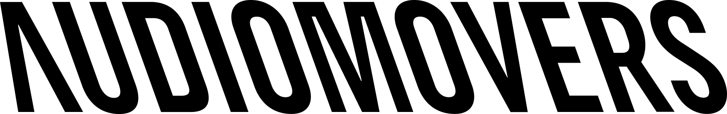

PR Contact:
Frank Wells
Senior Account Manager
Clyne Media, Inc.
T. 615.585.0597
frank.wells@clynemedia.com

Audiomovers Contact:
Matt Soczywko
Head of Marketing
Audiomovers
T. +44 (0)7403 478 993
matt@abbeyroad.com

For Immediate Release

Audiomovers presenting “Real-Time High Resolution Remote Collaboration” TEC Tracks session at The NAMM Show on Friday, April 14

— Igor Maxymenko, co-founder and Head of Product at Audiomovers, will present on remote collaboration at 3:00 p.m. PDT on Friday, April 14, 2023, at the Anaheim Convention Center in room 202A —

The NAMM Show, Anaheim, CA, April 13, 2023 – Audiomovers, a leading provider of audio tools designed for real-time, high-resolution remote collaboration, will be hosting an informative TEC Tracks session on Friday, April 14, 2023, at The NAMM Show in Anaheim, CA. “Real-Time High Resolution Remote Collaboration” will take place in room 202A at the Anaheim Convention Center from 3:00 to 4:00 p.m. PDT. Igor Maxymenko, co-founder and Head of Product at Audiomovers, will lead the presentation, which will include a Q&A portion.

Originally a necessity brought about by the pandemic, remote collaboration has now become another essential tool within the sound engineer’s arsenal. This year the GRAMMY® Awards had a record number of winning and nominated records that were produced at least in part remotely, be it for mix approval, mastering or the entire process from songwriting to release. Igor Maxymenko has been at the center of this remote revolution since 2017, designing tools that have become the industry standard for remote audio.

In this session, Maxymenko will explore where he sees the future of remote collaboration and production heading and what the potential is, beyond the ability to send and receive lossless multichannel quality audio. He will elaborate on and explore the technical barriers today to seamless remote collaboration, and the ways this could change in the future. Additionally, he will call out the formats he believes will come to dominate, and the ways in which workflows could radically change anywhere where high-quality audio and remote working combine, in the worlds of live broadcast, education, gaming, film and of course music.

Photo file: IgorMaxymenko.JPG
Photo caption: Igor Maxymenko, co-founder and Head of Product at Audiomovers

About Audiomovers:
Founded in 2017 by Igor Maxymenko (Waves, Blue Microphones) and Yuriy Shevyrov (Universal Audio, Waves, Avid, Logitech) and acquired by Abbey Road Studios in 2021, Audiomovers offers a set of audio tools designed for real-time, high-resolution collaboration with anyone in the world and easy audio management within a production system.

Their solutions meet the specifications of tens of thousands of music professionals around the world, from producers working on tracks with their co-writers to large-scale, scoring post-production facilities streaming out multichannel audio to multiple remote teams and listeners simultaneously.

Audiomovers has quickly gained recognition and became a standard for remote collaboration by meeting the rapidly changing demands of producers, mixers, songwriters and studios.

Proponents of Audiomovers tools include:
Aaron Dessner, Eddie Kramer, Bainz, Future Islands, Dave Fridmann, !llmind, Teezio, Jesse Ray Ernster, George Massenburg, Bring Me The Horizon, Count, Tim Bran, J Views, Phil Gornell, Matt Schwartz (Yungblud), Niko Moon, Cian Riordan, Lewis Capaldi, David Boucher, Josh Groban and many more.

Audiomovers Products include:

LISTENTO – a remote collaboration tool that allows users to stream uncompressed audio and is available as a DAW plugin, a desktop app and for browsers.

OMNIBUS – an audio routing application/virtual patchbay for MacOs.

Learn more at www.audiomovers.com.

