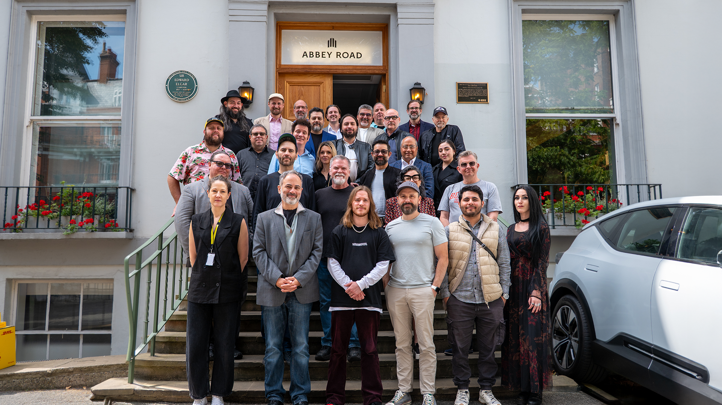

**Audiomovers Hosts Inaugural Educators Conference at Abbey Road Studios: The Future of Audio Education and Its Next Generation of Professionals**

***25 leading educators from around the globe gather at the historic Abbey Road Studios to discuss how remote workflows and Audiomovers technology are redefining the classroom for tomorrow’s audio professionals.***

[London, Thursday, 19 September 2025] — On Friday, August 22, Audiomovers brought together 25 leading educators from around the globe for the first-ever Audiomovers Educators Conference, held at the historic Abbey Road Studios. The day-long event, which took place in Studio 3, explored how institutions are preparing the next generation of audio professionals and showcased how Audiomovers’ technology is helping make the classroom experience more engaging, connected, and reflective of modern industry practice.

Through a series of presentations, discussions, and live demonstrations, one truth emerged: audio education is evolving rapidly, and the workflows driving today’s professional studios must also drive tomorrow’s classrooms.

For decades, learning audio engineering was limited by geography and studio access. The pandemic permanently changed that landscape, demonstrating that remote workflows are not temporary stopgaps but essential components of the future of education. The conference underscored how Audiomovers tools like LISTENTO and OMNIBUS enable students to work within the same workflows powering world-class studios from Abbey Road, London to Ocean Way, Nashville.

“Our commitment to education is simple: give students access to the same tools trusted by the industry, so the next generation of audio professionals are ready to shape the future of music in ways we can’t yet imagine,” says Dom Dronska, GM, Audiomovers. She continues, “What we took away from the event is that every educator, and every institution, shares that same goal: ensuring students are prepared not just to enter the industry, but to transform it.”

Examples of these workflows in action included cross-continental Foley sessions, immersive reverb experiments in Colorado’s Tank Center for Sonic Arts streamed to Connecticut, analog processing of Bogotá stems through a vintage Les Paul custom-built 8-channel console in Los Angeles, and real-time collaborative mixing projects spanning Europe, the U.S., and Latin America. These projects demonstrated that students are no longer constrained by classroom walls, they are engaging in global, real-time, professional-caliber collaborations.

Educators presented projects that brought this vision to life, including:

* John Machado (Five Towns College, USA) & Jorge Mario Valencia (ITM, Colombia) — streaming Colombian folk instruments into U.S. sessions.
* Gabe Herman (University of Hartford, USA) — led the “Tank and the Hartt” project, streaming guitar into the Tank Center for Sonic Arts in Colorado to teach immersive reverb and Atmos mixing.
* Bill Mueller (Omega Institute, USA) — a livestreamed multi-engineer mixing event.
* Julio Monroy (Javeriana University, Colombia) — connected students with engineers in Los Angeles and Brooklyn to experience analog processing through remote workflows
* Rick Allen (CRAS, USA) & Daniel Spirovski (JMC Academy, Australia) — ran a 7,500-mile Foley/SFX session streamed live to Australian campuses.
* Joe Baldridge (Belmont University & Ocean Way Nashville, USA) — live mixing demonstrations streamed between Ocean Way and Abbey Road.
* Plus contributions from educators at Trinity College Dublin, SAE Institute, Duquesne University, Tecnológico de Monterrey, University of York, and others.

Guests including Warren and Kasia Huart (Produce Like a Pro), Alex Case (Eventide), and Jorge and Natalia Urbano (sound:check Xpo, Mexico) further emphasized the growing recognition that audio education must mirror professional practice on a global scale.

In summary, from Brooklyn to Bogotá to Brisbane, students are no longer restricted by location. With Audiomovers technology embedded in curricula worldwide, they are mastering workflows that mirror the realities of today’s professional studios, ensuring the next generation is prepared for an industry that is global, connected, and real-time.

**Call to Action**

For more details on projects from the Audiomovers Educators Conference, contact [**education@audiomovers.com**](mailto:education@audiomovers.com).

To explore **Audiomovers for Education** and bring professional remote workflows into your classroom, reach out to our sales team: [**sales@audiomovers.com**](mailto:sales@audiomovers.com).

For further information about Audiomovers, please contact:

Media Contact:  
Robert Clyne – Clyne Media, Inc.  
[robert@clynemedia.com](mailto:robert@clynemedia.com)   
  
Audiomovers  
[pr@audiomovers.com](mailto:pr@audiomovers.com)

Supplementary document: Audiomovers_EducatorsConference2025_Quotes.docx

Supplementary comments from key attendees.

Photo file 1: Audiomovers_EducatorsConference2025_Steps.JPG

Photo caption 1: On Friday, August 22, Audiomovers brought together 25 leading educators from around the globe for the first-ever Audiomovers Educators Conference, held at the historic Abbey Road Studios. Attendees are pictured on the front steps of the facility.

Photo file 2: Audiomovers_EducatorsConference2025_Studio3.JPG

Photo caption 2: On Friday, August 22, Audiomovers brought together 25 leading educators from around the globe for the first-ever Audiomovers Educators Conference, held at the historic Abbey Road Studios. Attendees are pictured in the facility’s Studio 3.

**ABOUT AUDIOMOVERS**Audiomovers is the innovation engine behind Abbey Road Studios’ technology offering, pioneering remote audio tools for music producers, artists, composers, and sound engineers. With over 3 million creator sessions worldwide, Audiomovers is the remote collaboration backbone behind albums by Taylor Swift, J. Cole, Beyoncé, Burna Boy, Future Islands, Rihanna, Lewis Capaldi, and more. Whether in music, film, TV, or gaming, Audiomovers enables audio professionals to collaborate across platforms, formats, and borders—instantly.

Discover more: [www.audiomovers.com](http://www.audiomovers.com)