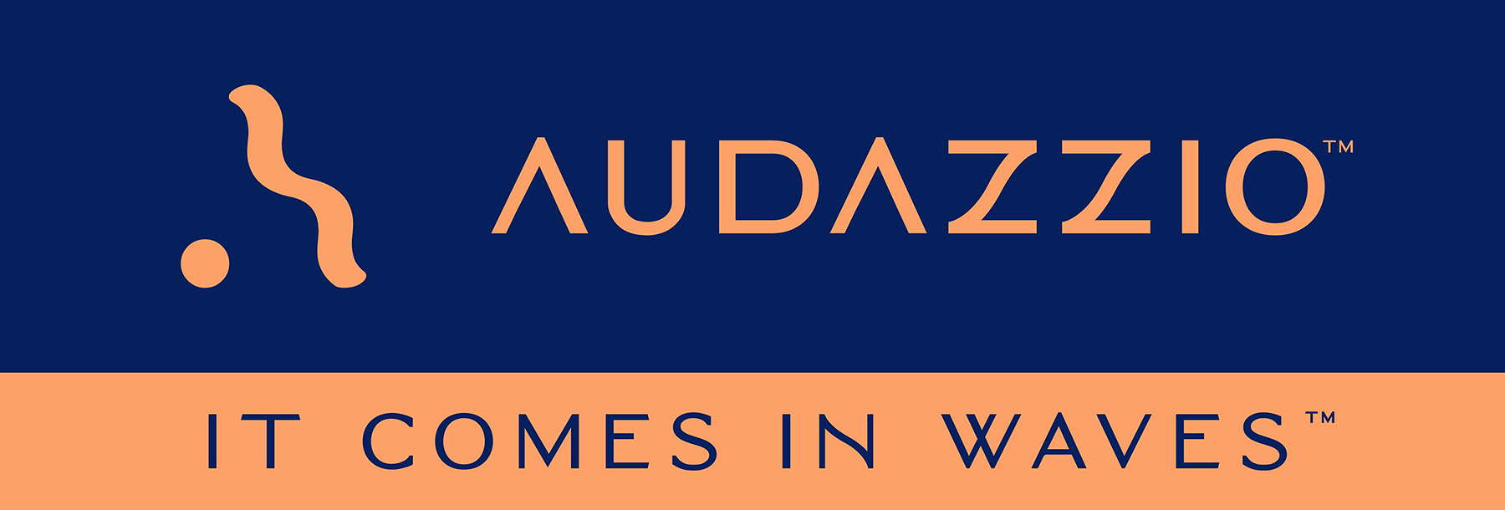

FOR IMMEDIATE RELEASE

Audazzio™ appoints Bryan Elliot as VP of Engineering

Longtime software and SaaS industry veteran joins Audazzio team

San Antonio, TX, and Boulder, CO (February 6, 2023): Audazzio™, an innovative software startup and finalist in Comcast NBCUniversal’s SportsTech Accelerator program, continues to expand and refine its executive leadership team. The newest addition is Bryan Elliot, who has been appointed VP of Engineering. Elliot is a SaaS industry veteran who enjoys decades of engineering leadership experience managing software teams. The announcement was made by Danny Abelson, Audazzio Chief Operating Officer.

In his new role, Elliot will be responsible for all technology development at Audazzio, including the software itself, as well as the use of other cloud services to aid with scaling. He will also be responsible for hiring and growing the Audazzio engineering team to support the business’s growth. He will report directly to Abelson.

As a software and SaaS industry veteran, Elliot successfully led many engineering teams to bring products and services to market. Notably, he was co-founder of Ping Identity Corporation, where he took the initial concept and grew the original engineering team to its early successes. Ping Identity recently was acquired by Thoma Bravo for $2.8 billion. Most recently, he served as Vice President, Platform Engineering, at IronNet Cybersecurity, where he led a large Engineering team to improve, refine and modernize legacy Cybersecurity products.

Elliot remarks, “Joining Audazzio, I am excited to return to a role at an organization in its early stages with tremendous growth potential. As Audazzio is embraced by the market, I am eager to help enact strategies for its long-term success.”

Abelson notes, “As we continue the rollout of Audazzio’s technology, we are dedicated to building the most effective executive team possible. Elliot comes to us with a strong pedigree of development and growth for software startups, and we look forward to working together with him as a key contributor.”

The Audazzio Live QR™ solution embeds micro-signaling into a broadcast audio stream to seamlessly deliver content on a phone or tablet, fully coordinated with the broadcast – opening the door to a whole world of applications for savvy broadcasters, sports rights holders, venues, sponsors, betting operators and beyond. Audazzio provides clients with tools that enable focused messaging directly to their fans in real time, either at home or in a stadium or arena.

For more information on Audazzio, please visit www.audazzio.com.
For a video primer on Live QR technology from Audazzio, visit www.audazzio.com/explainer.

Photo file 1: BryanElliot.JPG
Photo caption 1: Bryan Elliot, Audazzio VP of Engineering

FOR MORE INFORMATION PLEASE CONTACT:
Robert Clyne | Clyne Media, Inc. | 615.662.1616 | robert@clynemedia.com
Michele Klumb | Audazzio | Vice President of Marketing | 855.697.6627 | michele@audazzio.com

About Audazzio™
Audazzio™ is an innovative media company that was a recent participant in the Comcast NBCUniversal’s SportsTech Accelerator program. Based in San Antonio, TX, and Boulder, CO, Audazzio delivers groundbreaking technologies that enable broadcasters and event producers to seamlessly change the content on a fan’s mobile device, in real time, fully coordinated with their broadcast or event. In much the same way that a QR code graphic provides a unique digital fingerprint for a variety of uses, the Live QR™ algorithm from Audazzio embeds micro-signaling into a broadcast audio stream to seamlessly deliver content on a phone or tablet. By leveraging Live QR™ technology, marketers have access to an entirely new channel to reach consumers’ mobile devices, at critical moments in an event or broadcast, when they crave more information and storytelling. Audazzio can deliver any web page, at any time, to any device within range of the Live QR signaling, opening the door to a whole new world of applications for savvy broadcasters, sponsors and beyond.

