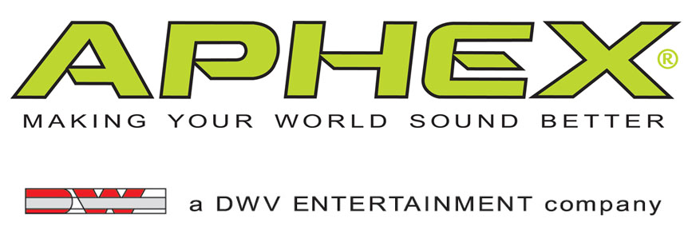

PRESS RELEASE
Media Contact: Robert Clyne
Clyne Media, Inc.
Robert@clynemedia.com
Tel: (615) 662-1616
Fax: (615) 662-1636

FOR IMMEDIATE RELEASE

Aphex® Deepens Its Relationship with the Music Industry Recording Arts (MIRA) Program at St. Petersburg College

— Leading audio processing product developer and innovative pro audio and music industry education center have a shared vision of how technology and academia can work together to the enhanced benefit of the school, the students and the quality of sound —

BURBANK, CA, February 12, 2013 — Aphex®, a leader in audio enhancement technology for more than 35 years, has deepened its unique relationship with the Music Industry Recording Arts (MIRA) program at St. Petersburg College in St. Petersburg, Florida. The MIRA program, which was launched four years ago with a dozen students and offers an accredited Associate of Science degree in a well-integrated curriculum of audio sciences and business acumen, now has between 250 and 300 students per semester in the program, and plans to launch a four-year Bachelor of Applied Science degree program in 2014. For the last two years, the MIRA program has collaborated closely with Aphex, using products including the Aural Exciter®, 500 Series EQ, Aphex Channel, Aphex Dominator II and Compellor® processors, as well as the HeadPod 4™ headphone amplifier, all integrated into MIRA’s pro audio curriculum. As new products become available, Aphex shares them with MIRA, providing the program’s students with state-of-the-art technology that offers them access to equipment identical to that being used in commercial facilities. At the same time, the faculty and students of MIRA regularly provide insightful feedback into how those products perform under the singular pressures of an academic environment. It’s a relationship from which everyone benefits, most of all the students.

This mutually beneficial association has come about because of the shared vision of Mark Matthews, Lead Instructor of the MIRA program, and Aphex wanting to bring the “real world” of recording and music to students. “At MIRA, we approach learning about audio arts and the music industry in an experiential, hands-on way, and Aphex has been a significant partner in how we go about that,” says Matthews.

Aphex CEO David Wiener agrees, adding, “Mark Matthews has the perfect combination of experience, talent and vision to lead their unique MIRA Program. Matthews is pioneering a new educational path to prepare students not only to enter the industry's workplace but also to grow and sustain within the many segments of the audio industry. We are thrilled that Aphex and MIRA have developed such a great working relationship and that we can be a part of helping the audio professionals of the future in such a powerful program. And as the students learn using our product, Aphex also learns while watching them use those products – we get to see how an entirely new generation of pro audio professionals looks at its tools."

As the relationship enters its next stage, Wiener points to MIRA’s new MYRA Radio Network, an internet-based radio station broadcasting from the St. Petersburg/Gibbs campus. The station is a multi-format platform completely managed and programmed by students, who produce their own programs and have complete creative control over the content. The HeadPod 4 is now an integral part of the station’s infrastructure, thanks to its four stereo power amplifiers and switchable multi-source inputs (including SPDIF) that make it a perfect fit for the needs of MIRA’s new broadcast center. The MYRA Radio Network will create another platform in which MIRA’s students and faculty can work together, but it’s also another level in a deepening relationship that’s totally student-focused, says Matthews. “It’s about how best to integrate not only Aphex products, but also all relevant production equipment, into the student workflow at MIRA. From this dialog, a new way of thinking has been developed regarding how educational institutions and manufacturers can work together in a mutually beneficial relationship.”

For more information please visit http://www.aphex.com.
###
… ends QQQ words
Photo File 1: MIRA_Photo1.JPG
Photo Caption 1: Aphex® processors employed for a session at the Music Industry Recording Arts (MIRA) program at St. Petersburg College.

Photo File 2: MIRA_Photo2_MYRAProductionStudio_HeadPod4.JPG
Photo Caption 2: Aphex®’s HeadPod 4™ (pictured, on table), employed for a MYRA Radio Network broadcast at the Music Industry Recording Arts (MIRA) program at St. Petersburg College.

About The Music Industry Recording Arts program (MIRA)
Our program helps students develop “real world” skills that musicians need to thrive in a diverse and competitive music industry. The program offers a well-rounded, technology-based educational experience to student musicians, composers, producers, DJs, live-sound reinforcement enthusiasts and post-production technologists. The program emphasizes creative processes, technical training, business practices and entrepreneurial skills in a collaborative environment.
· MIRA A.S. degree
- Offers instruction from experienced music professionals
- Prepares you for quick entry into the workforce
- Provides you with hands-on experience

About St. Petersburg College (SPC)
St. Petersburg College was Florida’s first two-year college (founded in 1927) as well as the state’s first community college to offer bachelor's degrees (2002). Today, SPC is one of 14 State Colleges, and served as a model for incorporating bachelor's degree programs into traditional two-year institutions.

About Aphex®
Founded in 1975, Aphex® is a leading designer and manufacturer of high-performance signal processing products for the professional audio, broadcast, fixed installation, M.I., touring-sound, home-recording and consumer-electronics market sectors. Aphex has built its reputation on providing the cleanest, clearest, most effective signal and dynamics processing technologies available. The company’s Aural Exciter® (a TECnology Hall of Fame inductee), Big Bottom® and Compeller® technologies have been the basis for Aphex’s product line and are widely considered to be industry standards. The company has recently expanded from its hardware platform and developed Audio Xciter™, the first audio app that brings studio-quality audio to smartphones and tablets. Aphex sells its products and licenses its technologies worldwide. Visit them at www.aphex.com.

About DWV Entertainment/David Wiener Ventures
DWV Entertainment is a leader in audio and entertainment product and technology innovation. Along with the Aphex brand, the company's DW Collection line of elegant home entertainment products has received worldwide acclaim for its uncompromising approach to product engineering, performance and style. This has resulted in visually stunning, high performance audio products, including the exclusive Ferrari Art.Engine, Art.Opera and Art.Studio series audiophile loudspeakers and audio transmission devices.

DWV Entertainment was spun out of David Wiener Ventures (DWV). The driving force behind DWV is David Wiener, whose talents and passions have led him to be a pioneer in several disciplines, including audio, aircraft design, human-powered vehicles, active wear fashion, photography, Formula One racing and more. Profiled in international magazines, newspapers, design books and television shows, including a PBS documentary about his work with high-performance vehicles, Mr. Wiener has a rich background in engineering, art and aerodynamics. He holds over a dozen patents and is the recipient of several international design and business awards. A creative visionary, Mr. Wiener brings his unique perspective to all his endeavors, and is now focused on helping musicians and music lovers make the most of every music experience.

Aphex Media Contact:
Robert Clyne, Clyne Media, Inc., P: (615) 662-1616, E: Robert@clynemedia.com

