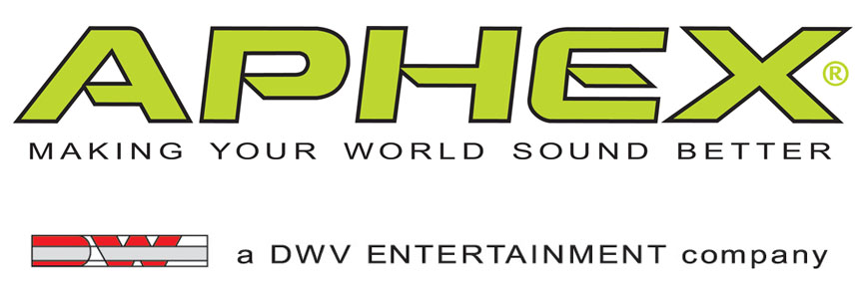

PRESS RELEASE
Media Contact: Robert Clyne
Clyne Media, Inc.
Robert@clynemedia.com
Tel: (615) 662-1616
Fax: (615) 662-1636

FOR IMMEDIATE RELEASE

Music Mix Mobile (M3) Continues to Choose Aphex®
Model 188 and 1788A Microphone Preamps for High-Profile
Television Programs and Broadcast Events

— Aphex® 188 mic preamps combine high efficiency with great sound for a variety of M3’s projects, and the 1788A offers added flexibility for hectic festival production schedules —

BURBANK, CA, November 14, 2012 —— Music Mix Mobile (M3), a New Jersey/California-based remote recording, mixing and production company, are one of the most in-demand remote facilities teams in the country, and they continue to reaffirm their strong reliance on products from Aphex® as a vital part of their signal chain. M3’s services have helped several television programs and large-scale events broadcast the highest quality audio. Such programs include The GRAMMY®s, The Latin GRAMMY®s, VH1 Storytellers, The Daily Show with Jon Stewart, The Colbert Report, and Late Night with Jimmy Fallon’s live broadcast from the University of North Carolina. A key part of M3’s signal chain is the Aphex Model 188 Microphone Preamp. M3 has been relying on the 188 at various gigs through the summer months, including the Bonnaroo festival in Manchester, Tennessee; the Budweiser Made in America festival in Philadelphia; and the upcoming Latin GRAMMYs.

Joel Singer, Chief Engineer for M3, states, “We continue to use the 188 in our Voyager, OBU and flightpack systems. The Aphex 188 is an important part of making the signal chain work efficiently and effectively. I can say that as a package we’re thrilled with it because of the sound quality, size and feature set. It solves many of the challenges that come with working on complex music programs in remote broadcast shows. We’re able to save space and still have loads of channels for some of these bigger events. They perform so much better than their competitors in this preamp category, and plain and simple, they sound great. Add into the mix that they’re remote-controlled and already have optical outputs – it’s a win-win. You really get a lot of bang for your buck.”

At the recent IHeartRadio festival in Las Vegas, M3 brought two trucks for added flexibility to cover a hectic itinerary. The California-based M3 West truck Horizon is equipped with Aphex’s Model 1788A Premium Eight Channel Microphone Preamp. Singer adds, “You know what you’re getting with a 1788A and 188’s, and that’s a musical sounding pre. I love both products, and we’ll continue to use them on our future gigs.”

“We are extremely pleased that top industry professionals such as M3 continue to choose Aphex as part of their audio signal chain,” stated David Wiener, Aphex CEO. “When you only have one shot to get it right for a live broadcast event, it’s an honor to have such talented people know they can rely on our products in a critical situation.”

The Aphex Model 188 provides eight high-quality Aphex transformer-coupled mic preamps in a 1U rack-mount chassis. Like the popular Aphex 1788A, all settings of the Model 188 can be remote controlled via Ethernet or MIDI, using the 1788A-RC remote or the 1788SW control software (PC and Mac). It can also be controlled via the Aphex 5200 interface from an Avid Pro Tools or Yamaha control surface. The Model 188 has an eight channel analog output as well as two ADAT Optical outputs, each carrying eight channels of audio. The two outputs can be used for redundant operation, or in combination for 2X sampling rates (SMUX).
###
… ends 513 words
Photo Files: Aphex_188.JPG, M3_Joel_Singer_Chief_Engineer.JPG

About Aphex
Founded in 1975, Aphex is a leading manufacturer of high-quality signal processing products for the professional audio, broadcast, fixed installation, M.I., touring-sound and home-recording markets. Aphex sells its products and licenses its technologies worldwide. Visit them at www.aphex.com

About DWV Entertainment/David Wiener Ventures
DWV Entertainment is a leader in audio and entertainment product and technology innovation. Along with the Aphex brand, the company's DW Collection line of elegant home entertainment products has received worldwide acclaim for its uncompromising approach to product engineering, performance and style. This has resulted in visually stunning, high performance audio products, including the exclusive Ferrari Art.Engine, Art.Opera and Art.Studio series audiophile loudspeakers and audio transmission devices.

DWV Entertainment was spun out of David Wiener Ventures (DWV). The driving force behind DWV is David Wiener, whose talents and passions have led him to be a pioneer in several disciplines, including audio, aircraft design, human-powered vehicles, active wear fashion, photography, Formula One racing and more. Profiled in international magazines, newspapers, design books and television shows, including a PBS documentary about his work with high-performance vehicles, Mr. Wiener has a rich background in engineering, art and aerodynamics. He holds over a dozen patents and is the recipient of several international design and business awards. A creative visionary, Mr. Wiener brings his unique perspective to all his endeavors, and is now focused on helping musicians and music lovers make the most of every music experience.

Aphex Media Contact:
Robert Clyne, Clyne Media, Inc., P: (615) 662-1616, E: Robert@clynemedia.com

