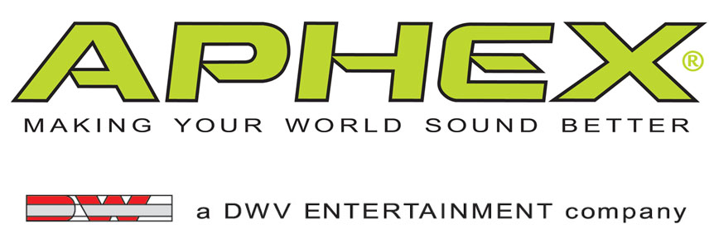

PRESS RELEASE
Media Contact: Robert Clyne
Clyne Media, Inc.
Robert@clynemedia.com
Tel: (615) 662-1616
Fax: (615) 662-1636

FOR IMMEDIATE RELEASE

Aphex® Exciter Keeps the Music Moving for
Mellow Mushroom Pizza Bakers

— Franchisees of the fast-growing pizza chain now have the power of the Aphex® Exciter available to them via approved AV systems integration vendor FirstComm, for which
the Exciter has become a crucial component for achieving great sound cost-effectively —

— Aphex®’s Exciter offers a cost-effective solution to maximize Mellow Mushroom’s audio —

133rd AES CONVENTION, SAN FRANCISCO, CA, October 27, 2012 — Aphex® (booth 715), a leader in audio enhancement technology for over 35 years, is proud to see its Exciter becoming the key processing component in the sound package put together by FirstComm, the approved-vendor AV systems integrator for Mellow Mushroom Pizza Bakers, the fast-growing Atlanta-based pizza restaurant brand that now has over 120 locations nationwide. Two Mellow Mushroom locations in the Charlotte, North Carolina area have recently had sound systems featuring the Aphex Exciter installed; three more, in Pooler, Georgia; Spring, Texas; and Decatur, Alabama, are scheduled to be the next stores that will feature the Exciter’s unique DSP capabilities. Each Mellow Mushroom franchise is individually owned, and each franchisee develops its own theme for the store, such as the “Magic Carpet Ride” and “Woodstock” motifs found at the Charlotte area stores. What the Aphex Exciter will assure is that its stores will have consistently great sound, all the time.

“Music is a big part of the Mellow Mushroom brand,” says Jacob Fuerstman, Director of Operations for FirstComm, which started in 2003 as a sub-contractor for the Muzak Corporation and has grown into a full-service commercial low-voltage systems designer and integrator with a specialty in designing and installing high-performance but cost-effective audio systems for restaurants. “Our mission has been to develop great sound systems for restaurants that don’t break the bank, and the systems we’ve been using for Mellow Mushroom locations do exactly that, thanks in large part to the Aphex Exciter. We’ve found that with the Exciter products we can add a lot of performance to systems through its DSP, giving the systems a rich, full sound without having to employ other kinds of DSP that would be overkill and too costly for most restaurants. The Exciter is virtually invisible as a line item because it’s so reasonably priced, but it makes a significant difference in the audio quality of the sound system. In the world of commercial installs, there’s no other product that gives you this kind of performance boost for such a low cost.”

As an approved vendor, FirstComm has found that Mellow Mushroom clients have responded very positively to both the upgrade in audio and the financial savings. “They especially like the ‘perceived loudness’ feature of the Aphex Exciter, which lets the music fill the restaurant with more impact, without getting too loud to talk over,” Fuerstman explains. “We’ve made the Aphex Exciter a standard part of the package we provide for their restaurants, as well as for other food service clients, such as the Cinebarre movie theaters in Charlotte, which also use the Exciter to enhance its system. Future projects will include Aphex Exciter retrofits to existing restaurants. “The Exciter is a great retrofit product because of its price point,” he says. “It increases the performance of the sound system so much, for such a small amount of money, it’s foolish not to use it. There’s nothing out there that can give you this kind of bang for the buck.”

For more information, please visit www.aphex.com.
###
… ends 500 words

Photo File 1: Aphex_MellowMushroom_Photo1.JPG
Photo Caption 1: A Mellow Mushroom location in the Charlotte, North Carolina area, benefitting from the unique DSP capabilities of the Aphex® Exciter installed by AV systems integrator FirstComm.

Photo File 2: Aphex_MellowMushroom_Photo2.JPG
Photo Caption 2: A Mellow Mushroom location in the Charlotte, North Carolina area, benefitting from the unique DSP capabilities of the Aphex® Exciter installed by AV systems integrator FirstComm. Pictured is FirstComm Director of Operations Jacob Fuerstman.

Photo File 3: Aphex_MellowMushroom_Photo3.JPG
Photo Caption 3: The equipment rack at a Mellow Mushroom location in the Charlotte, North Carolina area, featuring the Aphex® Exciter installed by AV systems integrator FirstComm.

About Aphex
Founded in 1975, Aphex is a leading designer and manufacturer of high-performance signal processing products for the professional audio, broadcast, fixed installation, M.I., touring-sound, home-recording and consumer-electronics market sectors. Aphex has built its reputation on providing the cleanest, clearest, most effective signal and dynamics processing technologies available. The company’s Aural Exciter®, Big Bottom® and Compeller® technologies have been the basis for Aphex’s product line and are widely considered to be industry standards. The company has recently expanded from its hardware platform and developed Audio Xciter™, the first audio app that brings studio-quality audio to smartphones and tablets. Aphex sells its products and licenses its technologies worldwide. Visit them at www.aphex.com.

About DWV Entertainment/David Wiener Ventures
DWV Entertainment is a leader in audio and entertainment product and technology innovation. Along with the Aphex brand, the company's DW Collection line of elegant home entertainment products has received worldwide acclaim for its uncompromising approach to product engineering, performance and style. This has resulted in visually stunning, high performance audio products, including the exclusive Ferrari Art.Engine, Art.Opera and Art.Studio series audiophile loudspeakers and audio transmission devices.

DWV Entertainment was spun out of David Wiener Ventures (DWV). The driving force behind DWV is David Wiener, whose talents and passions have led him to be a pioneer in several disciplines, including audio, aircraft design, human-powered vehicles, active wear fashion, photography, Formula One racing and more. Profiled in international magazines, newspapers, design books and television shows, including a PBS documentary about his work with high-performance vehicles, Mr. Wiener has a rich background in engineering, art and aerodynamics. He holds over a dozen patents and is the recipient of several international design and business awards. A creative visionary, Mr. Wiener brings his unique perspective to all his endeavors, and is now focused on helping musicians and music lovers make the most of every music experience.

Aphex Media Contact:
Robert Clyne, Clyne Media, Inc., P: (615) 662-1616, E: Robert@clynemedia.com

Aphex is exhibiting at Booth 715 during the 133rd AES Convention in San Francisco, CA.

