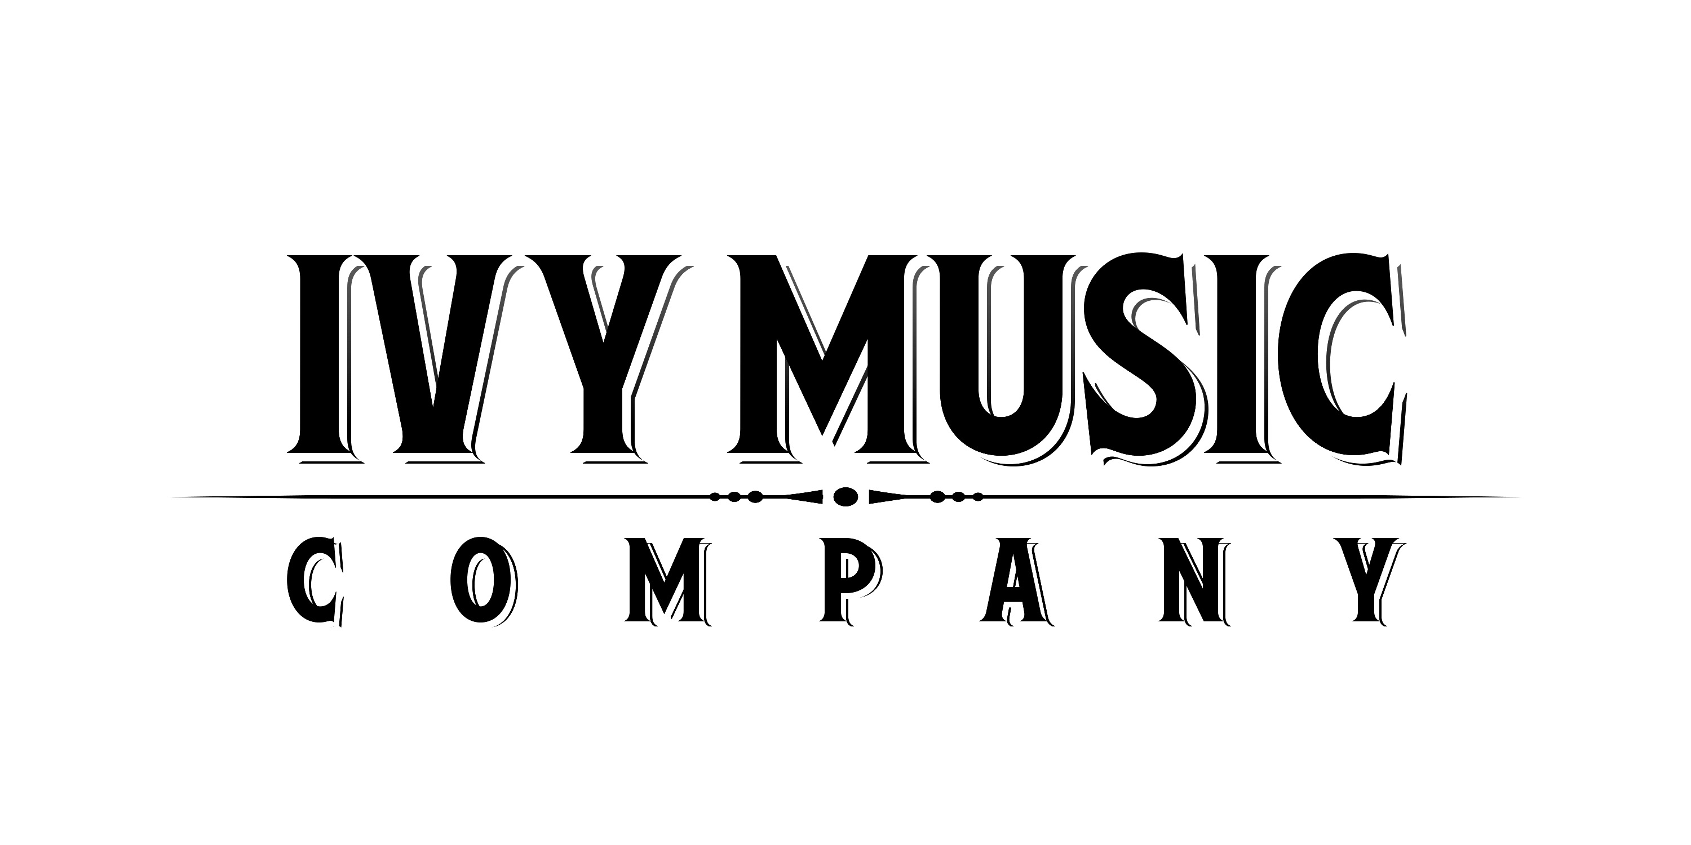
Albert Cummings turns it up to TEN with an expansive sound on his new album available April 8

– The acclaimed bluesman busts down genre walls on TEN, produced by GRAMMY®-winner Chuck Ainlay and featuring a guest appearance by Vince Gill –

– New single “Need Somebody” premieres today! –

February 17, 2022 - There are few albums today that are grounded in the blues but can still instantly jump off into a whole new sense of expression. On his new studio album TEN, Albert Cummings ventures into rock, country, soul and Americana, while his songs range from wall-ratting tunes to soft ballads, with Cummings’ rugged, world-wise vocals hitting all the right moods. Musically diverse and emotionally cohesive, TEN’s 13 original tracks stand as a compelling statement about who he is now and where he may be headed. TEN will be released on April 8 via Ivy Music Company.

The first single, scorching rocker “Need Somebody,” premiered earlier today via Guitar Player Magazine, who stated about Cummings, “With over two decades’ worth of solo releases under his belt, his recorded body of work catalogs a guitarist that has gone from strength to strength. Renowned for his raw, off-the-cuff stage performances, what you see really is what you get with this maestro.”

LISTEN TO THE TRACK HERE

TEN was recorded in Nashville at Peter Frampton’s Phenix Studios. Helping Cummings craft his vision for this album was GRAMMY®-winning producer Chuck Ainlay (Mark Knopfler, Dire Straits, George Strait, Peter Frampton, Miranda Lambert and Emmylou Harris, among others) and a dream team of musicians including drummer Greg Morrow, bassist Glenn Worf, keyboardist Michael Rojas, and guitarist Rob McNelley. “The music that started to be played in the studio sounded like it was being created on a whole new level,” Cummings raves, “I knew in a flash we were onto something.”

“Need Somebody” also represents another crucial element of TEN – the emotional depth Cummings reaches with his evocative lyrics. TEN is the first record where Cummings, as he explains it, “let the listener into my personal space.” The music is more songwriting-focused, with the guitar being used as a tool to drive the songs home. “Meet the Man” and “Too Old to Grow Up” provide vivid portraits of people living their lives, alongside a passionate ode of love on “She’s The One.” A song especially close to Cummings’ heart is “Beautiful Bride.” It’s the first song he ever sang in public – and he sang it at his own wedding.

A particular thrill for Cummings was working with Country Music Hall of Famer Vince Gill, who lends his vocal talent on the boisterous roadhouse tune “Last Call.”

Throughout his career, Cummings has strived not to place boundaries on his music, and with TEN, he has raised the bar to a place where anything seems possible. “I have been playing for a lot of years and still find new ways of expressing myself,” Cummings says. “That’s what this album is all about to me. It supports my belief that I can accomplish whatever I set my mind to.”

TEN is available for pre-order on February 18.

Cummings kicks off his 2022 tour tonight in San Juan Capistrano, CA, with additional stops including Los Angeles, Oakland, Seattle, New York and Nashville. The list of tour dates is below.

For more information on Albert Cummings, visit www.albertcummings.com.

TEN TRACKLISTING
1. Need Somebody
2. Too Old to Grow Up
3. Hard Way
4. Last Call
5. Beautiful Bride
6. Sounds Like the Road
7. Meet the Man
8. Two Hands
9. Take Me Away
10. Alive and Breathing
11. She’s The One
12. Got You Covered
13. Remember

TOUR DATES
February 17 – Coach House Concert Hall – San Juan Capistrano, CA
February 18 – Ramona Mainstage – Ramona, CA
February 19 – Grand Annex – Los Angeles, CA
February 20 – The Painted Table Event Center – Fresno, CA
February 23 – Felton Music Hall – Felton, CA
February 24 – Blue Note Napa – Napa, CA
February 25 – Auburn Placer Performing Arts Center – Auburn, CA
February 26 – Black Oak Concert Series – Tuolumne, CA
February 27 – Yoshi's Oakland – Oakland, CA
March 2 – The Jack London Revue – Portland, OR
March 3 – Triple Door – Seattle, WA
March 4 – The Spanish Ballroom – Tacoma, WA
March 5 – The Seasons Performance Hall – Yakima, WA
March 6 – Volcanic Theatre Pub – Bend, OR
March 8 – The Sapphire Room – Boise, ID
March 24 – Katharine Hepburn Cultural Arts Center – Old Saybrook, CT
March 25 – Bull Run Restaurant – Shirley, MA
March 26 – Spire Center for Performing Arts – Plymouth, MA
April 14 – The Iridium – New York, NY
April 15 – Fairfield Theatre Company Box Office – Fairfield, CT
April 16 – Jimmy's Jazz & Blues Club – Portsmouth, NH
April 22 – Gateway City Arts – Holyoke, MA
April 23 – Bearsville Theater – Woodstock, NY
May 25 – Open Chord Music – Knoxville, TN
May 26 – City Winery Nashville – Nashville, TN
May 28 – Downtown Brilliant – Brilliant, AL
May 29 – The Spinning Jenny – Greer, SC
June 2 – US National Whitewater Center – Charlotte, NC
June 3 – Blue Note Grill – Durham, NC
June 17 – Mauch Chunk Opera House – Jim Thorpe, PA
July 29 – Head of Falls and River Walk – Waterville, ME
August 7 – Donnacona Park – Quebec, QC
September 15 – One World Theatre – Austin, TX

Visit Albert Cummings on social media:
Facebook Instagram Twitter

DOWNLOAD BIO

Photo file: AlbertCummings_Ten_COVER_3000pxls.JPG
Photo caption: cover art for Albert Cummings’ upcoming album TEN
Photo credit: Nick Spanos

Contact:
Lucy Sabini - lucy.sabini@luciamediagroup.com - 917-864-0060
Robert Clyne - robert@clynemedia.com - 615-300-4666

