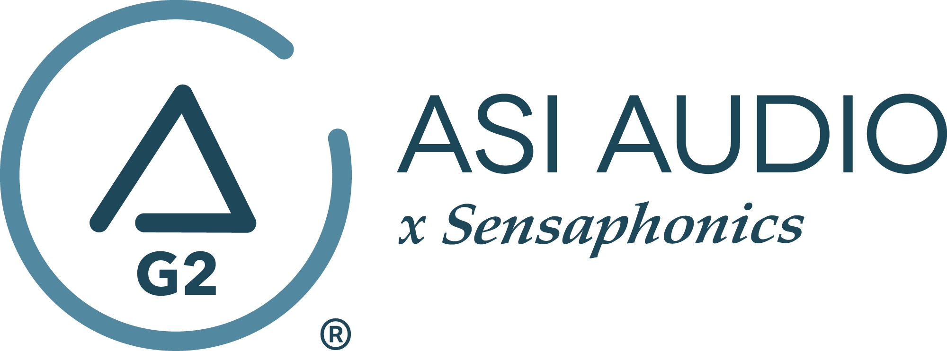 FOR IMMEDIATE RELEASE

Bassist, session player and mastering engineer Whynot Jansveld chooses ASI Audio x Sensaphonics 3DME Music Enhancement IEM System

— Currently on tour with The Wallflowers and Butch Walker, Whynot Jansveld is the latest player to employ ASI’s 3DME Gen2 Active Ambient Monitoring System for unparalleled monitoring and hearing protection —

Beachwood, OH, October 12, 2022 — Whynot Jansveld can be viewed as a triple threat. As primarily a bassist (and also a guitarist, singer and occasional keyboardist), Jansveld has performed, recorded and/or toured around the world with artists like The Wallflowers, Richard Marx, Butch Walker, Natasha Bedingfield and Sara Bareilles, to name a few. As a mastering engineer, he has put the final touches on tracks for artists such as Jewel, Martin Sexton, Elizabeth Cook, The Wallflowers, Butch Walker, Richard Marx, Andrew McMahon, Ingrid Michaelson and more. Working with legendary producers like Linda Perry, David Kahne, Neil Dorfsman, John O’Mahony and Butch Walker, he has become a sought-after, first-call studio bassist for a wide variety of projects.

Currently on tour playing bass with The Wallflowers and for Butch Walker, one of the key components of Jansveld’s touring rig is his ASI Audio x Sensaphonics 3DME Gen2 Active Ambient Monitoring System. “I’ve worked with the Sensaphonics people since 2018, and when I heard about their ASI product, I really wanted to check it out,” stated Jansveld. “And then I came across a YouTube video with guitarist Pete Thorn, a good friend of mine, talking about ASI in-ears. It piqued my interest immediately, because it seems like guitarists usually hate in-ears, so I was intrigued and was interested to see what Pete had to say. His video explained the whole thing: why he loved the ASI 3DME as a guitar player, and it made so much sense to me. He talked about being able to dial in the built-in ambient mics, which lets you hear your immediate surroundings. Not just the guitar amps and the drum sounds actually coming from the drum heads, but the crucial band interaction during the show: for instance, your frontman or frontwoman giving a setlist change, and being able to hear them say that without removing one of your in-ears, which to me is massive. And then obviously hearing the room, the crowd, feeling like you’re actually doing a rock show, as opposed to it looking like a rock show, but sounding like a studio recording.”

Jansveld talks about how he sets up his 3DME’s prior to a performance and how easy it is to tailor the sound for the gig. “In a setting where I need to create a new mix, what I like to do is turn the ambient mics off, and begin by getting a good balance going – I first approach it like I am using conventional in-ears, but then I dial in just enough ambience where I get that live feeling, without getting in the way of me hearing what I'm supposed to – my voice or some other key element. And so usually what that means is that, if it's a really good sounding room, all I might have it to do is drop it by minus 6dB. If the room is really booming and chaotic sounding, I might have it lower than that, like minus 8 or more. It really lets me dial in exactly what I need to hear.”

But what is paramount for Jansveld is hearing protection and hearing wellness. “Part of what I do is mastering records, and the MOST important tool you can have in the studio for critical listening is your ears,” stated Jansveld. “My advice to players who are resistant to in-ears is to stick with it and give your brain some time to adjust. It is a positive tool, and it is something worth getting used to. I remember many years ago I got a pair of custom molded ear plugs and I played a rocking blues rock show at a little club in New York. I put them in, and they just felt awkward, because it didn't feel like I was really part of the band playing live. Then I took them out for a second to ‘feel’ the music and the sound just clobbered me - so I put them back in. But with my 3DME’s, I can dial things in just right. I set the unit to a 9dB reduction, and it sounds like a full-on rock show. I just have the 3DME’s set exactly as loud as where it still feels rocking, but I know I’m not blowing my own head off and damaging my hearing. I want to do this for a long time, and ASI is helping me do that.”

The 3DME Music Enhancement IEM System Gen2 consists of Active Ambient earphones with embedded binaural MEMS ambient microphones, a bodypack mixer/controller/DSP processor/headphone amplifier and the Bluetooth-enabled ASI Audio App for control. The free ASI Audio App allows untethered adjustment of the system’s 7-band stereo EQ and limiter threshold. The App also offers an Audio Seal Test to confirm perfect IEM fit and allows the saving and recall of User Presets to ensure repeat access to preferred sound signatures. In operation, after locking in the preferred EQ and limiter settings, up/down switches on the bodypack make it easy to add the perfect amount of ambience to the monitor mix, so the performer can hear exactly what they want, no matter the style of music or type of venue. When used without a monitor mix, 3DME functions as variable-level, high fidelity earplugs. The universal-fit earphones supplied with 3DME can be converted to custom fit with silicone sleeves from Sensaphonics or upgraded to Custom Pro earpieces.

…ends 888 words

Photo file 1: Whynot_Jansveld.JPG
Photo caption 1: Whynot Jansveld performs using his ASI Audio x Sensaphonics 3DME Gen2 Active Ambient Monitoring System. Photo Credit: Tyler Silvestri
Photo file 2: Whynot_Jansveld2.JPG
Photo caption 2: Whynot Jansveld performs using his ASI Audio x Sensaphonics 3DME Gen2 Active Ambient Monitoring System. Photo Credit: Tyler Silvestri
Photo file 3: Whynot_Jansveld3.JPG
Photo caption 3: Whynot Jansveld performs using his ASI Audio x Sensaphonics 3DME Gen2 Active Ambient Monitoring System. Photo Credit: Tyler Silvestri

Press contact:
Clyne Media, Inc.
Frank Wells, Senior Account Manager
615.585.0597
frank.wells@clynemedia.com

ASI Audio contact:
Evan MacKenzie, Vice President, Marketing and Sales
216.970.4468 ext.104
evanmackenzie@asiaudio.com

ABOUT ASI AUDIO
Founded in 2019 by the team of hearing health advocate Dr. Michael Santucci Au.D. of Sensaphonics and Think-A-Move, Ltd. (developers of innovative speech recognition products for high-volume environments), ASI Audio x Sensaphonics has combined patented technologies and market insights to create 3DME Music Enhancement, a fundamentally different approach to in-ear monitoring and hearing protection. 3DME combines Active Ambient technology and personalized sound quality via the intuitive ASI Audio app, creating a system equally useful for amplified and acoustic monitoring for musicians and concertgoers alike. Web: www.ASIaudio.com.

