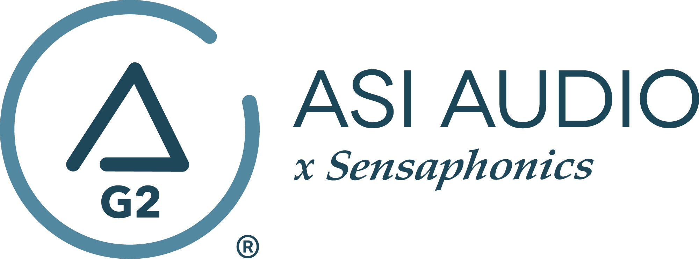 FOR IMMEDIATE RELEASE

Little Caesar’s drummer Tom Morris chooses ASI Audio x Sensaphonics 3DME Music Enhancement IEM System

— Tom Morris joins frontman Ron Young and bassist Pharoah Barrett as hard rockers Little Caesar standardize their personal monitors with ASI’s 3DME Gen2 Active Ambient Monitoring System —

Beachwood, OH, September 26, 2022 — Hard rockers Little Caesar just kicked off their European tour on September 8 in Verviers, Belgium. With upcoming shows in Germany, France, Austria, Spain and the Netherlands, the band, who has been thrilling audiences for over three decades, recently standardized their personal monitors with frontman Ron Young, bassist Pharoah Barrett and drummer Tom Morris now using the ASI Audio x Sensaphonics 3DME Gen2 Active Ambient Monitoring System.

Hearing protection has always been paramount for drummer Tom Morris, who has been with Little Caesar since its inception in 1987. He recalls the wake-up call he had regarding protecting his hearing and what he did about it: “I have always played with earplugs. Back before drummers were using plugs, I went to an ear doctor and had my hearing checked in my twenties, and he scared me so much about what could happen, that at that point, because I was still really young without damage, I started wearing earplugs. I used the little foamy plugs that they sell at pharmacies. I didn’t mind that there was a sound compromise, I just wanted the maximum amount of protection. And I got used to hearing music like that,” stated Morris. “I personally believe that drummers suffer more hearing damage than anyone else in the band. Particularly on whatever side your snare and hi-hats are set up on, you’re going to get more hearing damage. And losing your hearing isn’t cool. Our front man Ron Young started using in-ears a while back before we got to the Sensaphonics stuff. And I did that for a couple of tours, and I enjoyed it – it was different. But I found since we were all running our signal/mix though a central place, if things got glitchy if would affect all our feeds, even though our sends were all different to a degree. That lack of independence wasn’t ideal, and if something happens with the rig live, we’re all going to be in trouble. Now, with the 3DME, it’s completely independent. I have my own control. It’s super-easy to set up. Very user-friendly.”

Morris continues, “I admit that since I was so used to hearing everything muffled (from using the ear plugs for many years), the ambience setting just doesn’t feel right for me. So, I have that completely dialed out. I have it set super flat, a dry mix, to where I’m able to hear everything – guitars, left and right, bass, and particularly vocals, because I cue off the vocals a lot. It’s important for me to be able to hear the vocals on top of everything. I run them the same live as I would in rehearsal. The real beauty of the unit is it allows you the freedom and flexibility to change all your settings. You can have multiple settings, in fact – you could have different settings for different songs. The 3DME is so user-friendly that even a drummer can use it – and I can say that – HA!”

The 3DME Music Enhancement IEM System Gen2 consists of Active Ambient earphones with embedded binaural MEMS ambient microphones, a bodypack mixer/controller/DSP processor/headphone amplifier and the Bluetooth-enabled ASI Audio App for control. The free ASI Audio App allows untethered adjustment of the system’s 7-band stereo EQ and limiter threshold. The App also offers an Audio Seal Test to confirm perfect IEM fit and allows the saving and recall of User Presets to ensure repeat access to preferred sound signatures. In operation, after locking in the preferred EQ and limiter settings, up/down switches on the bodypack make it easy to add the perfect amount of ambience to the monitor mix, so the performer can hear exactly what they want, no matter the style of music or type of venue. When used without a monitor mix, 3DME functions as variable-level, high fidelity earplugs. The universal-fit earphones supplied with 3DME can be converted to custom fit with silicone sleeves from Sensaphonics or upgraded to Custom Pro earpieces.

…ends 655 words

Photo file 1: TomMorris.JPG
Photo caption 1: Little Caesar’s drummer Tom Morris with his ASI Audio x Sensaphonics 3DME Gen2 Active Ambient Monitoring System

Press contact:
Clyne Media, Inc.
Frank Wells, Senior Account Manager
615.585.0597
frank.wells@clynemedia.com

ASI Audio contact:
Evan MacKenzie, Vice President, Marketing and Sales
216.970.4468 ext.104
evanmackenzie@asiaudio.com

ABOUT ASI AUDIO
Founded in 2019 by the team of hearing health advocate Dr. Michael Santucci Au.D. of Sensaphonics and Think-A-Move, Ltd. (developers of innovative speech recognition products for high-volume environments), ASI Audio x Sensaphonics has combined patented technologies and market insights to create 3DME Music Enhancement, a fundamentally different approach to in-ear monitoring and hearing protection. 3DME combines Active Ambient technology and personalized sound quality via the intuitive ASI Audio app, creating a system equally useful for amplified and acoustic monitoring for musicians and concertgoers alike. Web: www.ASIaudio.com.

