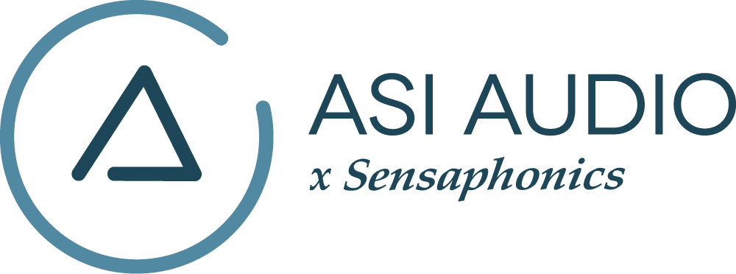 FOR IMMEDIATE RELEASE

Legendary Bassist Felton Crews Chooses ASI Audio 3DME System

GRAMMY®-nominated instrumentalist shares his thoughts on his move to the Active Ambient™ 3DME in-ear monitoring solution from ASI Audio

Beachwood, OH, June 7, 2022 — When jazz legend Miles Davis returned to the music scene after a five-year absence, the first bassist he called was Felton Crews. Growing up in Chicago, Crews was exposed to many genres of music including blues, jazz, pop, rock, R&B, funk and soul. That learning experience resulted in a highly versatile musician who can provide the right bass part for whatever music he is playing – it also made him one of the most sought-after players taking the stage with artists like Miles Davis, Minnie Ripperton, Charlie Musselwhite, Junior Wells, Otis Rush, Buddy Miles, Bonnie Raitt, Devon Allman and more. Additionally, Crews was fortunate enough to perform at some of the world’s most prestigious music events including The New Orleans Jazz Festival, The Montreux Jazz Festival and an Amnesty International concert that was televised across the U.S.

One of the key components of Crews’ setup is his recent addition of ASI Audio’s 3DME in-ear monitoring and hearing protection system. “During the pandemic I was getting pretty antsy with not performing live, so I decided I would do all my equipment maintenance,” stated Crews. “After I got all my equipment repaired and up to spec, I said, ‘this is a good time for me to check out new ear protection.’ I reached out to Sensaphonics’ Dr. Michael Santucci Au.D, who did my original in-ear molds that have protected my hearing for years, and he made me aware of the new ASI Audio x Sensaphonics 3DME Music Enhancement IEM system — so I checked it out.”

Crews took the 3DME system home and began trying it out, as he really liked the concept of having built-in microphones for him to be able to combine the sound of his bass with the natural ambience from the stage. “You get a much more accurate picture of who you're playing with because of those microphones,” stated Crews. “Any time you put ‘plugs’ in your ears, you immediately become isolated and your hearing is somewhat impaired. When the band is on stage and one of the musicians on the other side of the stage calls out a key to jam in, if you're not looking at them, you might not hear him correctly, and all you’ll hear is the vowel E! So, you don’t know whether the song is in G, D, B, C or E. With ASI’s 3DME and their ambient mics, problem solved.”

ASI’s 3DME Music Enhancement system incorporates a tiny electret MEMS microphone in each Active Ambient™ earphone that provides users with a binaural 3D perspective of their surroundings. The bodypack mixer/amplifier provides an input to link it from any wireless IEM receiver (a stereo jumper cable is supplied) and includes DSP, enabling users to customize ambient mic levels, limiting and EQ. Settings can be saved as presets on the 3DME BT app for easy recall and repeatability.

Another 3DME benefit Crews appreciates is how he can dial in the mix he needs when performing. “I always used to use a wedge, so I was dependent on the sound guy to get the mix I needed, but with other musicians on the stage, that might not be the right mix for them,” commented Crews. “What this 3DME system does for me now is to give me independence. Because, as a bass player, I must hear the instruments. I have to hear the chords, and I have to lock onto the drums to ride the rhythm, but I still have to hear a little vocals to keep reference to the song. The 3DME gives me the freedom to have my mix in my ears and decide what’s what. The control it gives of left and right balance is beautiful. If I have a player to my right on stage that is really loud, I just turn down the ambient mic on his side. I love that.”

Another important piece of the puzzle for Crews, which led him to the 3DME, was his ongoing desire for hearing protection. “As I use these more live, I’ve realized that you don’t need extreme volumes. I regularly see guys on an airplane, and they’re blasting the audio and you can hear them across the aisle. This is a different system. You’re not pumping that kind of volume and don’t need that much because you have the combination of the direct signal and the ambient mics. It’s mixed the way I need it to be and at the volume that works for me, and the bottom line is that my hearing is protected.”

To learn more, visit www.ASIaudio.com.
...ends 757 words

Photo file 1: FeltonCrews_Photo1.jpg
Photo caption 1: Renowned bassist Felton Crews has adopted the ASI Audio 3DME Active Ambient™ IEM system for its accurate and natural sound and the independent control it gives him over what he hears on stage

Photo file 2: FeltonCrews_Photo2.jpg
Photo caption 2: Renowned bassist Felton Crews, shown with the ASI Audio 3DME Active Ambient™ IEM system

Press contact:
Clyne Media, Inc.
Frank Wells, Senior Account Manager
615.585.0597
frank.wells@clynemedia.com

ASI Audio contact:
Evan MacKenzie, Vice President, Marketing and Sales
evanmackenzie@asiaudio.com

ABOUT ASI AUDIO
Founded in 2019 by the team of hearing health advocate Dr. Michael Santucci Au.D. of Sensaphonics and Think-A-Move, Ltd. (developers of innovative speech recognition products for high-volume environments), ASI Audio x Sensaphonics has combined patented technologies and market insights to create 3DME Music Enhancement, a fundamentally different approach to in-ear monitoring and hearing protection. 3DME combines Active Ambient technology and personalized sound quality via the intuitive ASI Audio app, creating a system equally useful for amplified and acoustic monitoring for musicians and concertgoers alike. Web: www.ASIaudio.com.

