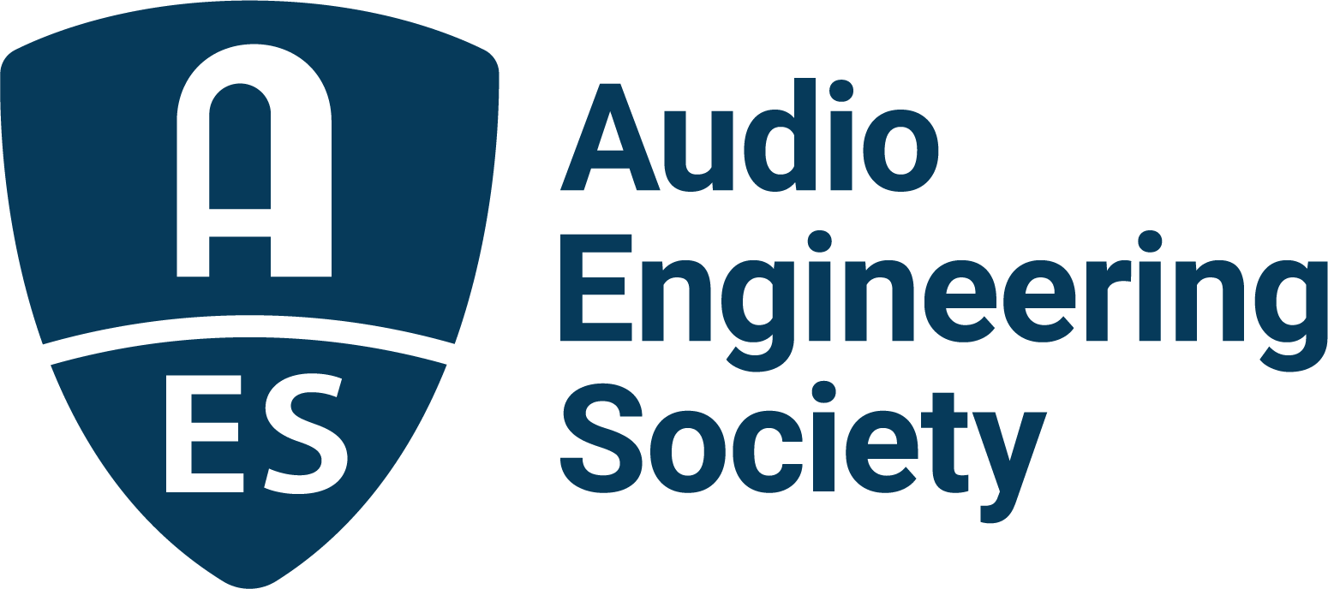

FOR IMMEDIATE RELEASE

Audio Engineering Society transitions management and administrative duties to Illuminating Engineering Society in shared resource agreement

— Shared resource agreement with IES brings Colleen Harper back as Executive Director and Graham Kirk as Director of Business Operations, plus an expanded staff and renewed momentum for membership and events —

New York, NY, October 15, 2025 — The Audio Engineering Society (AES) today announced a new shared resource arrangement with the Illuminating Engineering Society (IES), marking an important step forward in strengthening the organization’s leadership, operational capacity and long-term growth and stability. The new relationship between AES and IES will begin on December 16, 2025.

As part of this collaboration, Colleen Harper will serve as Executive Director, serving AES in a shared role with IES. Harper previously served as AES Executive Director from 2019-2022, and her proven leadership helped guide the Society through significant growth and development. Graham Kirk will also again work with AES in a shared role as Director of Business Operations, reinforcing a successful track record of industry partnerships and revenue growth.

“This partnership represents IES’s commitment to supporting technical and professional societies,” said IES President Wilson Dau. “By sharing our resources and expertise, we can help AES continue its important mission while leveraging the operational efficiencies that benefit both organizations.” In this new relationship, some current IES staff will support both IES and AES initiatives, and IES will hire three additional staff members to accommodate the increased workload.

“We are very excited about this next chapter,” said Audio Engineering Society president Gary Gottlieb. “The last time we had the winning combination of Colleen, Graham and Clyne Media, AES saw measurable gains in membership and event attendance. We believe this shared arrangement brings us back to that successful formula, while also giving AES access to the depth and flexibility of a larger team.”

AES leadership emphasized that this transition provides all the benefits of working with an association management company (AMC), including the ability to pivot staff resources to where they are most needed in an open collaboration between like-minded organizations. “This arrangement empowers AES to focus squarely on serving its members and advancing audio innovation,” stated Colleen Harper. “By partnering with IES, we’re able to add new resources, and tap into the strength of a team that already has critical experience working with a highly technical society. It allows AES’s membership and volunteer leadership to focus on what AES does best: connecting our global audio community, supporting education and research, and creating world-class events. Most importantly, it ensures that members remain at the heart of every decision we make and every initiative we pursue.”

Graham Kirk echoes Harper’s thoughts: “I’m thrilled to work with AES again in this new partnership with IES. I have seen firsthand its passion and creativity of this community. I know how important it is to have the right team and resources in place to support our members and partners. This arrangement gives us the flexibility to expand opportunities, strengthen industry relationships, and deliver even more value to our members, whether through conferences or conventions, events or ongoing global engagement throughout the year.”

The Audio Engineering Society remains committed to its mission of promoting the science and practice of audio by bringing together engineers, researchers, manufacturers and practitioners worldwide. The partnership with IES ensures AES is strategically positioned to expand its influence, enhance member services, and continue hosting world-class events.

Photo File 1: ColleenHarper.jpg
Photo Caption 1: Under a shared resource arrangement between the Audio Engineering Society (AES) and the Illuminating Engineering Society (IES), Colleen Harper will again serve as Executive Director in a shared role with IES.

Photo File 2: GrahamKirk.jpg
Photo Caption 2: Graham Kirk will again work with AES in a shared IES/AES role of Director of Business Operations.

About the Audio Engineering Society
For more than 75 years, the Audio Engineering Society has served as the pivotal force in fostering the advancement in audio technologies and application and the dissemination of technical information for the audio community. Its members are affiliated with 90 AES professional sections and more than 120 AES student sections around the world where activities include guest speakers, technical tours, demonstrations, online events and social functions. Through Conventions, Conferences, Training and Development events and peer-reviewed publications, as well as the Society’s vast online technical documents, Standards and video resources, members experience valuable opportunities for professional networking and personal growth. For additional information, visit AES.org.

About the IES
Established in 1906, the Illuminating Engineering Society is the recognized technical and educational authority on illumination. Our mission is to improve the lighted environment by bringing together those with lighting knowledge and by translating that knowledge into actions that benefit the public. We provide a variety of professional development, publications, networking and educational opportunities to our membership of engineers, architects, designers, educators, students, contractors, distributors, utility personnel, manufacturers and scientists in nearly 60 countries. Through our American National Standards Institute (ANSI) accredited process, we publish and maintain the Lighting Library®, with over 100 standards written by subject matter experts in our technical committees. In all our efforts, we strive to improve life through quality of light. To learn more about us, visit IES.org.

Join the conversation and keep up with the latest AES News and Events:
X: #AESorg (AES Official)
Facebook: facebook.com/AES.org
LinkedIn: https://www.linkedin.com/company/audio-engineering-society
Instagram: https://www.instagram.com/aes_org/

AES Marketing Communications:
Email: robert@clynemedia.com
Tel: 615-662-1616
Clyne Media, Inc.,
169-B Belle Forest Circle, Nashville, TN 37221;
Web: http://www.clynemedia.com

