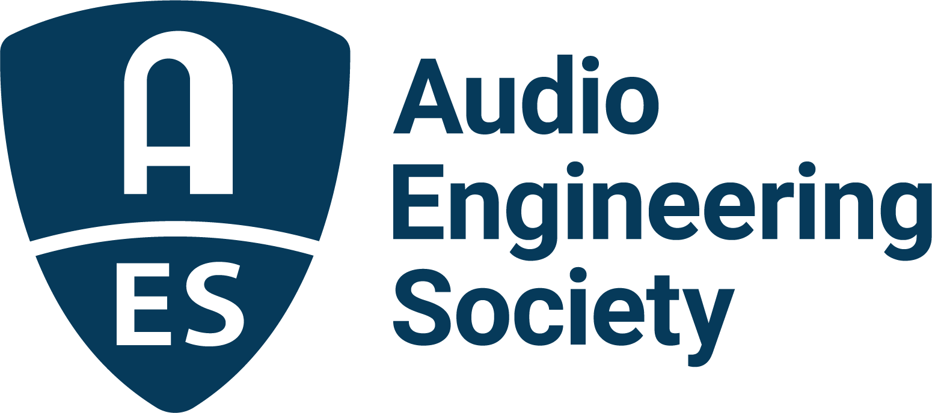

FOR IMMEDIATE RELEASE

AES Educational Foundation 2026 scholarships and grants submissions now open; new awards announced

— AES Student Members are invited to apply for grants and scholarships from the AES Educational Foundation, supported by generous industry contributions —

New York, NY, March 17, 2026 — The Audio Engineering Society, championing and advancing audio innovation and education for more than 75 years, has announced details of the 2026 AES Educational Foundation scholarships and grants. Applications for the annual AESEF Graduate Studies Grants, as well as scholarships supporting undergraduate studies, are open to AES Student Members through May 15, 2026. This year, two new awards have been added: the Olive Award for Excellence in Audio, honoring AES Fellow and Past President Sean Olive; and the William “Bil” Thomas VornDick Memorial Scholarship, established in memory of the legendary recording engineer and educator.

Since its establishment in 1984, the Foundation has awarded grants for graduate studies to hundreds of exceptional applicants, many of whom have gone on to prominent and successful careers throughout the audio engineering industry.

Graduate Studies Scholarships
Grants, including the named Scholarships, are awarded annually to exemplary students dedicated to the art and science of audio engineering. The AESEF Scholarship Committee selects recipients of the memorial scholarships based on which student best meets the criteria for each named scholarship.

Genelec Dr. Ilpo Martikainen Audio Visionary Scholarship
Coinciding with its 40th anniversary in 2018, Genelec announced the creation of a scholarship honoring its innovative and entrepreneurial founder. The Genelec Dr. Ilpo Martikainen Audio Visionary Scholarship is offered annually to U.S. graduate students in the field of audio engineering who are members of the Audio Engineering Society and have a passion for advancing audio through innovation and technology development.

The John Eargle Award
This award honors AES Past President and Fellow John Eargle, who authored several seminal textbooks on audio, as well as engineering more than 250 albums, and was posthumously awarded a Technical Grammy® Award in 2008. The scholarship is given annually to a student who excels in both technology and music.

Nancy Flannery Memorial Scholarship
This scholarship, sponsored by WSDG, an international company specializing in architectural acoustic consulting and media system engineering, has been established for women pursuing advancement and studies in architectural acoustics.

L-Acoustics Dr. Christian Heil Future of Sound Scholarship
This scholarship awards recipients who demonstrate curiosity and dedication to shaping the future of sound, including approaches that may question conventions or call upon bodies of scientific knowledge outside of the realm of audio. Students who have pursued undergraduate studies in areas other than audio are encouraged to apply in the interest of enriching cross-disciplinary thinking and exchanges that further the state of the art.

Garry Margolis Scholarship
This scholarship has been established in honor of Garry Margolis, who passed away in December 2022. Margolis was a Life Fellow of the Audio Engineering Society, served as AES President and Treasurer, and was a member of the AES Board of Governors for many years. He received the AES Distinguished Service Medal Award in 2019. Professionally, Margolis worked for several leading audio companies in marketing, sales and as a technologist and consultant in the areas of audio, video and digital cinema.

Genelec Mike Chafee Audio Pioneering Scholarship
This scholarship encourages passionate and outstanding women to continue their audio education while paying tribute to noted long-time Genelec manufacturer’s representative, audiophile, sound designer, acoustician, audio evangelist and supporter of women in audio, Michael Chafee. Chafee had been involved with Genelec since 1996 and is credited with being an early pioneer and key influencer in promoting the concept of Active Monitoring technology to the market.

Olive Award for Excellence in Audio
The Olive Award for Excellence in Audio recognizes an outstanding undergraduate student who has demonstrated exceptional promise in audio engineering, recording, or sound production. Honoring AES Fellow and Past President Sean Olive, a leading researcher in sound quality and acoustics, the award supports continued academic achievement while encouraging the next generation of innovative audio professionals and researchers.

The Emil Torick Award
This scholarship, awarded annually to an outstanding student with exceptional career goals, honors the former long-term AES Foundation President and founding member Emil Torick. Torick held 16 patents and authored more than 60 technical publications. He served on the National Radio Systems Committee and was a member of the U.S. delegation to the International Radio Consultative Committee in Geneva.

Undergraduate Studies Awards
The Mary Lea Simpson Memorial Scholarship
This scholarship offers tuition assistance for the final year of studies to an undergraduate student entering their senior year at a North American college or university Audio Engineering or Recording Arts program. The scholarship honors Mary Lea Simpson, a graduate of the Audio Production Program at the New England Institute of Art.

The William “Bil” Thomas VornDick Memorial Scholarship
Established in memory of legendary recording engineer, educator, and AES member, Bil VornDick, this scholarship supports an undergraduate student pursuing careers in audio engineering and music production at an accredited program in Tennessee. VornDick was widely respected for his work in Nashville studios, his mentorship of emerging engineers, and his lifelong dedication to advancing the craft of recording. The scholarship honors his legacy by supporting students who share his passion for excellence in audio.

Historically, AES Educational Foundation grants have been made possible through contributions from AES, Audio Precision, Dolby, Genelec, Harman International, JBL, L-Acoustics, the estate of John K. Hilliard, and the Mix Foundation for Excellence in Audio; the families of John Eargle, Mary Lea Simpson, David Smith and Emil Torick; and the family and friends of Larry Estrin, Garry Margolis, Don and Fran Pearson, and Bruce Swedien. The AES Educational Foundation also receives support from other benefactors including in-memoriam donors, individuals and companies committed to supporting education in audio.

Application forms and additional information are available on the AES Educational Foundation website.

Links:
AES Educational Foundation Scholarships and Grants

…ends 931 words

Photo File 1: AES_Scholarships_and_Grants.JPG
Photo Caption 1: The AES Educational Foundation is accepting applications for its annual scholarships and grants through May 15. Applications are available via the AES Educational Foundation web pages.

About the Audio Engineering Society
For more than 75 years, the Audio Engineering Society has served as the pivotal force in fostering the advancement in audio technologies and application and the dissemination of technical information for the audio community. Its members are affiliated with 90 AES professional sections and more than 120 AES student sections around the world where activities include guest speakers, technical tours, demonstrations, online events and social functions. Through Conventions, Conferences, Training and Development events and peer-reviewed publications, as well as the Society’s vast online technical documents, Standards and video resources, members experience valuable opportunities for professional networking and personal growth. For additional information, visit AES.org.

Join the conversation and keep up with the latest AES News and Events:
X: #AESorg (AES Official)
Facebook: facebook.com/AES.org
LinkedIn: https://www.linkedin.com/company/audio-engineering-society
Instagram: https://www.instagram.com/aes_org/

AES Marketing Communications:
Email: robert@clynemedia.com
Tel: 615-662-1616
Clyne Media, Inc.,
169-B Belle Forest Circle, Nashville, TN 37221;
Web: http://www.clynemedia.com

