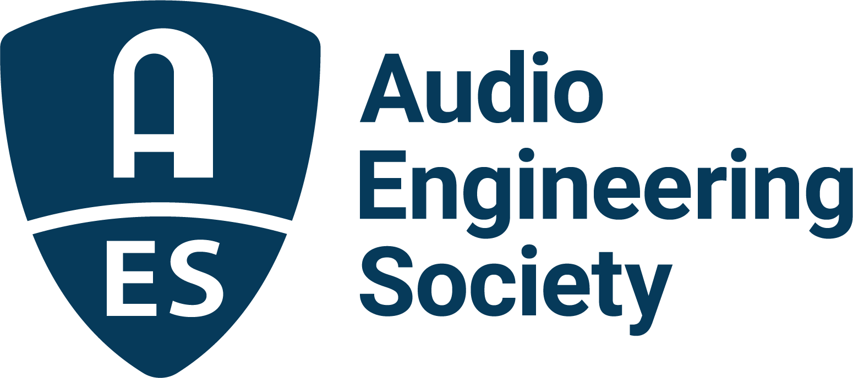

FOR IMMEDIATE RELEASE

AES Educational Foundation 2025 scholarships and grants submissions open through May 15

— AES Student Members are invited to apply for grants and scholarships from the AES Educational Foundation, supported by generous industry contributions —

New York, NY, March 26, 2025 — The Audio Engineering Society, celebrating over 75 years of audio innovation and education, has announced details on this year’s AES Educational Foundation scholarships and grants. Applications for the annual AESEF Graduate Studies Grants and Mary Lea Simpson Memorial Scholarship for undergraduate studies are open to AES Student Members through May 15, 2025.

Since its establishment in 1984, the Foundation has awarded grants for graduate studies to hundreds of exceptional applicants, many of whom have gone on to prominent and successful careers in the audio engineering industry.
Graduate Studies Scholarships:
Grants, including the named Scholarships, are awarded annually for exemplary students dedicated to the art and science of audio engineering. The AESEF Scholarship Committee selects the recipients of the memorial scholarships based on which student best meets the criteria for each named scholarship.
Genelec Mike Chafee Audio Pioneering Scholarship
This scholarship encourages passionate and outstanding women to continue their audio education while paying tribute to noted long-time Genelec manufacturer’s representative, audiophile, sound designer, acoustician, audio evangelist and supporter of women in audio, Michael Chafee. Chafee had been involved with Genelec since 1996 and is credited with being an early pioneer and key influencer in promoting the concept of Active Monitoring technology to the market.

The John Eargle Award
This award honors AES Past-President and Fellow, John Eargle, who authored several seminal textbooks on audio, as well as engineering more than 250 albums, and was posthumously awarded a Technical GRAMMY® Award in 2008. The scholarship is given annually to a student who excels in both technology and music.

Nancy Flannery Memorial Scholarship
This scholarship, sponsored by WSDG, an international company specialized in architectural acoustic consulting and media system engineering, has been established for women pursuing advancements and studies in architectural acoustics.

L-Acoustics Dr. Christian Heil Future of Sound Scholarship
This scholarship awards recipients who demonstrate curiosity and dedication to shaping the future of sound, including approaches that may question conventions or call upon bodies of scientific knowledge outside of the realm of audio. Students having pursued an undergraduate course of study in an area other than audio are encouraged to apply in the interest of enriching cross-disciplinary thinking and exchanges to further the state of the art.

Garry Margolis Scholarship
This scholarship has been established in honor of Garry Margolis, who passed in December 2022. Garry was a Life Fellow of the Audio Engineering Society, served as AES President and Treasurer, and was a member of the AES Board of Governors for many years. He was awarded the AES Distinguished Service Medal Award in 2019. Professionally, Garry worked for several leading audio companies in marketing, sales and as a technologist and consultant in the areas of audio, video and digital cinema.

Genelec Dr. Ilpo Martikainen Audio Visionary Scholarship
Coinciding with its 40th anniversary in 2018, Genelec announced the creation of a scholarship honoring its innovative and entrepreneurial founder. The Genelec Dr. Ilpo Martikainen Audio Visionary Scholarship is offered annually to U.S. graduate students in the field of audio engineering who are members of the Audio Engineering Society and have a passion for advancing audio through innovation and technology development.

The Emil Torick Award
This scholarship, awarded annually to an outstanding student with exceptional career goals, honors the former long-term AES Foundation President and founding member, Emil Torick. Torick held 16 patents and authored more than 60 technical publications. He served on the National Radio Systems Committee and was a member of the U.S. delegation to the International Radio Consultative Committee in Geneva.

Undergraduate Studies Scholarship:
The Mary Lea Simpson Memorial Scholarship
This scholarship covering full tuition for final year of studies is being offered to an undergraduate student entering senior year at a North American college or university Audio Engineering/Recording Arts Program. The scholarship honors Mary Lea Simpson, who was a graduate of the Audio Production Program at New England Institute of Art.

Historically, grants have been made possible by contributions from AES, Audio Precision, Dolby, Genelec, Harman International, JBL, L-Acoustics, the estate of John K. Hilliard, and the Mix Foundation for Excellence in Audio; the families of John Eargle, Mary Lea Simpson, David Smith, Emil Torick; and the family and friends of Larry Estrin, Don and Fran Pearson, and Bruce Swedien. The AES Educational Foundation also receives support from other benefactors such as in-memoriam donors and individuals and companies that support education in audio.

Application forms and additional information online at the AES Educational Foundation website.

Links:
AES Educational Foundation 2025 Scholarships and Grants

…ends 743 words

Photo File 1: AES_Scholarships_and_Grants.JPG
Photo Caption 1: The AES Educational Foundation is accepting applications for its annual scholarships and grants through May 15. Applications are available via the AES Educational Foundation web pages.

About the Audio Engineering Society
For more than 75 years, the Audio Engineering Society has served as the pivotal force in fostering the advancement in audio technologies and application and the dissemination of technical information for the audio community. Its members are affiliated with 90 AES professional sections and more than 120 AES student sections around the world where activities include guest speakers, technical tours, demonstrations, online events and social functions. Through Conventions, Conferences, Training and Development events and peer-reviewed publications, as well as the Society’s vast online technical documents, Standards and video resources, members experience valuable opportunities for professional networking and personal growth. For additional information, visit AES.org.

Join the conversation and keep up with the latest AES News and Events:
X: #AESorg (AES Official)
Facebook: facebook.com/AES.org
LinkedIn: https://www.linkedin.com/company/audio-engineering-society
Instagram: https://www.instagram.com/aes_org/

AES Marketing Communications:
Email: robert@clynemedia.com
Tel: 615-662-1616
Clyne Media, Inc.,
169-B Belle Forest Circle, Nashville, TN 37221;
Web: http://www.clynemedia.com

