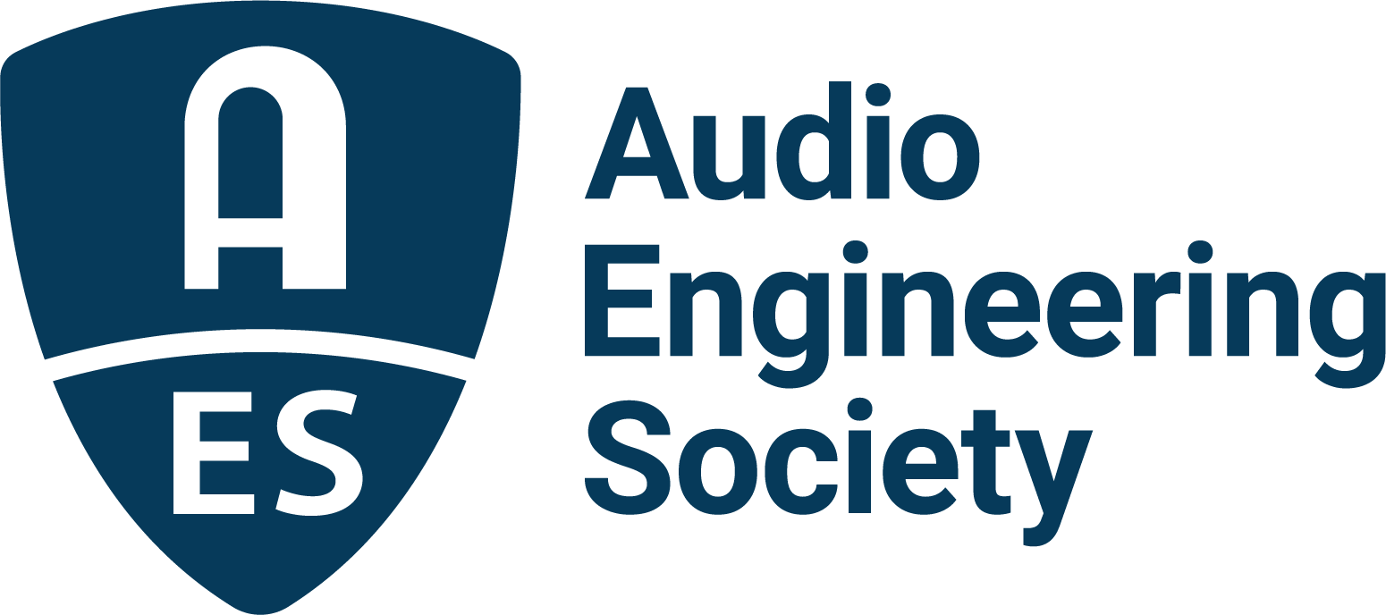

FOR IMMEDIATE RELEASE

AES Show Nashville Early Bird registration now open

— Join audio innovators, musicians, educators and industry leaders in Music City for a reimagined experience that blends creativity, technology and education —

New York, NY, July 7, 2026 — Early Bird registration is now open for AES Show Nashville 2026, the Audio Engineering Society’s reimagined three-day event taking place October 30–November 1 at the Gaylord Opryland Resort & Convention Center in Nashville, TN. Take advantage of discounted Early Bird rates, available through August 27, and secure one of the limited reduced-rate rooms at the Gaylord Opryland Resort before they sell out. This year’s show expands on the AES’s decades of innovation with pre-show experiences, extensive studio tours and collaborations with Nashville’s vibrant audio community, all while highlighting the cutting-edge science and initiatives that keep the AES at the forefront of audio science and technology.

Meanwhile, the Call for Submissions is open for peer-reviewed papers, express papers, JAES papers, workshops and tutorials. Proposals are due by July 17, giving researchers, engineers and educators a chance to shape the program and share their work with the global audio community.

Nashville has earned its nickname “Music City” by way of a uniquely concentrated ecosystem of world-class studios, live music venues, leading audio education institutions, pro audio manufacturers, engineers, artists and audio professionals where music creation and production are woven into daily life. In addition to its many world-class recording studios, production and rehearsal facilities, and local network of top engineers and producers, Nashville is also home to a host of major record labels, music award shows and specials, film and TV scoring studios, live sound venues, broadcast facilities and top-tier professionals pushing the art and science of audio to its limits.

AES Show Nashville will also take advantage of the unique offerings of the iconic Gaylord Opryland Resort and Convention Center, located just steps from the world-famous Opry House facilities, home to the Grand Ole Opry live radio broadcast, the longest-running live radio broadcast in U.S. history. The AES offers exhibitors and attendees specially-priced hotel rooms on a first-come, first-served basis, affording a convenient and immersive way to experience this updated AES Show with other industry peers and pros.

For the latest information and updates and to register now, visit AESShow.com.

Photo File 1: AES_Show_Nashville_2026.JPG
Photo Caption 1: Early Bird registration is now open for AES Show Nashville 2026, taking place October 30–November 1 at the Gaylord Opryland Resort & Convention Center in Nashville, TN. Attendees can now reserve discounted on-site hotel rooms while availability lasts, and the Call for Submissions is open for technical papers, workshops, tutorials, and other program content.

About the Audio Engineering Society
For more than 75 years, the Audio Engineering Society has served as the pivotal force in fostering the advancement in audio technologies and application and the dissemination of technical information for the audio community. Its members are affiliated with 90 AES professional sections and more than 120 AES student sections around the world where activities include guest speakers, technical tours, demonstrations, online events and social functions. Through Conventions, Conferences, Training and Development events and peer-reviewed publications, as well as the Society’s vast online technical documents, Standards and video resources, members experience valuable opportunities for professional networking and personal growth. For additional information, visit AES.org.

Join the conversation and keep up with the latest AES News and Events:
X: #AESorg (AES Official)
Facebook: facebook.com/AES.org
LinkedIn: https://www.linkedin.com/company/audio-engineering-society
Instagram: https://www.instagram.com/aes_org/

AES Marketing Communications:
Email: robert@clynemedia.com
Tel: 615-300-4666
Clyne Media, Inc.,
169-B Belle Forest Circle, Nashville, TN 37221;
Web: http://www.clynemedia.com

