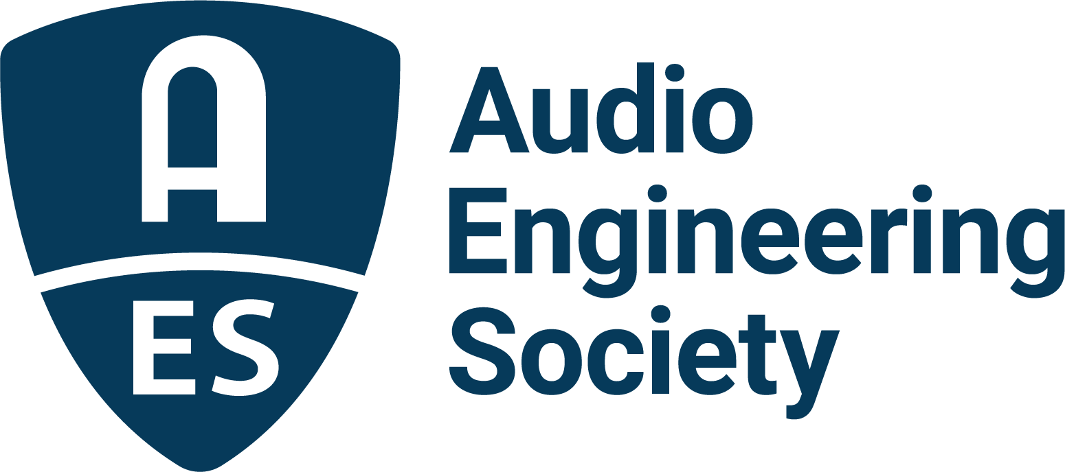

FOR IMMEDIATE RELEASE

AES Show Nashville 2026 builds momentum with industry exhibitors, leadership committee and Early Bird registration

— Leading audio brands join reimagined Music City event as industry experts shape a new AES Show experience; Early Bird rates available through August 27 —

New York, NY, August 17, 2026 — Momentum continues to build for AES Show Nashville 2026, with leading audio manufacturers and technology innovators securing exhibit space and a wide-ranging committee of industry experts shaping this year’s newly redesigned event. Early Bird registration is also underway, with discounted rates available through August 27. Taking place October 30 – November 1 at the Gaylord Opryland Resort & Convention Center, this next-generation AES Show experience will bring the global audio community together in one of the world’s most influential centers for recording, live sound, music production, audio education and professional audio.

A growing roster of exhibitors and partners has already committed to AES Show Nashville, representing technologies and expertise from across the professional audio landscape. Participating companies and brands include Abbey Road, Allen & Heath, AMS Neve Ltd., API, ATR Service, Inc., Audeze, Audinate, Audio Alchemist, Audio Distribution Group, Audio-Technica, Audioscape Engineering Co., AudioShake, Austrian Audio, AuviTran, BeesNeez Microphones, Belmont University, Blackmagic Design, Chameleon Labs, Chandler Limited, Clear-Com, Cloud Microphones, Dangerous Music, DiGiCo, Digigram, Eleven Dimensions Media, EMI, Eventide, Ex Machina Soundworks, Ferrofish, Firehouse 12, Fostex, FullScale AV, Genelec, Google, Grace Design, Gyraf Audio, Harrison Audio, Hear Technologies, Hisong Global, Immersive Design Labs, Jam Industries USA, JamRacks, JoeCo, L-Acoustics, Lauten Audio, Lawo, Lectrosonics, Marian, MyMix, Neumann, Niron Magnetics, Nordic Audio Labs, One F Sound, PACE Anti-Piracy, Peluso Microphone Lab, Prism Sound, PSI Audio, RCF, Recording the Masters, Reloop, RME, Rupert Neve Designs, Sennheiser, Shure, Solid State Logic, Sony Electronics, Sound Ideas, Sound Radix, Soundproof Windows, STAGETEC North America, Synthax Inc., TELEFUNKEN Elektroakustik, Triad-Orbit Advanced Stand Systems, Violet Audio, WAVE Distribution, Waves, Wolff Audio, Yamaha and Zynaptiq.

Designed to encourage meaningful interaction between brands and attendees, AES Show Nashville will combine exhibits with technical sessions, workshops, research presentations, studio tours, networking and special events. Recording and production, live sound and touring, installed audio, broadcast, immersive audio, education, AI and machine learning, game audio and emerging technologies will all be represented, creating new opportunities to discover products, exchange ideas and build relationships across the audio industry.

“Nashville is more than a destination — it is one of the world’s great centers for music production and audio technology,” said AES Show Nashville Convention Chair Graham Kirk. “Bringing the AES Show to Music City gives manufacturers, developers and audio professionals an opportunity to connect across multiple disciplines while becoming part of a new Show experience built around the people, technologies and ideas shaping what comes next in audio.”

Kirk leads the AES Show Nashville committee alongside Co-chairs Russ Long and Brian (Bt) Gibbs. The leadership team includes Areti Andreopoulou and Braxton Boren, Papers; Ian Corbett and Angela Piva, Education & Students; Jim Kaiser, Recording & Production; Jonathan Wyner, AI & Machine Learning; Steve Martz, Game & XR; Vince Lepore, Networking; Mary Mazurek, DEIR; Jim Jordan and Jim Gilmore, Facilities; Brad McCoy, Historical; Matt Pogorelc and Scott (Scooter) Hernbeck with Ryan Shelton, Live Sound/Touring/Install; Michael Hanson, Volunteers; and Robert Clyne, Special Events/Keynotes.

The Nashville setting will be central to the new experience, with programming and activities designed to extend beyond the traditional show floor and connect attendees with Music City’s renowned studio, production and professional audio community.

Early Bird registration rates are available through August 27. Exhibitors and sponsors can also still secure opportunities to showcase products, demonstrate technologies and put their brands directly in front of an engaged professional audio audience.

Register, exhibit and learn more at AESShow.com.

…ends 562 words

Photo File 1: AES_Show_Nashville_2026.JPG
Photo Caption 1: AES Show Nashville will take place October 30 – November 1 at the Gaylord Opryland Resort & Convention Center.
Photo File 2: Graham_Kirk.JPG
Photo Caption 2: AES Show Nashville Chair Graham Kirk

Photo File 3: Brian_Bt_Gibbs.JPG
Photo Caption 3: AES Show Nashville Co-chair Brian (Bt) Gibbs

Photo File 4: Russ_Long.JPG
Photo Caption 4: AES Show Nashville Co-chair Russ Long

About the Audio Engineering Society
For more than 75 years, the Audio Engineering Society has served as the pivotal force in fostering the advancement in audio technologies and application and the dissemination of technical information for the audio community. Its members are affiliated with 90 AES professional sections and more than 120 AES student sections around the world where activities include guest speakers, technical tours, demonstrations, online events and social functions. Through Conventions, Conferences, Training and Development events and peer-reviewed publications, as well as the Society’s vast online technical documents, Standards and video resources, members experience valuable opportunities for professional networking and personal growth. For additional information, visit AES.org.

Join the conversation and keep up with the latest AES News and Events:
X: #AESorg (AES Official)
Facebook: facebook.com/AES.org
LinkedIn: https://www.linkedin.com/company/audio-engineering-society
Instagram: https://www.instagram.com/aes_org/

AES Marketing Communications:
Email: robert@clynemedia.com
Tel: 615-662-1616
Clyne Media, Inc.,
169-B Belle Forest Circle, Nashville, TN 37221;
Web: http://www.clynemedia.com

