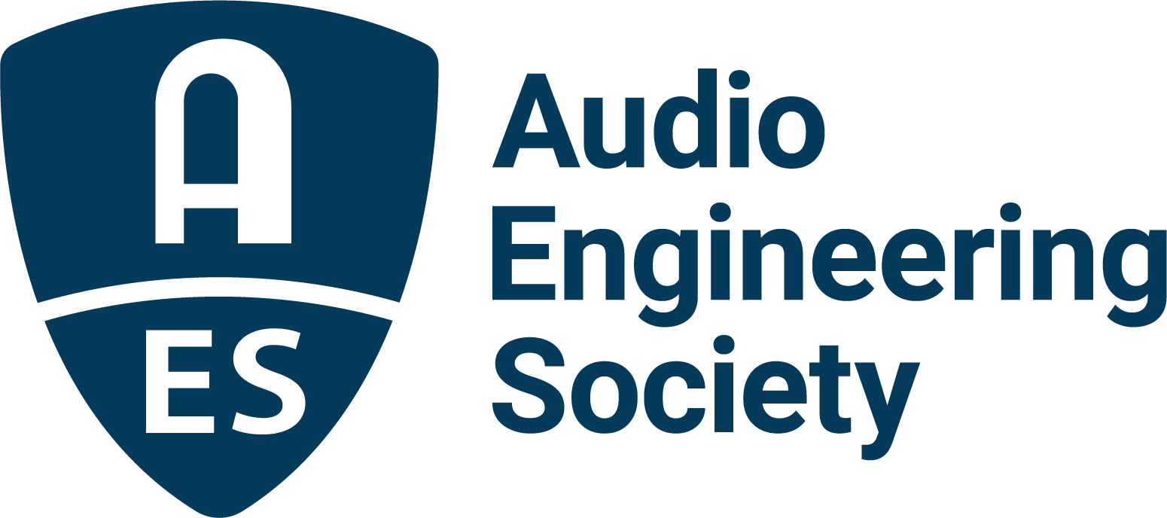

FOR IMMEDIATE RELEASE

GRAMMY® award–winning producer Sounwave to share creative insights at AES Show 2025 in Long Beach

— The session, titled “Inside the Creative Process with Sounwave: Shaping Sound and Artist Identity (moderated by Manny Marroquin),” will take place on Thursday, October 23, 2025, from 1:15–2:15 p.m. PDT —

New York, NY, September 25, 2025 — The Audio Engineering Society (AES) is proud to announce an exclusive featured session at the upcoming AES Show 2025 in Long Beach with GRAMMY® Award–winning producer and songwriter Sounwave, the creative force behind era-defining projects for Kendrick Lamar, SZA, Taylor Swift, Beyoncé and more. The session, titled “Inside the Creative Process with Sounwave: Shaping Sound and Artist Identity (Moderated by Manny Marroquin),” will take place on Thursday, October 23, 2025, from 1:15–2:15 p.m. PDT.

In this highly anticipated presentation, Sounwave (born Mark Anthony Spears) will offer a rare, in-depth look at how he approaches collaboration, builds trust with artists, and shapes the sonic identity of music that resonates across genres and generations. From early creative concepts to final mixes, attendees will gain exclusive insights into the mindset and methodology that have made Sounwave one of the most influential producers, songwriters and collaborators of his generation.

Sounwave stands as a defining voice in today’s music landscape. A seven-time GRAMMY® winner and contender for Producer of the Year, Sounwave’s career began in Compton, California, where he emerged as a central figure within Kendrick Lamar’s creative circle. Over more than a decade, he has helped craft a body of work that has not only won global acclaim but also earned Lamar the Pulitzer Prize for DAMN., released in 2017.

Most recently, Sounwave played a key role in producing Lamar’s groundbreaking album GNX, contributing to standout moments including the cultural phenomenon “Not Like Us.” The track dominated charts and earned three GRAMMY® Awards including Record of the Year, Song of the Year, and Rap Song of the Year, cementing its place as one of the defining anthems of the year. He also co-produced “Luther” by Kendrick Lamar and SZA, which spent 13 consecutive weeks at No. 1 on the Billboard Hot 100.

Beyond the studio, Sounwave has served as music director for Lamar’s historic Super Bowl halftime performance and Grand National Tour. His collaborations extend far beyond hip-hop, with credits on Beyoncé’s Renaissance, Kali Uchis’ Red Moon in Venus, and Taylor Swift’s Midnights, including the singles “Karma” and “Lavender Haze.” He is also the founder of the creative collective new.ordinary, where he not only has developed rising producer MTech (who contributed 6 songs to GNX), but he also broke into the music/consumer tech world, designing the limited-edition, retro-inspired Songbook MAX home speakers with the renowned premium audio brand Tivoli Audio.

Guiding the session will be Manny Marroquin, one of the industry’s most accomplished mixers whose work has touched nearly 250 million albums worldwide. With over 40 No. 1 albums, 100 Billboard Top 10 albums, 12 No. 1 singles, and 40 Top 10 singles, Marroquin’s impact spans every corner of the music landscape. His 18 GRAMMY® Awards include recognition for Best Engineered Album (John Mayer’s Battle Studies) and Record of the Year (Lizzo’s “About Damn Time”). Widely respected for his versatility and deep musical intuition, Marroquin is uniquely positioned to lead an intimate and wide-ranging conversation with Sounwave about the craft of production, collaboration and innovation in modern music.

“This session is about more than production techniques; it’s about understanding the art of building trust with artists and shaping music that defines a generation,” said Audio Engineering Society president Gary Gottlieb. “Sounwave’s creative vision and Manny Marroquin’s extraordinary perspective as a mixer and producer promise an unforgettable discussion.”

Attendees at AES Show 2025 will leave with an insider’s perspective on how Sounwave balances technical mastery, instinct, and innovation to bring out the best in each artist’s vision.

The Sounwave session is part of a comprehensive program of the AES Show 2025, which takes place October 23–25 at the Long Beach Convention & Entertainment Center. The convention will once again gather audio professionals, engineers, producers and students from around the world to share knowledge, explore new technologies, and celebrate the art and science of sound.

For more information about the AES Show 2025 program and registration, please visit www.aesshow.com.

Photo File 1: Sounwave.JPG
Photo Caption 1: Seven-time GRAMMY® winner and contender for Producer of the Year, Sounwave.

Photo File 2: Manny_Marroquin.JPG
Photo Caption 2: Manny Marroquin, one of the industry’s most accomplished mixers whose work has touched nearly 250 million albums worldwide and has garnered 18 GRAMMY® Awards, will moderate the Sounwave session.

About the Audio Engineering Society
For more than 75 years, the Audio Engineering Society has served as the pivotal force in fostering the advancement in audio technologies and application and the dissemination of technical information for the audio community. Its members are affiliated with 90 AES professional sections and more than 120 AES student sections around the world where activities include guest speakers, technical tours, demonstrations, online events and social functions. Through Conventions, Conferences, Training and Development events and peer-reviewed publications, as well as the Society’s vast online technical documents, Standards and video resources, members experience valuable opportunities for professional networking and personal growth. For additional information, visit AES.org.

Join the conversation and keep up with the latest AES News and Events:
X: #AESorg (AES Official)
Facebook: facebook.com/AES.org
LinkedIn: https://www.linkedin.com/company/audio-engineering-society
Instagram: https://www.instagram.com/aes_org/

AES Marketing Communications:
Email: robert@clynemedia.com
Tel: 615-662-1616
Clyne Media, Inc.,
169-B Belle Forest Circle, Nashville, TN 37221;
Web: http://www.clynemedia.com

