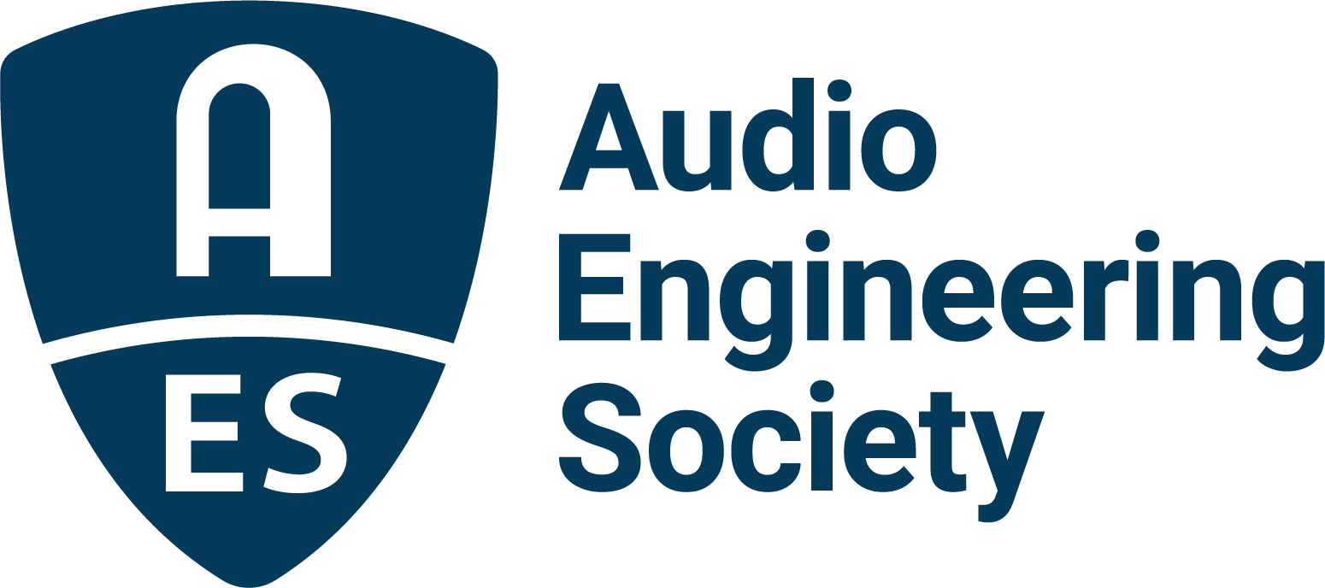

FOR IMMEDIATE RELEASE

AES Show 2025 to feature special session: “Buzz Me In – The Legend of the Record Plant”

— An inside look at the legendary studios that defined modern recording while providing the musical backdrop that set the tone for an era —

New York, NY, September 23, 2025 — The Audio Engineering Society (AES) is proud to announce a special session at the upcoming AES Show 2025 – Long Beach titled “Buzz Me In – The Legend of the Record Plant.” This unique program will feature acclaimed authors Martin Porter and David Goggin (aka Mr. Bonzai) in a wide-ranging discussion about their new book, Buzz Me In: Inside the Record Plant Studios, which chronicles the untold story of the Record Plant Studios, one of the most innovative and influential recording institutions in the history of the music industry. The session will be moderated by industry veteran Daniel Keller and will take place Friday, October 24, from 4:45pm-5:45pm PDT.

Buzz Me In: Inside the Record Plant Studios offers an insider’s account of the Record Plant’s pivotal role in shaping the sound of popular music. Drawing on decades of firsthand knowledge, Porter and Goggin reveal behind-the-scenes stories previously known only to the studio’s employees, engineers, producers and artists. From its groundbreaking founding in 1968, the Record Plant redefined the idea of what a recording studio could be. In the 1970s, Record Plant Studios was the beating heart of one of rock’s most creative periods. With flagship locations in New York, Los Angeles and Sausalito, plus its pioneering mobile recording trucks, Record Plant was present wherever music history was being made.

Based on the memoirs of co-founder Chris Stone and Porter and Goggin’s personal relationships with him, which provided access to firsthand stories, along with more than one hundred interviews with former staff, producers and artists, Buzz Me In: Inside the Record Plant Studios, captures the untold story of this legendary institution. Along the way, readers encounter defining moments: Stevie Wonder crafting his masterpieces at Record Plant L.A., John Lennon making Record Plant New York his creative home after the Beatles, and Fleetwood Mac and the Eagles shaping era-defining classics at Record Plant Sausalito and Los Angeles respectively. At every location, the studio fused cutting-edge technology with an extravagant, artist-centric environment, complete with themed bedrooms, hot tubs and all-night jam sessions that made it an unmistakable hub of creativity, excess and musical innovation. Blending state-of-the-art technology with lavish amenities and a culture of creativity, Record Plant redefined what a recording studio could be.

“Record Plant was more than just a studio; it was a culture, a movement, and in many ways the driving force of an era,” said Martin Porter, co-author of Buzz Me In: Inside the Record Plant Studios. “Because David and I had a close personal relationship with Chris Stone, we were fortunate to hear and preserve stories directly from him that had never been shared publicly before. Our goal with this book, and this AES session, is to bring those stories to life and highlight why Record Plant remains one of the most legendary studios in history.”

David Goggin echoes Porter’s comments: “The Record Plant was a place where creativity thrived without boundaries. It was important to Chris that the book recognized the innovations of his partner Gary Kellgren as well as credited the contributions of hundreds of staffers who made the studio what it became.”

This AES Show session promises to be an essential experience for anyone passionate about the history of recording, the evolution of studio culture, and the creative environments that foster musical innovation. Attendees will hear firsthand from the authors about the stories, legacy, and continuing relevance of the Record Plant.

The AES Show 2025 – Long Beach will take place October 23–25, 2025 at the Long Beach Convention & Entertainment Center. Program details and registration information are online at www.aesshow.com.

For more information about Buzz Me In: Inside the Record Plant Studios visit: http://recordplantdiaries.com/
Facebook: http://facebook.com/recordplantdiaries

Photo File 1: Martin_Porter.JPG
Photo Caption 1: Buzz Me In: Inside the Record Plant Studios co-author Martin Porter (Credit Courtesy of the Author).

Photo File 2: David_Goggin.JPG
Photo Caption 2: Buzz Me In: Inside the Record Plant Studios co-author David Goggin (aka Mr. Bonzai) (Credit Courtesy of the Author).

Photo File 3: Buzz_Me_In.JPG
Photo Caption 3: Buzz Me In: Inside the Record Plant Studios will be the topic of the AES Show 2025 – Long Beach session titled “Buzz Me In – The Legend of the Record Plant,” featuring the book’s co-authors, Martin Porter and David Goggin (aka Mr. Bonzai), will take place Friday, October 24, from 4:45pm-5:45pm PDT.

About the Audio Engineering Society
For more than 75 years, the Audio Engineering Society has served as the pivotal force in fostering the advancement in audio technologies and application and the dissemination of technical information for the audio community. Its members are affiliated with 90 AES professional sections and more than 120 AES student sections around the world where activities include guest speakers, technical tours, demonstrations, online events and social functions. Through Conventions, Conferences, Training and Development events and peer-reviewed publications, as well as the Society’s vast online technical documents, Standards and video resources, members experience valuable opportunities for professional networking and personal growth. For additional information, visit AES.org.

Join the conversation and keep up with the latest AES News and Events:
X: #AESorg (AES Official)
Facebook: facebook.com/AES.org
LinkedIn: https://www.linkedin.com/company/audio-engineering-society
Instagram: https://www.instagram.com/aes_org/

AES Marketing Communications:
Email: robert@clynemedia.com
Tel: 615-662-1616
Clyne Media, Inc.,
169-B Belle Forest Circle, Nashville, TN 37221;
Web: http://www.clynemedia.com

