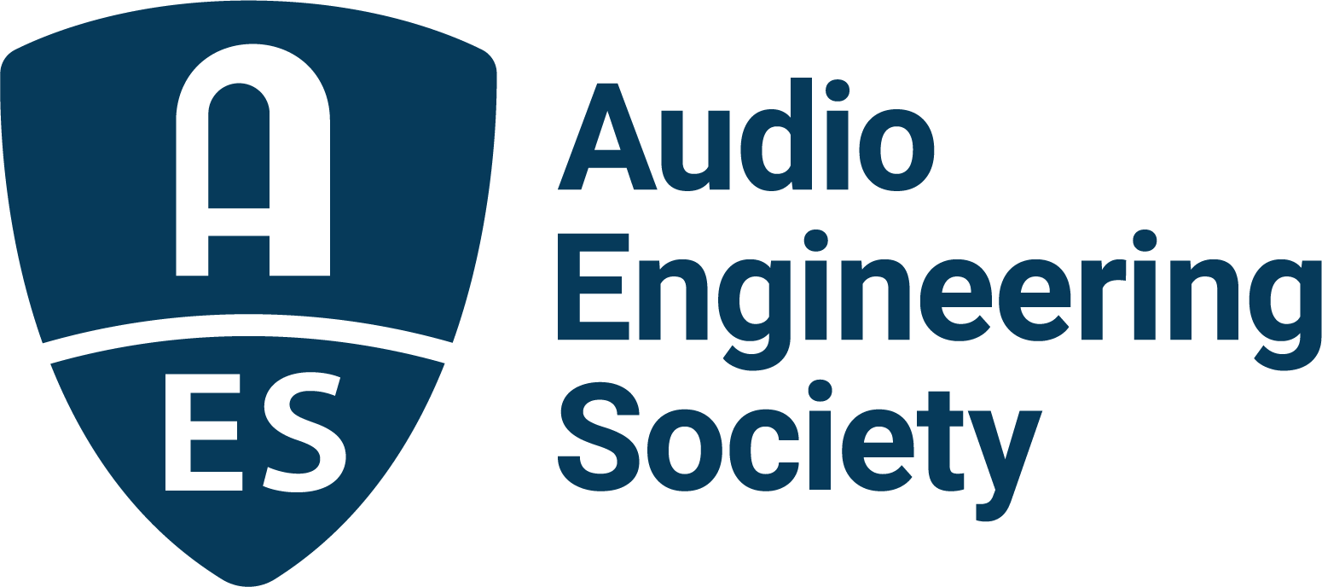

FOR IMMEDIATE RELEASE

AES Show 2025 – Long Beach Technical Program bolstered by AES L.A. Section

— AES Los Angeles Section delivers people, places and insights to sessions and events as the AES Show returns to the West Coast —

New York, NY, October 16, 2025 — The AES Show 2025 – Long Beach is just days away, as organizers and attendees look ahead to the Audio Engineering Society’s first West Coast convention in almost 10 years, taking place October 23–25 at the Long Beach Convention & Entertainment Center, with additional skill-building workshops on October 22 and area Technical Tours on October 22 and 25. One group holding particular interest in the AES’s return to Southern California is the local Los Angeles Section which has helped curate many featured events for this year’s AES Show, spanning a wealth of topics of interest to the global audio community.

Daniel Liston Keller, writer, musician, multimedia producer and current Chair of the AES Los Angeles Section will be the interviewer/moderator at the following sessions as well as a panelist on one session. “We in the AES Los Angeles section are thrilled to be hosting the AES Convention in Southern California this year,” stated Keller. “In addition to a full roster of panels and workshops, we’re honored to be hosting two days of excursions to the epicenters of production in Burbank and the West Side of L.A., including legendary studios, post-production facilities, manufacturers, and more. We’re looking forward to welcoming our AES colleagues from around the world.”

On Thursday, October 23, one noted session, “Sound Design - Capturing and Manipulating” will host an interview and demonstration with noted sound designer Rick Allen on unique methods of capturing found sounds (e.g., planes, wildlife, explosions, etc.), and equally unique ways of manipulating those sounds to create different and often other-worldly sound effects for film, TV, and games. Later, an “Interview with Live Sound Engineer David Morgan” will dig into Morgan’s 50-year career, which has included decades as FOH for artists including James Taylor, Paul Simon, Cher, Bette Midler, and many more, as well as writing hundreds of columns for Mix and FOH magazines, and consulting for companies including Shure, Waves, Earthworks, and more.

Friday will see another slate of L.A. Section-curated events, kicking off with one-on-one “Interview with Robert Margouleff,” whose credits include Stevie Wonder, Devo, Oingo Boingo, among others. The session will cover Margouleff’s early work in synthesis and immersive mixing, as well as his upcoming memoir, to be released in January 2026. Next is a very special session featuring Ross Hogarth, Daniel Liston Keller, Leslie Ann Jones, Suzy Shinn, and Kathleen Wirt titled “Feel the Fear and Say Yes Anyway” which will examine anxiety and other personal and less-technical issues that can have an effect on one’s career. These industry leaders will share relatable stories of how they overcame such obstacles with great success. The afternoon also includes the session “In the Mix with Mick Guzauski,” an interview with the renowned mix engineer whose credits include Daft Punk, Michael Jackson, Mariah Carey, Prince, Talking Heads, and more. Later, the session “Buzz Me In - The Legend of the Record Plant” will feature Keller interviewing acclaimed authors Martin Porter and David Goggin (aka Mr. Bonzai) in a wide-ranging discussion about their new book, Buzz Me In: Inside the Record Plant Studios, which chronicles the untold story of one of the most innovative and influential recording institutions in the history of the music industry.

Saturday will offer up another pair of exciting and educational sessions, beginning with “Beyond the Rec Button: Telling the Story of Sound,” a discussion with producer/engineer/educator Julio Monroy, exploring how audio engineers, producers, and musicians are becoming storytellers, not only through their mixes, but by sharing what happens behind the scenes as professionals with multifaceted roles, including how content creation is reshaping the public perception of audio careers, building new bridges with brands, and even redefining professional success. Finally, the session “Trident – Legendary Studios and Consoles” will take an in-depth look at London's Trident Studios as the home to sessions with the Beatles, Pink Floyd, and dozens of other legendary artists, as well as a look at the company's consoles, which were in a class by themselves, with their first model, the A-Range, remaining a revered and coveted console more than half-a-century later.

AES Show 2025 takes advantage of the West Coast locale in its popular Tech Tours series, offering a set of excursions bookending the Show on Wednesday, October 22 and Saturday, October 25. Wednesday’s tour stops include visits to One on One Studios in North Hollywood, the Royer Microphones headquarters in Burbank, a visit to Iron Mountain Media and Archive Services facilities in Hollywood, and a stop to catch up with the LA Audio Lunch Bunch, a weekly gathering of Los Angeles’ audio industry leaders founded and hosted by convention co-chair Peter Doell, held every Wednesday in Burbank, California. Saturday's itinerary explores different eras of LA audio on the West side, starting with tours through iconic vintage studios The Village and 4th Street Recording, The Bakery Mastering's state-of-the-art facility, the historic Sony Scoring stage, and concluding with Apogee Electronics' cutting-edge studio and headquarters.

The complete schedule of Technical Program sessions and workshops, as well as the latest Exhibition Floor updates, travel information, and registration, are online at AESShow.com.

Photo File 1: AESShow_2025.JPG
Photo Caption 1: AES Show 2025 – Long Beach will take place October 23–25 at the Long Beach Convention & Entertainment Center, with additional skill-building workshops on October 22 and area Technical Tours on October 22 and 25.

About Daniel Liston Keller
In addition to being the current Chair of the AES Los Angeles Section, writer, musician, and multimedia producer Daniel Liston Keller is CEO and founder of Get It In Writing, a media and PR firm focused on music and media technology. His career has spanned live and studio work, audio engineering, music and video production, as well as executive positions in artist relations, music publishing, product design and management, marketing, and media relations. An obsessive communicator and innovative thinker, he is hard-wired to the world of high-tech, and drawn to anything that blinks, whirs, moves, manipulates, makes a cool noise, or is interactive.

About the Audio Engineering Society
For more than 75 years, the Audio Engineering Society has served as the pivotal force in fostering the advancement in audio technologies and application and the dissemination of technical information for the audio community. Its members are affiliated with 90 AES professional sections and more than 120 AES student sections around the world where activities include guest speakers, technical tours, demonstrations, online events and social functions. Through Conventions, Conferences, Training and Development events and peer-reviewed publications, as well as the Society’s vast online technical documents, Standards and video resources, members experience valuable opportunities for professional networking and personal growth. For additional information, visit AES.org.

Join the conversation and keep up with the latest AES News and Events:
X: #AESorg (AES Official)
Facebook: facebook.com/AES.org
LinkedIn: https://www.linkedin.com/company/audio-engineering-society
Instagram: https://www.instagram.com/aes_org/

AES Marketing Communications:
Email: robert@clynemedia.com
Tel: 615-300-4666
Clyne Media, Inc.,
169-B Belle Forest Circle, Nashville, TN 37221;
Web: http://www.clynemedia.com

