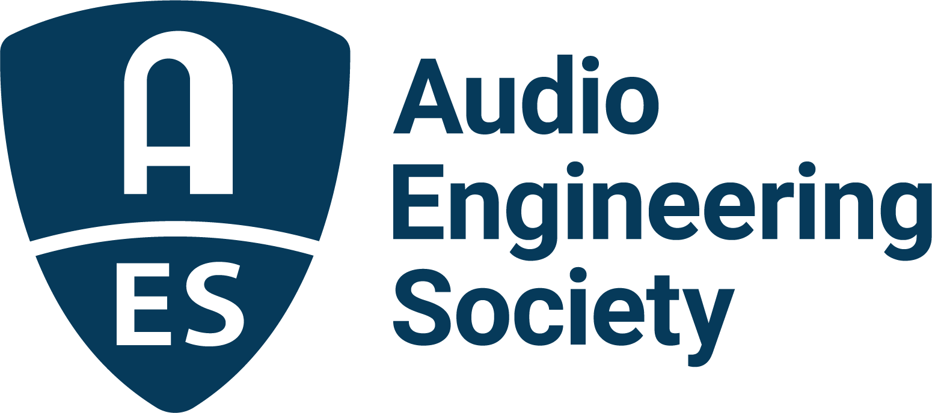

FOR IMMEDIATE RELEASE

Sean Olive to deliver Richard C. Heyser Memorial Lecture at the AES Show 2025 – Long Beach Convention

— Renowned researcher and past AES President Sean Olive to explore science-based approaches to achieving consistent audio quality —

New York, NY, September 30, 2025 — The Audio Engineering Society has announced that renowned audio researcher and AES Past President Dr. Sean Olive will deliver the Richard C. Heyser Memorial Lecture at the upcoming AES Show 2025, taking place October 23–25 at the Long Beach Convention & Entertainment Center.

Olive’s lecture, titled “Make Audio Great Always: Using Science for Consistent Quality,” will explore the results of decades of psychoacoustic research, including well-controlled double-blind listening tests that have identified which loudspeakers, headphones and listening environments consistently deliver the most preferred sound quality. He will address how objective measurements can predict listener preferences, the improvements already realized in product quality and affordability, and how the industry can overcome its persistent “circle of confusion” by embracing best practices in both subjective and objective testing.

With a background spanning music, psychoacoustics and product innovation, Sean Olive has shaped the field of sound quality research for four decades. After early research in collaboration with Floyd Toole at the National Research Council in Ottawa, Olive joined Harman International in 1993, ultimately serving as Senior Fellow while leading groundbreaking work in loudspeakers, headphones, automotive audio and room acoustics. Since May 2025, he has worked as an independent consultant. A Fellow and Past President of the AES, Olive is also the author of more than 55 research papers, and co-author of Floyd Toole’s forthcoming Sound Reproduction: The Acoustics and Psychoacoustics of Loudspeakers, Rooms and Headphones (4th Edition) to be published in November 2025.

Established in 1999 by the AES Technical Council and the Board of Governors, in conjunction with the Richard Heyser Scholarship fund, the Heyser Lecture series, featured at each AES Convention, brings eminent individuals in audio engineering and related fields to speak on a relevant topic of choice.

The Heyser Lecture will be presented on Friday, October 24, at 6:00 p.m. during AES Show 2025 in Long Beach.

Photo File 1: Sean_Olive.JPG
Photo Caption 1: Sean Olive will deliver the Richard C. Heyser Memorial Lecture, titled “Make Audio Great Always: Using Science for Consistent Quality,” on Friday, October 24, at 6:00 p.m. during AES Show 2025 - Long Beach Convention.

About the Audio Engineering Society
For more than 75 years, the Audio Engineering Society has served as the pivotal force in fostering the advancement in audio technologies and application and the dissemination of technical information for the audio community. Its members are affiliated with 90 AES professional sections and more than 120 AES student sections around the world where activities include guest speakers, technical tours, demonstrations, online events and social functions. Through Conventions, Conferences, Training and Development events and peer-reviewed publications, as well as the Society’s vast online technical documents, Standards and video resources, members experience valuable opportunities for professional networking and personal growth. For additional information, visit AES.org.

Join the conversation and keep up with the latest AES News and Events:
X: #AESorg (AES Official)
Facebook: facebook.com/AES.org
LinkedIn: https://www.linkedin.com/company/audio-engineering-society
Instagram: https://www.instagram.com/aes_org/

AES Marketing Communications:
Email: robert@clynemedia.com
Tel: 615-300-4666
Clyne Media, Inc.,
169-B Belle Forest Circle, Nashville, TN 37221;
Web: http://www.clynemedia.com

