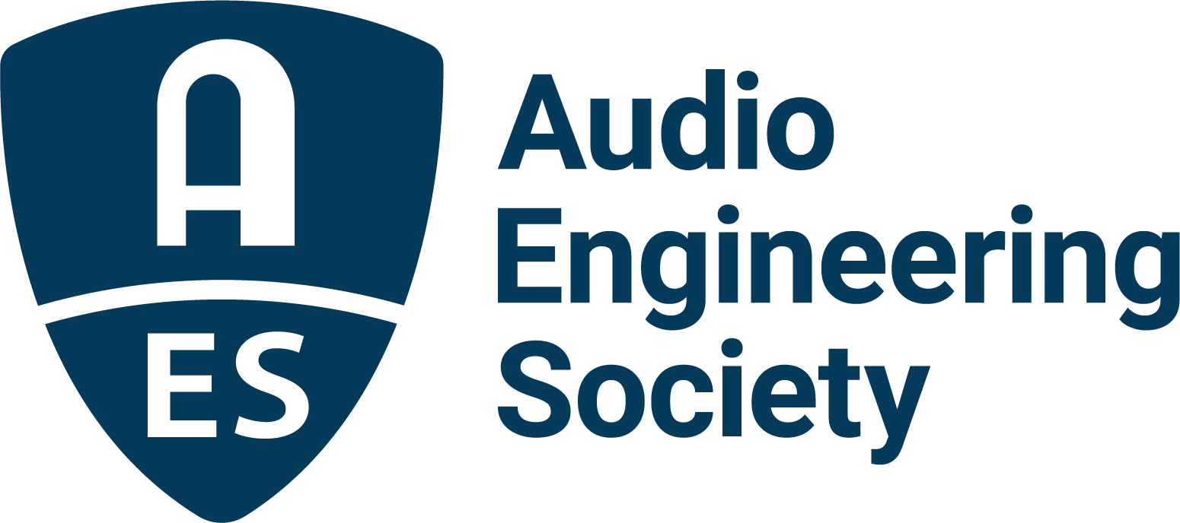

FOR IMMEDIATE RELEASE

AES Show 2025 – Long Beach exclusive: “A conversation with Jack Douglas and Marc Daniel Nelson, hosted by Warren Huart”

— Session offers rare insights into the artistry, stories, and techniques behind some of the most influential recordings in music history —

New York, NY, September 16, 2025 — The Audio Engineering Society (AES) is proud to announce an exclusive session at the upcoming AES Show 2025 – Long Beach: “A conversation with Jack Douglas and Marc Daniel Nelson, hosted by Warren Huart.” This unmissable session will take place on Thursday, October 23, from 2:30pm-4:00pm PDT in the Special Events room, and brings together three of the most respected creative voices in modern music production for a rare, behind-the-scenes discussion on the art and craft of record-making.

Warren Huart, GRAMMY®-nominated producer and engineer, best-selling author, and founder and host of Produce Like A Pro, whose credits include work with The Fray, Korn, James Blunt and Aerosmith, will guide the conversation. The session will include legendary GRAMMY Award-winning producer Jack Douglas, whose career includes landmark collaborations with John Lennon, Aerosmith, Cheap Trick, Patti Smith and countless others, alongside acclaimed GRAMMY and French Academy Award nominated mixer Marc Daniel Nelson, celebrated for his nuanced, award-winning work with artists such as Fleetwood Mac, Colbie Caillat and Jason Mraz, as well as a wide range of film and television projects.

The trio will draw on decades of combined experience to offer a deep delve into the creative process at the highest level, giving attendees an unprecedented window into the making of some of the world’s most celebrated music. They will share how iconic records are conceived, shaped and ultimately realized, from the earliest spark of inspiration to the final mix. Beyond technical insights, they will explore the human side of collaboration, the role of intuition in the studio, and timeless lessons that continue to influence today’s producers, engineers and artists.

“Jack Douglas has been a mentor to me for years,” stated Warren Huart. “I always loved his work. I bought the Double Fantasy album for my mum for Christmas, but when Lennon passed, I unwrapped it and basically confiscated it. I played it daily, and those songs became an intricate part of my life. A highlight in my career that I will always treasure was when I got a chance to work with Jack in the studio beginning in 2011 for the recording of Aerosmith’s Music from Another Dimension. To now be able to call Jack not only a mentor but a family friend is a true honor. His insight, passion and uncanny ability to bring out the best in every performance has left an indelible mark on my own approach to engineering and mixing. And Marc Daniel Nelson is not only a trusted friend but someone I share a genuine love of great music with, which makes working together even more special.”

The “Conversation” session promises to deliver inspiration and practical wisdom as part of the comprehensive Technical Program at AES Show 2025 taking place at the Long Beach Convention and Entertainment Center, October 23 – 25, with additional Skill Building Workshops and Tech Tours taking place on Wednesday, October 22. Program details and registration information are online at www.aesshow.com.

Photo File 1: Douglas_Huart.JPG
Photo Caption 1: Shown L-R: Jack Douglas, legendary GRAMMY® Award-winning producer whose career includes landmark collaborations with John Lennon, Aerosmith, Cheap Trick, Patti Smith, and Warren Huart, GRAMMY-nominated producer, engineer, best-selling author, founder and host of Produce Like A Pro.

Photo File 2: Marc_Daniel_Nelson.JPG
Photo Caption 2: GRAMMY® and French Academy Award nominated mixer Marc Daniel Nelson, celebrated for his award-winning work with artists such as Fleetwood Mac, Colbie Caillat, Jason Mraz, and a wide range of film and television projects.

About the Audio Engineering Society
For more than 75 years, the Audio Engineering Society has served as the pivotal force in fostering the advancement in audio technologies and application and the dissemination of technical information for the audio community. Its members are affiliated with 90 AES professional sections and more than 120 AES student sections around the world where activities include guest speakers, technical tours, demonstrations, online events and social functions. Through Conventions, Conferences, Training and Development events and peer-reviewed publications, as well as the Society’s vast online technical documents, Standards and video resources, members experience valuable opportunities for professional networking and personal growth. For additional information, visit AES.org.

Join the conversation and keep up with the latest AES News and Events:
X: #AESorg (AES Official)
Facebook: facebook.com/AES.org
LinkedIn: https://www.linkedin.com/company/audio-engineering-society
Instagram: https://www.instagram.com/aes_org/

AES Marketing Communications:
Email: robert@clynemedia.com
Tel: 615-300-4666
Clyne Media, Inc.,
169-B Belle Forest Circle, Nashville, TN 37221;
Web: http://www.clynemedia.com

