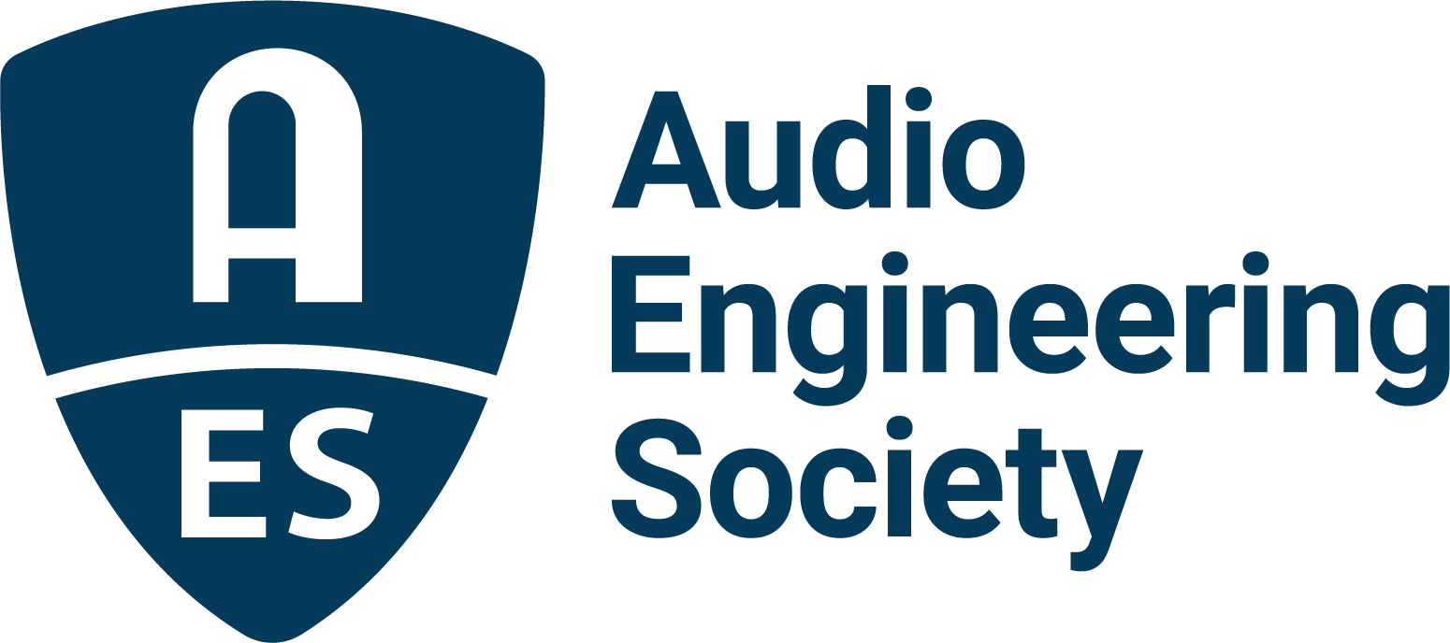

FOR IMMEDIATE RELEASE

AES Show 2025 to feature special session: “Inside the Productions of Brian Wilson” with GRAMMY®-winning engineer Mark Linett and producer Warren Huart

— A behind-the-scenes conversation on the albums that changed pop music forever —

New York, NY, August 28, 2025 — The Audio Engineering Society is proud to announce a featured session at the upcoming AES Show 2025 in Long Beach: “Inside the Productions of Brian Wilson: GRAMMY®-winning Engineer/Producer Mark Linett in Conversation with Warren Huart.” This in-depth conversation will take place Friday, October 24, from 2:30 PM to 4:00 PM PDT.

Legendary engineer and producer Mark Linett, a three-time GRAMMY® winner, will join acclaimed producer and Produce Like A Pro host Warren Huart for an intimate exploration of one of the most ambitious recording journeys in popular music history— Brian Wilson and the Beach Boys’ Pet Sounds and SMiLE.

From the lush orchestration of Pet Sounds to the long-mythologized and ultimately completed SMiLE project, Linett has played a central role in preserving and presenting Wilson’s legacy for modern audiences. His work on The Pet Sounds Sessions box set, featuring the album’s first-ever stereo mix, earned a GRAMMY nomination and set a new standard for archival reissues. He also recorded and mixed Pet Sounds Live and Brian Wilson Presents SMiLE in both stereo and 5.1 surround formats, offering fans immersive experiences of these timeless works.

The session will offer attendees behind-the-scenes insights into the studio techniques, challenges, and creative decisions that shaped Wilson’s most iconic projects. Drawing from a 50-year career, Linett will also discuss his work on celebrated Beach Boys box sets including Good Vibrations: Thirty Years of the Beach Boys, Made in California (1962–2012), Feel Flows: The Sunflower & Surf’s Up Sessions 1969–1971, and Sail on Sailor.

Beyond his collaboration with Wilson, Linett’s extensive credits include projects with Randy Newman, Rickie Lee Jones, Jane’s Addiction, Red Hot Chili Peppers, Los Lobos and Laura Nyro, among others.

“Inside the Productions of Brian Wilson” is a must-attend session for audio professionals, producers, and fans of studio innovation – a rare opportunity to hear firsthand from the engineer who helped bring some of the most complex and beloved pop recordings to life.

The AES Show 2025 will take place October 22–25, 2025 at the Long Beach Convention & Entertainment Center. Program details and registration information are online at www.aesshow.com.

For more information about Mark Linett, visit:
https://en.wikipedia.org/wiki/Mark_Linett
http://www.bignoisenow.com/marklinett.html

Photo File 1: Wilson_Linett.JPG
Photo Caption 1: Shown L-R: Brian Wilson and Mark Linett

Photo File 2: Linett_Wilson_McCartney.JPG
Photo Caption 2: Shown L-R: Mark Linett, Brian Wilson and Paul McCartney

Photo File 3: Mark_Linett.JPG
Photo Caption 3: Mark Linett

Photo File 4: Warren_Huart.JPG
Photo Caption 4: Warren Huart

About the Audio Engineering Society
For more than 75 years, the Audio Engineering Society has served as the pivotal force in fostering the advancement in audio technologies and application and the dissemination of technical information for the audio community. Its members are affiliated with 90 AES professional sections and more than 120 AES student sections around the world where activities include guest speakers, technical tours, demonstrations, online events and social functions. Through Conventions, Conferences, Training and Development events and peer-reviewed publications, as well as the Society’s vast online technical documents, Standards and video resources, members experience valuable opportunities for professional networking and personal growth. For additional information, visit AES.org.

Join the conversation and keep up with the latest AES News and Events:
X: #AESorg (AES Official)
Facebook: facebook.com/AES.org
LinkedIn: https://www.linkedin.com/company/audio-engineering-society
Instagram: https://www.instagram.com/aes_org/

AES Marketing Communications:
Email: robert@clynemedia.com
Tel: 615-662-1616
Clyne Media, Inc.,
169-B Belle Forest Circle, Nashville, TN 37221;
Web: http://www.clynemedia.com

