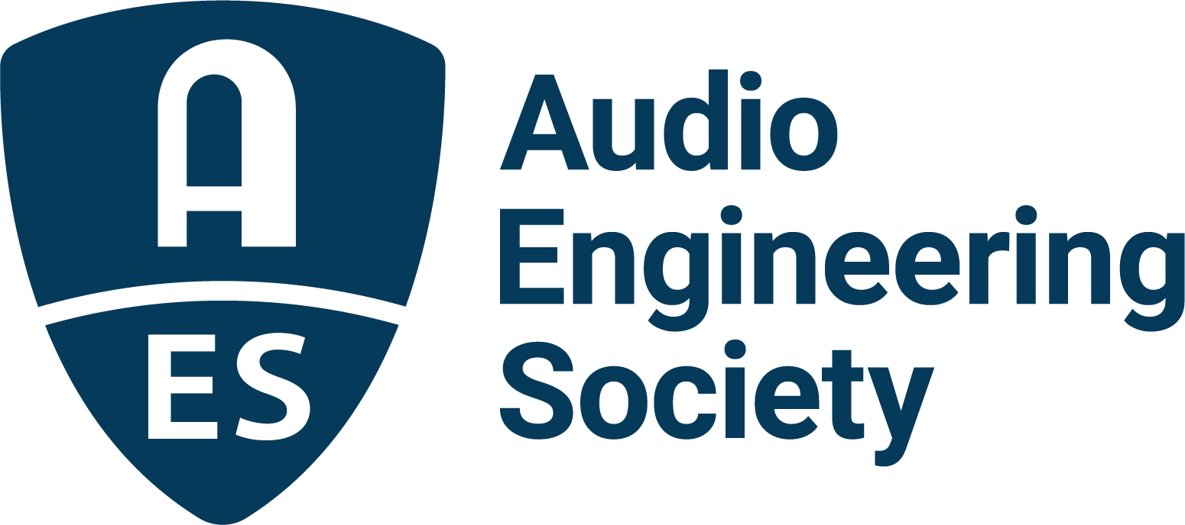

FOR IMMEDIATE RELEASE

GRAMMY® Award-winning producer Andrew Watt to deliver Friday’s keynote address at AES Show 2025 in Long Beach

— The conversation, moderated by longtime friend and collaborator Chad Smith of the Red Hot Chili Peppers, will explore Watt’s genre-spanning career, his work with icons from Elton John to The Rolling Stones, and the trust and creativity that define both his productions and his enduring bond with artists —

New York, NY, September 18, 2025 — The Audio Engineering Society (AES) is proud to announce that multi-GRAMMY® Award-winning and platinum-selling producer Andrew Watt will deliver a keynote address at the upcoming AES Show 2025 in Long Beach, CA. The event will take place on Friday, October 24, 2025, from 12:00 p.m. to 1:00 p.m. PDT. Moderating the conversation will be special guest, Rock and Roll Hall of Famer Chad Smith, legendary drummer of the Red Hot Chili Peppers.

Andrew Watt, one of today’s most in-demand producers, has shaped some of the defining works of the past decade, collaborating with an extraordinary range of artists including Lady Gaga, Elton John, Brandi Carlile, Post Malone, Dua Lipa, Justin Bieber, Ozzy Osbourne and The Rolling Stones. In his keynote, titled “Creativity, Collaboration, and the Modern Producer’s Role,” Watt will share insights from his journey at the forefront of contemporary music, exploring how he navigates genres, fosters collaboration and trust in the studio, and helps artists at every stage of their careers create career-defining work.

The keynote will offer attendees an intimate look into the unique creative bond between Watt and Smith. Longtime friends and collaborators, the two GRAMMY® winners have worked together on a range of award-winning projects, in addition to performing with their critically praised cover band, Smith & Watt Steakhouse, which performed memorable gigs in the Hamptons and at Brooklyn Bowl. That spirit of collaboration and camaraderie will be on full display as Smith brings his trademark energy and insight to the role of moderator.

“Andrew has become one of the defining producers of our time, and we’re thrilled to bring him to the AES stage,” said Audio Engineering Society president Gary Gottlieb. “Having Chad Smith moderate the discussion with Andrew makes this keynote even more special. We will see two musicians with a genuine history together offering an authentic, behind-the-scenes perspective on creativity and production in today’s music industry.”

This keynote will be a centerpiece of AES Show 2025, which takes place October 23–25 at the Long Beach Convention & Entertainment Center. The convention will once again gather audio professionals, engineers, producers and students from around the world to share knowledge, explore new technologies, and celebrate the art and science of sound.

For more information about the AES Show 2025 program and registration, please visit www.aesshow.com.

Photo File 1: Andrew_Watt-30.JPG
Photo Caption 1: Multi-GRAMMY® Award–winning, platinum-selling producer Andrew Watt

Photo File 2: Chad_Smith.JPG
Photo Caption 2: Rock and Roll Hall of Famer Chad Smith, legendary drummer of the Red Hot Chili Peppers

About Andrew Watt:
The name Andrew Watt has become synonymous with one undeniable truth: he is the music industry’s not-so-secret weapon. Since 2015, the multi-GRAMMY-winning, platinum-selling music producer has collaborated with some of the past decade’s most groundbreaking artists, including The Rolling Stones, Lady Gaga, Brandi Carlile, Pearl Jam, Justin Bieber, Elton John, Cardi B, Post Malone, Dua Lipa, Metallica, Stevie Wonder, Miley Cyrus, Bruno Mars, Shawn Mendes, Lana Del Rey, Paul McCartney, Ozzy Osbourne, Smokey Robinson and many more. In 2021, Watt won his first GRAMMY Award for Producer of the Year at the 63rd Annual GRAMMY Awards, thanks to his work on Ozzy Osbourne’s Ordinary Man, Miley Cyrus’ Plastic Hearts, Dua Lipa’s Future Nostalgia, and Post Malone’s Hollywood’s Bleeding. The following year, Watt produced a string of widely praised projects, including the Elton John and Britney Spears collaboration “Hold Me Closer,” Eddie Vedder’s Earthling, and Ozzy Osbourne’s Patient Number 9, which earned him his second GRAMMY for Best Rock Album at the 65th Annual GRAMMY Awards.

2023 was another standout year, with releases like Iggy Pop’s Every Loser, The Kid LAROI’s "Forever and Again" from the Barbie movie soundtrack, and Jungkook’s “Seven,” which debuted at #1 on the Billboard Hot 100. Watt capped the year with Hackney Diamonds, The Rolling Stones’ first album of original music in 18 years, which he fully produced. The album’s lead single, “Angry,” earned Watt a GRAMMY nomination for Best Rock Song for his co-writing and production work, with the full album earning him a win for Best Rock Album in 2025.

In 2024, Watt produced Pearl Jam’s Dark Matter, Peso Pluma and Quavo’s “Pa No Pensar,” Lana Del Rey and Quavo’s “Tough,” and Quavo and Lenny Kravitz’s “Fly.” That same year Watt worked on the groundbreaking track “Die With a Smile” by Bruno Mars and Lady Gaga, which debuted at #1 on the Billboard Hot 100 and remained at the top for five weeks. The song also spent 18 weeks at #1 on the Billboard Global 100 chart, and spent 204 days at #1 on Spotify's Global Chart, setting a new record for the longest-running number one in the platform's history. He also executive produced Lady Gaga’s latest album Mayhem, which debuted at #1 on the Billboard 200 chart, and produced the collaboration album between Elton John and Brandi Carlile, Who Believes in Angels, featuring the highly acclaimed track “Never Too Late.” The song, which was featured in the documentary Elton John: Never Too Late, earned Watt an Oscar nomination for Best Original Song in 2025. Most recently, Watt produced Lady Gaga’s new single, “Dead Dance,” featured in Part Two of Wednesday Season 2, as well as Brandi Carlile’s new track, “Returning to Myself” — the lead single from her highly anticipated album, also produced by Watt, due out next year.

About the Audio Engineering Society
For more than 75 years, the Audio Engineering Society has served as the pivotal force in fostering the advancement in audio technologies and application and the dissemination of technical information for the audio community. Its members are affiliated with 90 AES professional sections and more than 120 AES student sections around the world where activities include guest speakers, technical tours, demonstrations, online events and social functions. Through Conventions, Conferences, Training and Development events and peer-reviewed publications, as well as the Society’s vast online technical documents, Standards and video resources, members experience valuable opportunities for professional networking and personal growth. For additional information, visit AES.org.

Join the conversation and keep up with the latest AES News and Events:
X: #AESorg (AES Official)
Facebook: facebook.com/AES.org
LinkedIn: https://www.linkedin.com/company/audio-engineering-society
Instagram: https://www.instagram.com/aes_org/

AES Marketing Communications:
Email: robert@clynemedia.com
Tel: 615-662-1616
Clyne Media, Inc.,
169-B Belle Forest Circle, Nashville, TN 37221;
Web: http://www.clynemedia.com

