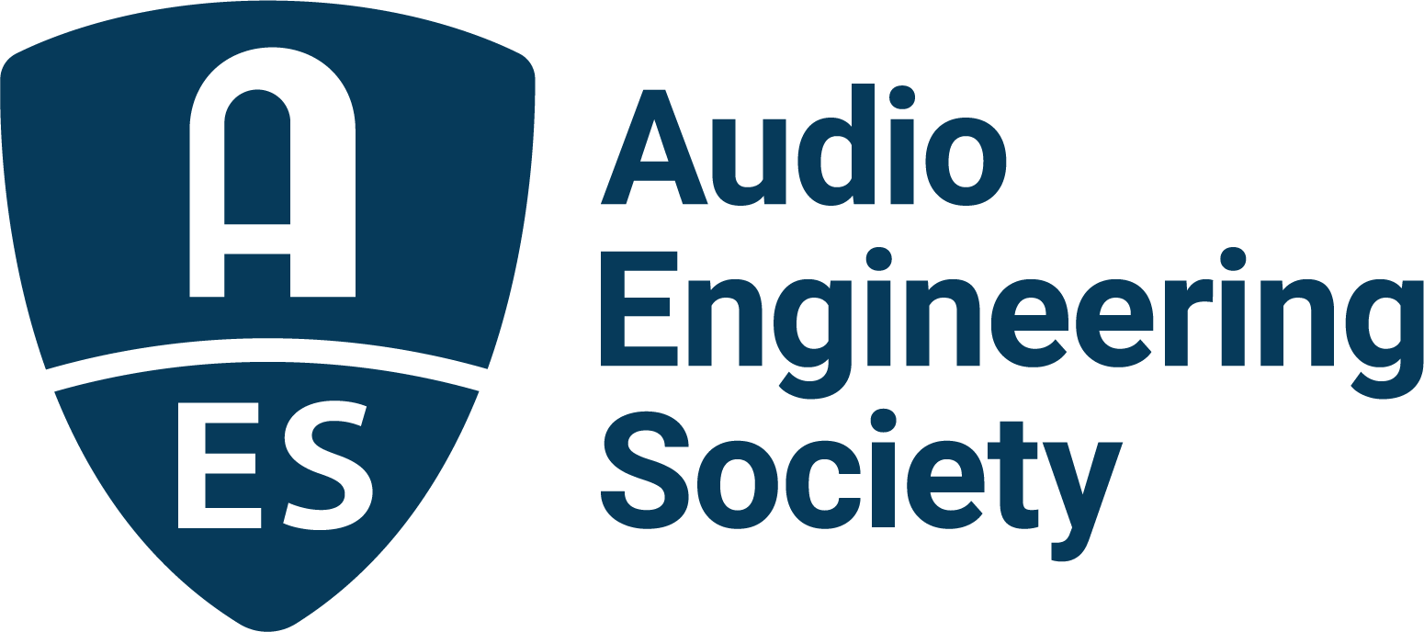

FOR IMMEDIATE RELEASE

From Bon Iver to Lorde: Boundary-pushing producer, songwriter, multi-instrumentalist Jim-E Stack brings creative insights to AES Show 2025

— The session, titled Inside the Sound: Producer, Songwriter, Multi-Instrumentalist Jim-E Stack in Conversation with Ian Gold, will take place on Thursday, October 23, from 4:45pm–5:45pm PT —

New York, NY, October 14, 2025 — The Audio Engineering Society is pleased to announce a featured session at the upcoming AES Show in Long Beach: Inside the Sound: Producer, Songwriter, Multi-Instrumentalist Jim-E Stack in Conversation with Recording and Mix Engineer Ian Gold. The session will take place on Thursday, October 23, from 4:45–5:45 p.m. PT in the Special Events Room.

This intimate conversation will give attendees a rare look into the creative process of acclaimed producer, songwriter and multi-instrumentalist Jim-E Stack, whose rhythm-driven, emotionally resonant productions have helped shape some of the most compelling records of the past decade. From co-producing Bon Iver’s SABLE fABLE to writing and producing much of Lorde’s Virgin, Stack has emerged as one of today’s most versatile and in-demand collaborators, working across genres with a wide variety of artists including Caroline Polachek, Gracie Abrams, Dominic Fike, Lola Young, Hayley Williams and Aminé.

Stack primarily works from his Los Angeles home studio, where his arsenal of equipment ranges from trusted analog synths like the Moog Rogue, Prophet 5 and Juno-106 to studio staples like ATC SCM25 monitors, Neumann U47s and Coles 4038s, tools he deploys with precision to serve the emotional core of each song.

“I try to foster a low-pressure and open environment in whatever studio I’m in and maximize the room for my collaborators’ creativity,” said Jim-E Stack. “Simple tools like an SM7, Korg PolySix, a Moog Rogue, and maybe some Coles help me document that day’s feeling.”

Moderated by engineer, producer and musician Ian Gold (Bon Iver, Miley Cyrus, Shawn Everett), the session will explore Stack’s genre-defying approach, his balance of experimentation and emotion, and his collaborative practices that bring out the best in artists.

Attendees will gain valuable insight into the tools, techniques and philosophies that define Stack’s work, from his roots as a jazz drummer to his present role as a sonic craftsman at the forefront of modern production.

With credits spanning indie, pop, R&B and experimental projects, Stack continues to inspire by bridging raw emotion with cutting-edge sound design. His creative ethos prioritizes humanity and imperfection over polish, embracing the “jagged edges” of sound in a digital age. This AES session promises to be a deep dive into the mindset of a producer reshaping the boundaries of contemporary music.

“AES has always been about learning directly from the innovators shaping the music of today and tomorrow,” said Audio Engineering Society president Gary Gottlieb. “This session offers attendees a front-row seat into Jim-E Stack’s unique vision and the philosophies behind some of the most compelling music of the past decade.”

Attendees can expect an engaging discussion covering Stack’s rhythm-driven style, his philosophy of embracing imperfection, and the collaborative practices that continue to push the boundaries of modern music production.

For more information about the AES Show 2025 program and registration, please visit www.aesshow.com.

Photo File 1: JimEStack.JPG
Photo Caption 1: Acclaimed producer, songwriter and multi-instrumentalist Jim-E Stack.

Photo File 2: IanGold.JPG
Photo Caption 2: Los Angeles-based recording and mix engineer Ian Gold

About the Audio Engineering Society
For more than 75 years, the Audio Engineering Society has served as the pivotal force in fostering the advancement in audio technologies and application and the dissemination of technical information for the audio community. Its members are affiliated with 90 AES professional sections and more than 120 AES student sections around the world where activities include guest speakers, technical tours, demonstrations, online events and social functions. Through Conventions, Conferences, Training and Development events and peer-reviewed publications, as well as the Society’s vast online technical documents, Standards and video resources, members experience valuable opportunities for professional networking and personal growth. For additional information, visit AES.org.

Join the conversation and keep up with the latest AES News and Events:
X: #AESorg (AES Official)
Facebook: facebook.com/AES.org
LinkedIn: https://www.linkedin.com/company/audio-engineering-society
Instagram: https://www.instagram.com/aes_org/

AES Marketing Communications:
Email: robert@clynemedia.com
Tel: 615-662-1616
Clyne Media, Inc.,
169-B Belle Forest Circle, Nashville, TN 37221;
Web: http://www.clynemedia.com

