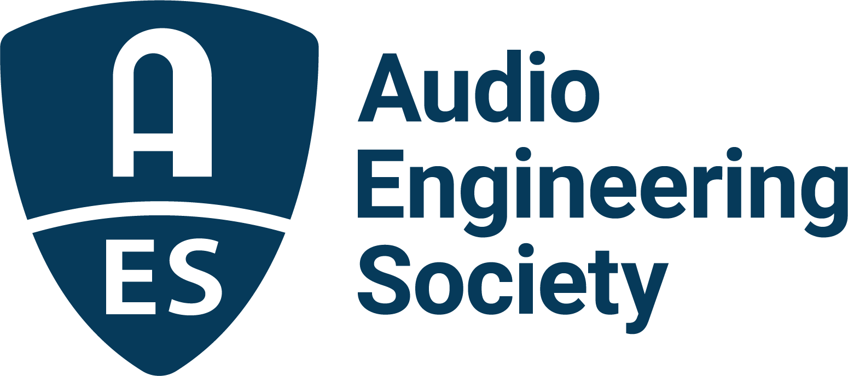

FOR IMMEDIATE RELEASE

The Audio Engineering Society welcomes Gary Gottlieb as President

— Gottlieb brings decades of experience in AES leadership to his role as President for 2025 —

New York, NY, January 9, 2025 — The Audio Engineering Society (AES) welcomes Gary Gottlieb as President as of January 1, 2025. An AES Member for forty years, Gottlieb has been deeply engaged in various levels of leadership in the organization for the last twenty.

“Gary Gottlieb has an amazing history of service to the AES,” says AES immediate Past President Leslie Gaston-Bird. “When we first met, he was a leader in the St. Louis Section and mentoring the Webster University Student Section, who jointly established the wildly successful Central Regional Audio Student Summit series. He has contributed hugely to AES’s educational, historical and event initiatives and it’s been my pleasure and honor to work with him on the AES Board of Directors this past year. AES will no doubt thrive under his leadership and continue to build on our forward progress. I’m eager to see Gary’s boundless enthusiasm and dedication in action as he leads the Society for the coming year.”

“It’s an exciting time to lead AES,” says Gottlieb, “We are constantly evolving, and I am ready to do my part to continue this evolution, with a goal to bring many of the initiatives started in the last few years to fruition.” He is enthusiastic about the lineup of AES events in 2025, with three conventions and three conferences confirmed, and work has already begun on creating a compelling slate of events for 2026 and 2027. “In service to our members and our sponsors we are thinking as far ahead as possible, and also are looking to evolve and adapt our events to better serve all our stakeholders,” according to Gottlieb, who feels that these events drive our engagement. “We are a membership organization, and our members want that sense of community and camaraderie. We want to meet each other, network and connect, and there is no better way to get that sense of belonging than by attending events – locally, regionally and internationally.”

Along with member engagement through events and through cross-pollination between student and professional sections, Gottlieb is focused on ensuring that technology is in place to give members the best possible experience regarding all of the Society’s digital assets, including the E-library, the AES LIVE: Videos archive, and the Oral History Project. Gottlieb says, “We have a wealth of valuable information about the audio industry, workflows and methods, and how the industry and AES evolved over the last 77 years,” says Gottlieb. “We are working behind the scenes to make all those assets available to members in an organized and intuitive interface.”

An AES Fellow, Gottlieb attended AES Conventions starting in 1983 in New York, where he began his career as an assistant engineer at Counterpoint Studios. He moved on to National Edison Studios before beginning his freelance career in some of the most storied studios in New York, including A&R, Sigma Sound, The Hit Factory, and Clinton Recording. By the early 1990s, Gottlieb expanded his career to Sound Design and Sound Reinforcement. In 1991 he relocated to Vermont where he earned his master’s degree in Audio Aesthetics & Technology from Marlboro College.

In the early 2000s Gottlieb moved to St. Louis, where he ran and revamped Webster University’s Audio Program, expanding it to become the school’s Department of Audio Aesthetics & Technology. While in St. Louis he revitalized the St. Louis AES Section, which had lain dormant for 13 years, and helped students form the Webster University AES Student Section. Their Student Summit was a watershed event for the Central Region and the University.

During his time in St. Louis, he authored three books: Shaping Sound in the Studio & Beyond, Recording on the Go, and How Does It Sound Now? – Legendary Engineers and Vintage Gear, which won the 2010 Association for Recorded Sound Collections’ award for Excellence in Historical Recorded Sound Research. Second Editions of Shaping Sound and How Does It Sound Now? are due to be released in 2025.

Along with holding every local AES Section office possible, Gottlieb served two-year terms on the Society’s Board of Governors, first as a Governor then later as Regional Vice President for the Eastern Region of U.S. and Canada, and is now on the Board of Directors. He has served in leadership roles on the Historical Committee, the Conference Committee, and the Events Coordination Committee. “AES is a volunteer organization,” shares Gottlieb. “Our strength is in our ability to support the organization by volunteering. I encourage all members to pitch in to help build a stronger community, whether it’s on the local level, regionally or internationally”.

For the latest AES news, events and membership opportunities, visit AES.org.

…ends 755 words

Photo File 1: GaryGottlieb.jpg
Photo Caption 1: Gary Gottlieb, President, Audio Engineering Society

About the Audio Engineering Society
For more than 75 years, the Audio Engineering Society has served as the pivotal force in fostering the advancement in audio technologies and application and the dissemination of technical information for the audio community. Its members are affiliated with 90 AES professional sections and more than 120 AES student sections around the world where activities include guest speakers, technical tours, demonstrations, online events and social functions. Through Conventions, Conferences, Training and Development events and peer-reviewed publications, as well as the Society’s vast online technical documents, Standards and video resources, members experience valuable opportunities for professional networking and personal growth. For additional information, visit AES.org.

Join the conversation and keep up with the latest AES News and Events:
X: #AESorg (AES Official)
Facebook: facebook.com/AES.org
LinkedIn: https://www.linkedin.com/company/audio-engineering-society
Instagram: https://www.instagram.com/aes_org/

AES Marketing Communications:
Email: robert@clynemedia.com
Tel: 615-300-4666
Clyne Media, Inc.,
169-B Belle Forest Circle, Nashville, TN 37221;
Web: http://www.clynemedia.com

