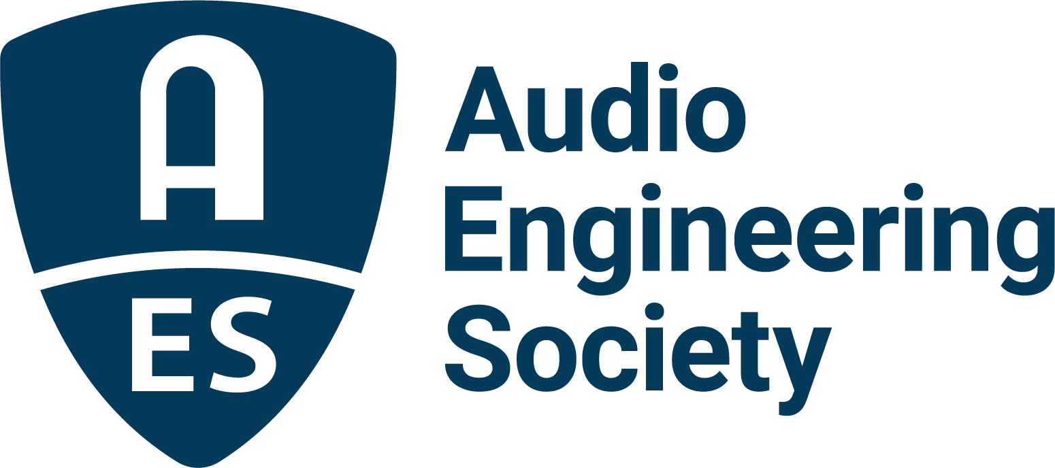

FOR IMMEDIATE RELEASE

AES Vegas 2021 Canceled; AES Fall Online 2021 Proceeding as Scheduled
Due to the evolving realities of the COVID pandemic, the NAB announced its decision to cancel the upcoming in-person Las Vegas convention. The AES convention was collocated with the NAB Show, and following the NAB announcement, the AES will regrettably cancel the in-person AES Show Las Vegas 2021, planned for October 10 – 13.

The AES Fall Online program will proceed, with events taking place online between October 16 – 31, including a broadly focused technical program October 20 – 23.

Visit aesshow.com/fall2021 for updates and to register.

Further information is forthcoming for those who have registered for the in-person convention, including converting that registration to experience the online program.

We apologize for the change in plans, but we hope you understand that it was not feasible to continue as planned. Please focus on your continued health and safety, and hopefully, 2022 can see the much-anticipated return of in-person Audio Engineering Society community events.

About the Audio Engineering Society
The Audio Engineering Society, celebrating over 70 years of audio excellence, now counts over 12,000 members throughout the U.S., Latin America, Europe, Japan and the Far East. The organization serves as the pivotal force in the exchange and dissemination of technical information for the industry. Currently, its members are affiliated with 90 AES professional sections and more than 120 AES student sections around the world. Section activities include guest speakers, technical tours, demonstrations and social functions. Through local AES section events members experience valuable opportunities for professional networking and personal growth. For additional information, visit aes.org.

Join the conversation and keep up with the latest AES News and Events:
Twitter: #AESorg (AES Official)
Facebook: facebook.com/AES.org

AES Marketing Communications:
Email: robert.clyne@aes.org
Tel: 615-662-1616, Fax: 615-662-1636,
Clyne Media, Inc.,
169-B Belle Forest Circle, Nashville, TN 37221;
Web: http://www.clynemedia.com

