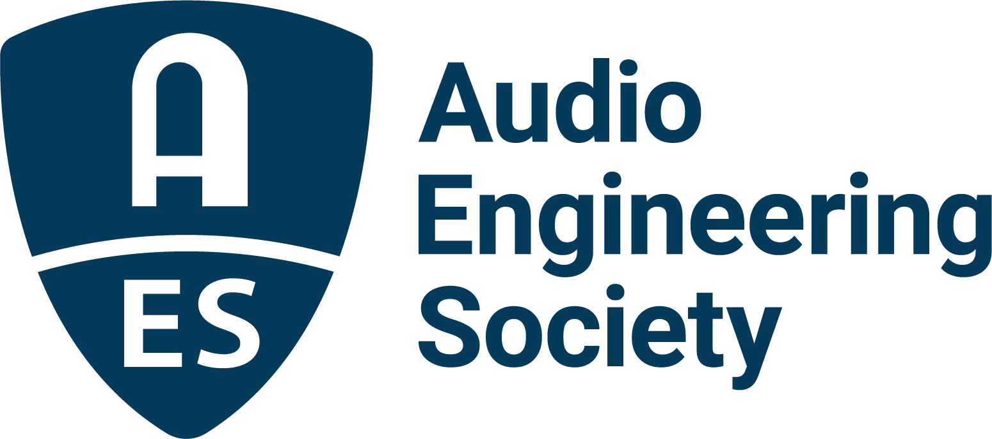

FOR IMMEDIATE RELEASE

Full program details now online for upcoming AES Europe Convention in Warsaw, Poland

— International gathering of top audio engineers, researchers, students to feature hundreds of audio’s best minds presenting in more than 130 sessions —

New York, NY, May 8, 2025 — The Audio Engineering Society is gearing up for the AES Europe 2025 Convention, taking place in Warsaw, Poland, May 22 – 24, at ATM Studio. Featuring over 130 sessions covering the breadth of audio engineering science, technology, and applications, the 158th Audio Engineering Society International Convention will once again bring together leading professional audio innovators and researchers for three days of networking and immersion in the latest audio innovations. The complete program schedule (including the Heyser Lecture and Hyunkook Lee’s “Dimensions of Immersive Audio Experiences” keynote address abstracts), travel information, student competition details, and more are now online at AESEurope.com.

For audio professionals at any stage of their career, or just starting out, there’s something for everyone at AES Europe 2025, where a who’s-who in audio will educate, illuminate, and inspire. The program and presenter roster ranges from audio visionary Thomas Lund’s immersive audio “Enveloping Masterclass” series with Florian Camerer, Kimio Hamasaki and Morten Lindberg to technology perspectives from the likes of Richard King and Jamie Angus-Whiteoak. There’s practical advice and guidance with educator Ian Corbett leading a panel of esteemed audio professionals in the session, “Ask us anything about starting your career,” plus lessons in leadership with AES leaders Gary Gottlieb, Ewa Lukasik, Brecht De Man, and Leslie Gaston-Bird. Production insights will be delivered by a host of leading practitioners like Bob Lee sharing what audio engineers need to know about RF in the session “Best practices for wireless audio in live production,” and studio insights from Tom Ammermann, David Bowles, Hyunkook Lee and Marcela Rada.

AES Europe 2025’s Richard C. Heyser Memorial Lecture will be given by Dr. Jurgen Herre, Professor of Audio Coding at International Audio Laboratories Erlangen. In his 36-year journey from a young DSP engineer at Fraunhofer IIS to a pioneer of technologies like MP3, AAC and AI-driven audio coding, Dr. Herre has pursued one core truth: in audio, it’s all about perception. Rather than relying solely on metrics like signal-to-noise ratio, frequency response and linearity, Herre emphasizes the importance of optimizing what we actually hear. In his Heyser lecture, Dr. Herre will share how this guiding principle has shaped innovations across the world of media, VR/AR, and beyond.

AES Europe will also offer a variety of events and competitions aimed at audio students and educators. These include a Student Welcoming event on Thursday in addition to several specialized sessions based on audio education. This year’s events will also include the popular Student Recording Competition, in the categories of Traditional Acoustic Recording, Traditional Studio Recording, Modern Studio Recording and Electronic Music, and Sound for Visual Media. In addition, the Student Project Expo offers students a chance to show off their latest innovations and research into topics including software and hardware design, technology integrations, and the artistic use of technology.

This year’s AES Europe Convention is headed by co-chairs Bozena Kostek, Magdalena Piotrowska and Jan Zera. Additional organizers, offering their own unique insights and institutional knowledge, include Workshop Chairs Bartlomiej Chojancki, Pawel Malecki and Przemyslaw Plaskota; Paper Chairs Nils Peters, Alicja Wieczorkowska and Slawomir Zielinski; Facilities Chairs Michal Mika and Marek Walaszek; Technical Tours Chairs Pawel Gorski and Radoslaw Smolinski; Education Chairs Ian Corbett and Angela Piva, working together with Student Volunteers Chairs Marta Gospodarek, Bartlomiej Mroz and Agnieszka Paula Pietrzak; Special Events Chair Andrzej Lipinski; and Liaisons Chair Ewa Lukasik.

Visit AESEurope.com to access the interactive program schedule, travel information, and event updates.

…ends 568 words

Photo File 1: AES_Europe_2025.JPG
Photo Caption 1: Complete program schedule information is now available for the AES Europe Convention in Warsaw, Poland, taking place May 22 – 24 at ATM Studio.

Photo File 2: Dr_Jurgen_Herre.JPG
Photo Caption 2: Dr. Jurgen Herre, Professor of Audio Coding at International Audio Laboratories Erlangen, will deliver the Richard C. Heyser Memorial Lecture at the AES Europe 2025 Convention.

About the Audio Engineering Society
For more than 75 years, the Audio Engineering Society has served as the pivotal force in fostering the advancement in audio technologies and application and the dissemination of technical information for the audio community. Its members are affiliated with 90 AES professional sections and more than 120 AES student sections around the world where activities include guest speakers, technical tours, demonstrations, online events and social functions. Through Conventions, Conferences, Training and Development events and peer-reviewed publications, as well as the Society’s vast online technical documents, Standards and video resources, members experience valuable opportunities for professional networking and personal growth. For additional information, visit AES.org.

Join the conversation and keep up with the latest AES News and Events:
X: #AESorg (AES Official)
Facebook: facebook.com/AES.org
LinkedIn: https://www.linkedin.com/company/audio-engineering-society
Instagram: https://www.instagram.com/aes_org/

AES Marketing Communications:
Email: robert@clynemedia.com
Tel: 615-662-1616
Clyne Media, Inc.,
169-B Belle Forest Circle, Nashville, TN 37221;
Web: http://www.clynemedia.com

