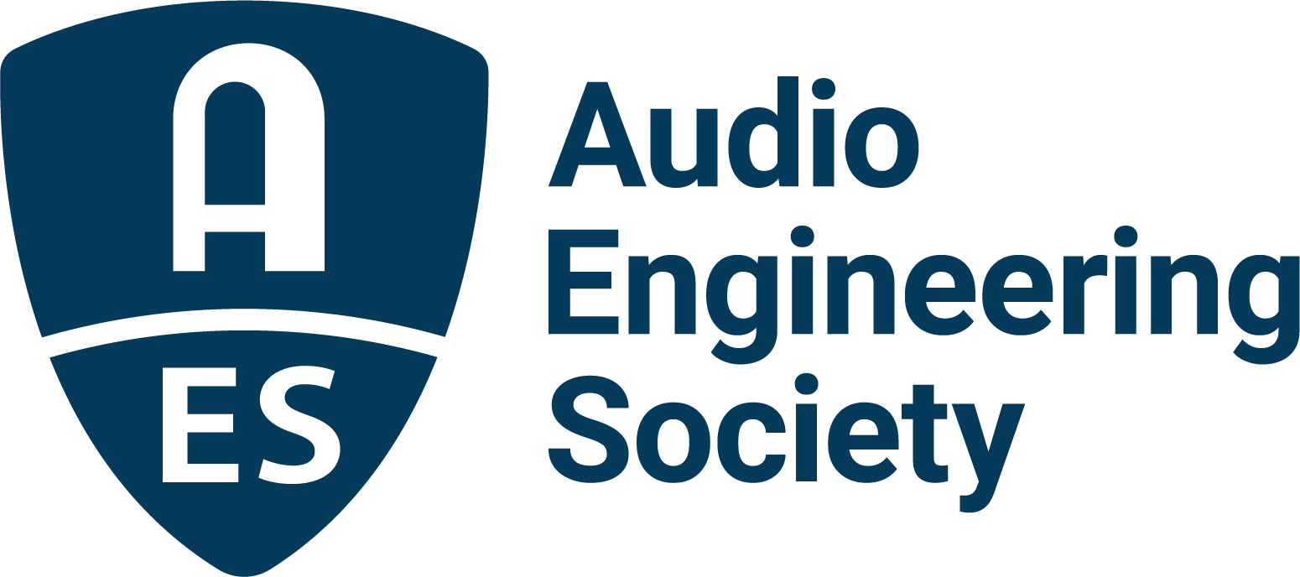

FOR IMMEDIATE RELEASE

Audio Engineering Society announces results of 2025 elections

— Cesar Lamschtein will join the Board of Directors as President-Elect in 2026 and Jayant Datta as Treasurer-Elect; new Governors and Regional Vice Presidents were also elected —

New York, NY, July 29, 2025 — The Audio Engineering Society has announced the results of its 2025 Board of Directors and Board of Governors elections. The Society’s Membership has elected Cesar Lamschtein as President-Elect, and Jayant Datta as AES Treasurer.
In the AES Elections for the Board of Governors (BoG), the following have been elected/re-elected as regional Vice Presidents: Kelvin Grimble, VP Central Region USA & Canada; Huseyin Hacihabiboglu, VP Southern Europe/Middle East/Africa Region; Piotr Majdak, VP Central Region, Europe; Ezequiel Morfi, VP Latin America Region; and Masataka Nakahara, VP Asia-Pacific Region. Additionally, newly elected as at-large Governors are Bernarda Ubidia, Jamie Baker and Fariuska Lira Barully. AES Members also ratified the four AES Bylaws amendments proposals presented on the ballot.

“As a volunteer-driven society, we are so grateful to our AES Members who step forward to serve in leadership roles,” says AES President Gary Gottlieb. “I offer sincere thanks to all who participated as nominees in this year’s elections – every one of them extremely qualified, and I applaud their willingness to serve. Congratulations and welcome to those who will take office in January; we look forward to your participation in the years to come.”
Save for the President-Elect and Treasurer, each newly elected individual will serve a two-year term. Cesar Lamschtein will serve on the AES Board of Directors as President-Elect in 2026, in 2027 as President, in 2028 as Past-President, followed by two years as a Governor. Jayant Datta will serve on the AES Board of Directors as Treasurer-Elect in 2026, and as Treasurer in 2027 and 2028. All those newly elected will begin their terms on January 1, 2026.
Also on January 1, 2026, current Past-President Leslie Gaston-Bird will transition to Governor for the first year of a two-year term. Beginning one-year terms will be President Gary Gottlieb, who will transition to Past-President, and President-Elect Brecht De Man, who will become President. Exiting the Board of Governors at that time will be Bill Schulenberg, Director and VP Central Region, USA/Canada; Jorge Azama, VP Latin American Region; Ewa Lukasik, Central Region, Europe; Kazuhiko Kawahara, VP Asia-Pacific Region; and Governors Lenise Bent, Mary Mazurek, Josh Reiss, and Jiayue Cecilia Wu
The 2026 Audio Engineering Society Board of Directors will be:
- Brecht De Man: President
- Gary Gottlieb: Past-President
- Cesar Lamschtein: President-Elect
- Valerie Tyler: Secretary
- Glenn Lorbecki: Treasurer
- Jayant Datta: Treasurer-Elect
- Marcela Zorro: Director
- One additional Director will be elected by the Board of Governors within the next 60 days.

The AES 2026 Board of Governors (in addition to the Directors above) will be:
- Masataka Nakahara: VP Asia-Pacific Region
- Jamie Angus Whiteoak: VP Northern Region, Europe
- Piotr Majdak: VP Central Region, Europe
- Huseyin Hacihabiboglu: VP Southern Europe/Middle East/Africa Region
- Ezequiel Morfi: VP Latin American Region
- Angela Piva: VP Eastern Region, USA/Canada
- Kelvin Grimble: VP Central Region, USA/Canada
- David v.R. Bowles: VP Western Region, USA/Canada
- Jamie Baker: Governor
- Leslie Gaston-Bird: Governor
- Brett Leonard: Governor
- Fariuska Lira Barully: Governor
- Bruce Olson: Governor
- Bernarda Ubidia: Governor
- Merlijn van Veen: Governor
- Malik Williams: Governor
…ends 495 words

Photo File 1: Cesar_Lamschtein.jpeg
Photo Caption 1: Cesar Lamschtein, incoming Audio Engineering Society President-Elect in 2026.

About the Audio Engineering Society
For more than 75 years, the Audio Engineering Society has served as the pivotal force in fostering the advancement in audio technologies and application and the dissemination of technical information for the audio community. Its members are affiliated with 90 AES professional sections and more than 120 AES student sections around the world where activities include guest speakers, technical tours, demonstrations, online events and social functions. Through Conventions, Conferences, Training and Development events and peer-reviewed publications, as well as the Society’s vast online technical documents, Standards and video resources, members experience valuable opportunities for professional networking and personal growth. For additional information, visit AES.org.

Join the conversation and keep up with the latest AES News and Events:
X: #AESorg (AES Official)
Facebook: facebook.com/AES.org
LinkedIn: https://www.linkedin.com/company/audio-engineering-society
Instagram: https://www.instagram.com/aes_org/

AES Marketing Communications:
Email: robert@clynemedia.com
Tel: 615-662-1616
Clyne Media, Inc.,
169-B Belle Forest Circle, Nashville, TN 37221;
Web: http://www.clynemedia.com

