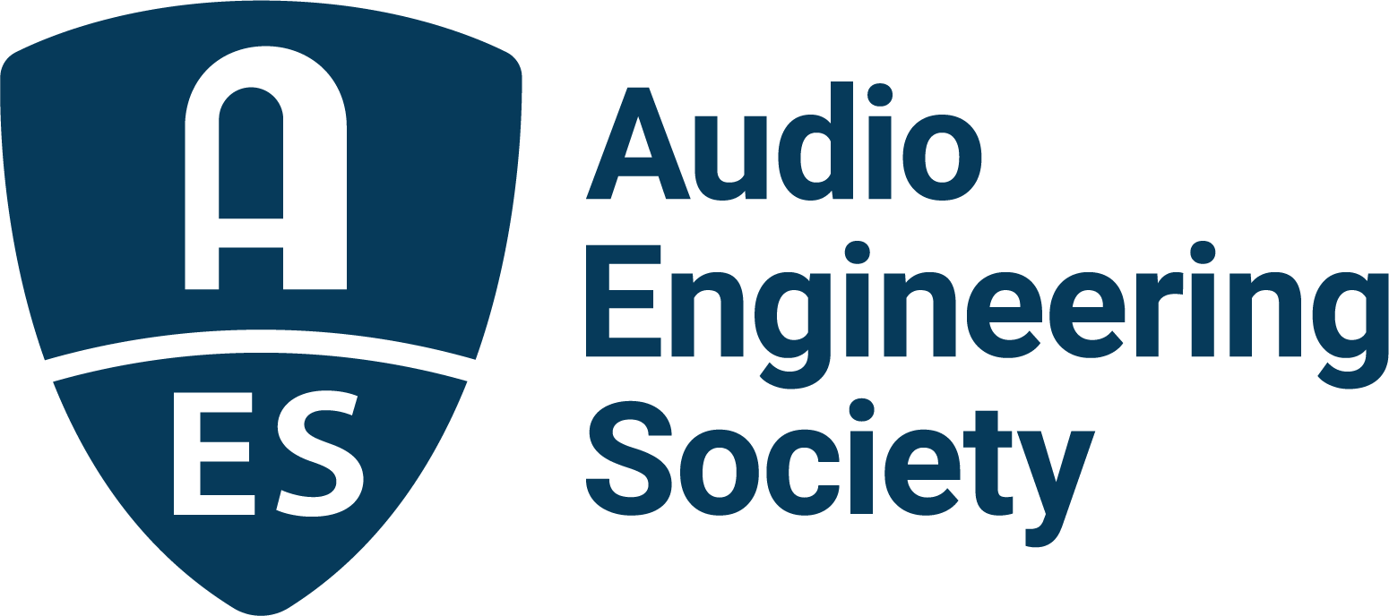

FOR IMMEDIATE RELEASE

AES Board of Governors elects Agnieszka Roginska as Director

— An AES Past President, Roginska will rejoin the Board of Directors in 2026, reprising her 2023/2024 role as a BoG-elected Director —

New York, NY, September 18, 2025 — The Audio Engineering Society’s Board of Governors (BoG) has elected Agnieszka Roginska to assume the role of AES Director beginning January 1, 2026. Roginska will replace outgoing Director Bill Schulenburg as one of two BoG-elected Directors on the AES Board of Directors (BoD). She will serve on the Board of Directors through 2027.

An AES Fellow and Past President, Roginska has served the Society in a plethora of leadership roles, including previous terms on the BoD. She currently serves as the co-chair of the AES Event Coordination Committee. Roginska earned a Ph.D. in Music Technology from Northwestern University. She is now a Professor of Music Technology at New York University, where she conducts research in the simulation and applications of immersive and 3D audio including the capture, analysis and synthesis of auditory environments.

“I am delighted that Agnieszka will be returning to the Board of Directors,” AES President Gary Gottlieb stated. “We welcome her wisdom and experience as AES continues to evolve to better serve our members.”

“We are also grateful for Bill Schulenburg’s devoted service,” added Gottlieb. “He has been a steadfast champion for our membership.”

“I am deeply honored to have been elected to the AES Board of Directors” Roginska said. “I look forward to working with my fellow Board members to support our community and to contribute to the AES mission of advancing audio innovation and fostering collaboration across our global community.”

The Board of Directors is the governing body of the AES with responsibility for the overall function and direction of the Society. Each Director is also a member of the larger Board of Governors, alongside regional Vice Presidents and Governors at large. Save for two Directors elected to the BoD by the BoG from within the BoG’s recent and current membership, each of these volunteer Board members are elected by the voting membership of the Society. The AES Boards manage AES business, membership, events, publications and online resources with the assistance of the Society’s volunteer-led topical committees.

Audio Engineering Society
aes.org

Photo File 1: Roginska.jpeg
Photo Caption 1: Agnieszka Roginska will rejoin the AES Board of Directors in 2026

About the Audio Engineering Society
For more than 75 years, the Audio Engineering Society has served as the pivotal force in fostering the advancement in audio technologies and application and the dissemination of technical information for the audio community. Its members are affiliated with 90 AES professional sections and more than 120 AES student sections around the world where activities include guest speakers, technical tours, demonstrations, online events and social functions. Through Conventions, Conferences, Training and Development events and peer-reviewed publications, as well as the Society’s vast online technical documents, Standards and video resources, members experience valuable opportunities for professional networking and personal growth. For additional information, visit AES.org.

Join the conversation and keep up with the latest AES News and Events:
X: #AESorg (AES Official)
Facebook: facebook.com/AES.org
LinkedIn: https://www.linkedin.com/company/audio-engineering-society
Instagram: https://www.instagram.com/aes_org/

AES Marketing Communications:
Email: robert@clynemedia.com
Tel: 615-662-1616
Clyne Media, Inc.,
169-B Belle Forest Circle, Nashville, TN 37221;
Web: http://www.clynemedia.com

