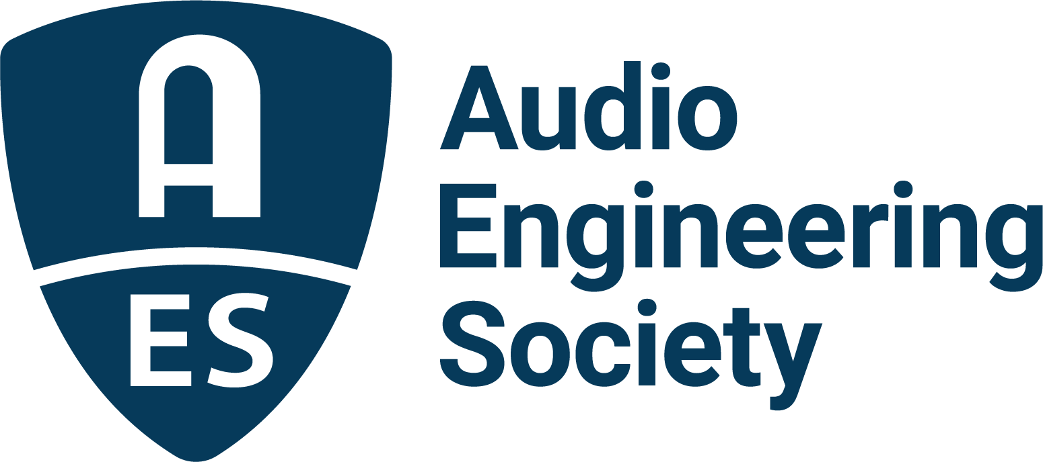

FOR IMMEDIATE RELEASE

Technical program announced for AES 6th International Automotive Audio Conference

— AI, immersive audio and next-generation vehicle sound headline this month’s AES Automotive Audio Conference in Detroit, MI —

New York, NY, July 16, 2026 — The Audio Engineering Society has announced the complete technical program for the AES 6th International Automotive Audio Conference, taking place July 29-31, 2026, at Huntington Place in Detroit, Michigan. Bringing together leading automotive manufacturers, suppliers, researchers and audio technology innovators, the conference will explore the future of in-vehicle sound under this year’s theme, “Automotive Audio in the AI Era.” Registration is now open, and the complete program is available at auto.aes.org.

The three-day event features peer-reviewed papers, workshops, demonstrations and networking focused on the latest advances in immersive audio, software-defined vehicles, artificial intelligence, active sound management and next-generation vehicle acoustics. Among the featured sessions are “Protecting AI-Driven Audio: From Model Training to In-Vehicle Deployment,” “When Real-Time Isn’t Real: Exposing and Fixing Audio Failures in Multi-Core SoCs,” and “Designing Cabin-Centric Audio Experiences: UX and System Challenges for Autonomous Vehicle Interiors,” each highlighting the technologies shaping tomorrow’s automotive listening experiences.

This year’s keynote presentations span the history, science and future of automotive audio. Mirek Stiles, Head of Audio Products at Abbey Road Studios, opens the conference with “A History of Sound Recording and Innovation at Abbey Road Studios,” exploring how the legendary studio’s engineering legacy now influences automotive listening experiences. On Thursday, Dr. Sean Olive presents “Subjective Evaluation of Automotive Audio Systems,” examining the science behind listener preference and premium in-vehicle sound. The conference concludes with Minsuk Choi of KAIST presenting “DDSP-based Neural Vehicle Sound Synthesis Conditioned on Driving Signals,” showcasing emerging AI-driven approaches to realistic vehicle sound synthesis.

Attendees will also experience the Mobile Immersive Rig (MIR), a transportable 7.1.4 Dolby Atmos® listening environment developed by Lawrence Technological University’s Audio Engineering Technology Program in collaboration with Plymouth Rock Recording Company. Designed to demonstrate immersive audio across music, automotive entertainment and emerging spatial media applications, the MIR provides a unique opportunity to experience next-generation automotive audio technologies firsthand.
In addition to the Conference’s technical sessions, attendees are encouraged to take advantage of the many networking opportunities throughout the week. A Wednesday evening happy hour with food and the Conference dinner and entertainment on Thursday offer ideal opportunities to connect with fellow engineers, researchers and industry professionals while building new relationships within the automotive audio community.

The Audio Engineering Society gratefully acknowledges the companies supporting this year’s conference. Emerald Sponsors include Analog Devices, DSP Concepts, Audio Foundry, Bose, Harman, Mobis, Panasonic Automotive and QNX. Platinum Sponsors include Aptiv, NXP, Pioneer, Klippel, Premium Sound Solutions, Qualcomm, and Sennheiser. Gold Sponsors include Cirrus Logic, HEAD acoustics and Texas Instruments. Silver Sponsors include audiokinetic, Aumovio Engineering Solutions, Axiometrix Solutions/AP/GRAS/imc, COMSOL, CrySound, Fraunhofer IIS, GPU Audio, Impulse Audio Lab, Immersiv, Listen, Müller-BBM Active Sound Technology and SPB Audio Lab.

The complete conference program, registration information and event details are available at auto.aes.org.

Photo File 1: Mirek_Stiles.JPG
Photo Caption 1: Mirek Stiles, Head of Audio Products at Abbey Road Studios, will present the featured Keynote “A History of Sound Recording and Innovation at Abbey Road Studios” at the AES Automotive Audio Conference in Detroit, MI, taking place July 29-31, 2026.

Photo File 2: Sean_Olive.JPG
Photo Caption 2: Sean Olive, Ph.D., (Sean Olive Audio Consulting) will present the featured Keynote “Subjective Evaluation of Automotive Audio Systems” at the AES Automotive Audio Conference in Detroit, MI, taking place July 29-31, 2026.

Photo File 3: Minsuk_Choi.JPG
Photo Caption 3: Minsuk Choi (Korea Advanced Institute of Science and Technology) will present the featured Keynote “DDSP-based Neural Vehicle Sound Synthesis Conditioned on Driving Signals” at the AES Automotive Audio Conference in Detroit, MI, taking place July 29-31, 2026.

About the Audio Engineering Society
For more than 75 years, the Audio Engineering Society has served as the pivotal force in fostering the advancement in audio technologies and application and the dissemination of technical information for the audio community. Its members are affiliated with 90 AES professional sections and more than 120 AES student sections around the world where activities include guest speakers, technical tours, demonstrations, online events and social functions. Through Conventions, Conferences, Training and Development events and peer-reviewed publications, as well as the Society’s vast online technical documents, Standards and video resources, members experience valuable opportunities for professional networking and personal growth. For additional information, visit AES.org.

Join the conversation and keep up with the latest AES News and Events:
X: #AESorg (AES Official)
Facebook: facebook.com/AES.org
LinkedIn: https://www.linkedin.com/company/audio-engineering-society
Instagram: https://www.instagram.com/aes_org/

AES Marketing Communications:
Email: robert@clynemedia.com
Tel: 615-300-4666
Clyne Media, Inc.,
169-B Belle Forest Circle, Nashville, TN 37221;
Web: http://www.clynemedia.com

