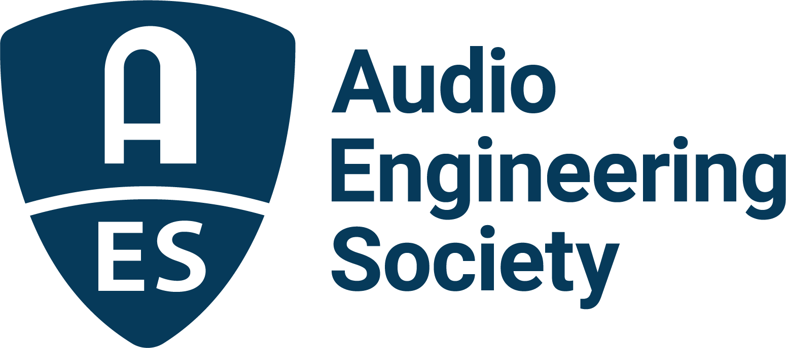

FOR IMMEDIATE RELEASE

AES announces the International Conference on Audio for Virtual and Augmented Reality and Immersive Games (AVARIG2026)

New York, NY, November 6, 2025 — The Audio Engineering Society (AES) has announced its International Conference on Audio for Virtual and Augmented Reality and Immersive Games (AVARIG2026), taking place June 30 through July 3, 2026, at Sorbonne University/d’Alembert and IRCAM/STMS in Paris, France.

Marking the first time that AES’s landmark AVAR conference will be hosted in Europe, AVARIG2026 expands on the legacy of the Audio for Virtual and Augmented Reality series with the overlapping interests of the Audio for Games conference series by adding a new dimension: Immersive Gaming. This evolution reflects the rapidly converging fields of extended reality (XR), spatial audio and interactive entertainment, and unites these disciplines under the AES Technical Committee on Interactive Media and Games.

Co-chaired by Brian F.G. Katz, CNRS Research Director at Sorbonne Université’s Institute d’Alembert and Editor-in-Chief of the Journal of the AES, and Markus Noisternig, Deputy Director of the STMS Laboratory (IRCAM–CNRS–Sorbonne Université–Ministry of Culture), the conference will gather global experts in spatial and immersive audio, virtual and augmented reality, signal processing, AI for sound, psychoacoustics, game audio and cross-modal interaction, as well as researchers and practitioners developing next-generation tools, standards and experiences for immersive sound across entertainment, research and industry, for four days of papers, workshops, demonstrations and networking.

The program will highlight emerging technologies shaping immersive sound for XR and interactive media — from dynamic spatial rendering and perceptual modeling to hybrid approaches blending acoustics and game audio. Researchers, developers and creative professionals will explore how innovations in audio contribute to realism, emotion and interactivity across both artistic and commercial contexts.

Brian Katz commented, “We are thrilled to bring the AES’s leading platform for immersive audio research to Europe for the first time. AVARIG2026 represents a milestone in how we think about sound in extended realities — not just as a layer of experience, but as a core driver of presence, emotion and engagement. By joining forces with the immersive gaming community, we’re opening the door to groundbreaking collaborations that will shape the future of interactive sound.”

The event will be hosted jointly between Sorbonne Université/d’Alembert and IRCAM/STMS, institutions renowned for their contributions to both scientific and artistic frontiers in sound. Conference content will include technical papers, poster sessions, live demonstrations and immersive audio experiences, all set around the heart of Paris’s historic Latin Quarter, a fitting setting for an exploration of sound innovation and creativity.

AVARIG2026 is presented with the support of the Sonicom EU project, an initiative dedicated to transforming auditory-based social interaction and communication in AR/VR environments. More information on paper submission, registration and sponsorship opportunities will be announced in the coming months.

Photo File 1: AVARIG.JPG
Photo Caption 1: The AES International Conference on Audio for Virtual and Augmented Reality and Immersive Games (AVARIG2026) will take place June 30 through July 3, 2026, at Sorbonne University/d’Alembert and IRCAM/STMS in Paris, France.

About the Audio Engineering Society
For more than 75 years, the Audio Engineering Society has served as the pivotal force in fostering the advancement in audio technologies and application and the dissemination of technical information for the audio community. Its members are affiliated with 90 AES professional sections and more than 120 AES student sections around the world where activities include guest speakers, technical tours, demonstrations, online events and social functions. Through Conventions, Conferences, Training and Development events and peer-reviewed publications, as well as the Society’s vast online technical documents, Standards and video resources, members experience valuable opportunities for professional networking and personal growth. For additional information, visit AES.org.

Join the conversation and keep up with the latest AES News and Events:
X: #AESorg (AES Official)
Facebook: facebook.com/AES.org
LinkedIn: https://www.linkedin.com/company/audio-engineering-society
Instagram: https://www.instagram.com/aes_org/

AES Marketing Communications:
Email: robert@clynemedia.com
Tel: 615-300-4666
Clyne Media, Inc.,
169-B Belle Forest Circle, Nashville, TN 37221;
Web: http://www.clynemedia.com

