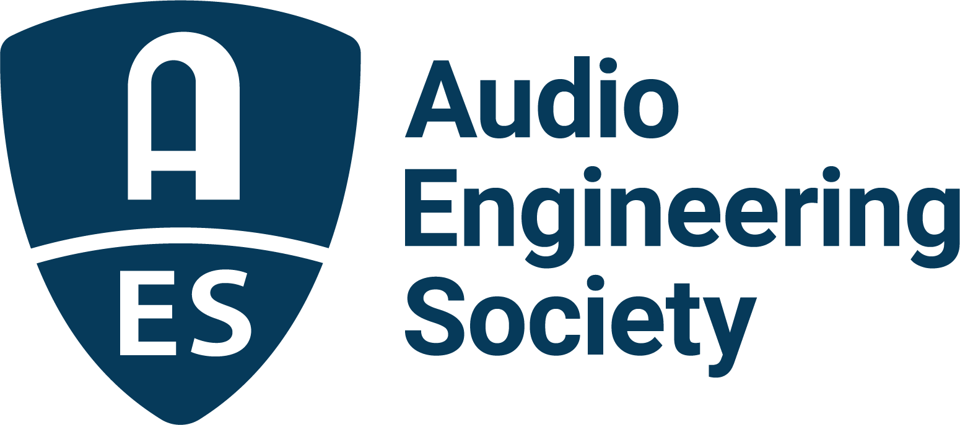

FOR IMMEDIATE RELEASE

Audio Engineering Society opens submissions for 6th International Conference on Audio for Virtual and Augmented Reality and Immersive Games

New York, NY, February 11, 2026 — The Audio Engineering Society (AES) has announced details for its 6th International Conference on Audio for Virtual and Augmented Reality and Immersive Games (AVARIG2026), taking place in Europe and including immersive game audio for the first time, June 30 – July 3, 2026, at Sorbonne University/d'Alembert and IRCAM/STMS in Paris, France.

Submissions for peer-reviewed papers, extended summaries, workshops and tutorials are now being accepted through March 24, 2026. Accepted contributions will be included in the AES E-Library and considered for a special Journal of the Audio Engineering Society issue following the conference.

The event is being organized by Conference co-chairs Brian F.G. Katz (CNRS Research Director at Sorbonne Université, Institute d’Alembert) and Markus Noisternig (Deputy Director of the STMS Laboratory [IRCAM–CNRS–Sorbonne Université–Ministry of Culture]). “AVARIG2026 represents a milestone in how we think about the role of audio in extended realities and interactive entertainment,” said Katz. “By converging communities focused on virtual and augmented reality with those in immersive games, we’re fostering collaborations that will help shape future tools, standards and creative experiences.”

Sponsorship opportunities are currently available, with conference registration opening soon. For details on submissions, programming, and how to participate, visit AES.org.

Hosted jointly by Sorbonne Université / d’Alembert and IRCAM / STMS, AVARIG2026 will bring together researchers, developers and audio professionals from around the world to explore cutting-edge innovations in spatial sound, audio signal processing, psychoacoustics, AI for audio and interactive media. The conference program will blend single- and dual-track sessions, technical papers, poster presentations, live demonstrations and immersive audio experiences, giving attendees a comprehensive platform to connect, collaborate and contribute to the ongoing evolution of immersive audio.

Link: https://aes.org/events-calendar/2026-6th-international-conference-on-audio-for-virtual-and-augmented-reality-and-immersive-games/

Photo File 1: AVARIG2026.JPG
Photo Caption 1: The Audio Engineering Society (AES) has announced details for its 6th International Conference on Audio for Virtual and Augmented Reality and Immersive Games (AVARIG2026), taking place June 30 – July 3, 2026, at Sorbonne University/d'Alembert and IRCAM/STMS in Paris, France.

About the Audio Engineering Society
For more than 75 years, the Audio Engineering Society has served as the pivotal force in fostering the advancement in audio technologies and application and the dissemination of technical information for the audio community. Its members are affiliated with 90 AES professional sections and more than 120 AES student sections around the world where activities include guest speakers, technical tours, demonstrations, online events and social functions. Through Conventions, Conferences, Training and Development events and peer-reviewed publications, as well as the Society’s vast online technical documents, Standards and video resources, members experience valuable opportunities for professional networking and personal growth. For additional information, visit AES.org.

Join the conversation and keep up with the latest AES News and Events:
X: #AESorg (AES Official)
Facebook: facebook.com/AES.org
LinkedIn: https://www.linkedin.com/company/audio-engineering-society
Instagram: https://www.instagram.com/aes_org/

AES Marketing Communications:
Email: robert@clynemedia.com
Tel: 615-300-4666
Clyne Media, Inc.,
169-B Belle Forest Circle, Nashville, TN 37221;
Web: http://www.clynemedia.com

