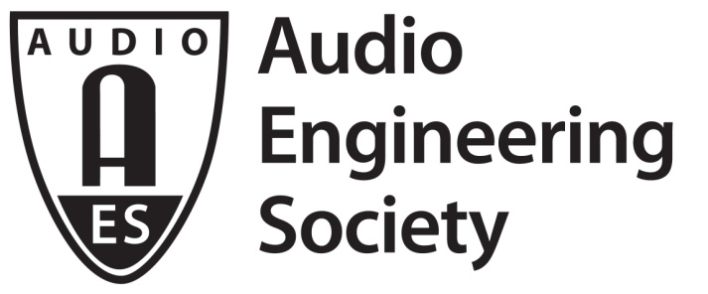

FOR IMMEDIATE RELEASE

AES New York 2018 Detailed Technical Program Calendar of Presentations and Events Now Online

— The AES New York Convention will celebrate the Audio Engineering Society’s 70 years of pro audio innovation with over 330 sessions and workshops —

New York, NY, August 31, 2018 — The AES New York 2018 Technical Program – the highlight of the AES’s 70th Anniversary year – offers the ultimate audio experience, spanning all audio specialties and topics, and digging as deep as it is wide. The AES has posted online its detailed, interactive AES New York 2018 calendar of events for attendees to explore when planning their AES convention experience. The more than 330 presentations and workshops – offering an inside look at nearly every facet of the audio engineering industry – is available only with All Access registration. There’s no better opportunity to listen, learn and connect with audio engineers from around the world than the AES New York 145th International Convention, being held October 17 – 20 at the Jacob Javits Center. Visit aesshow.com for the complete schedule of events.

The comprehensive Technical Program content, brought together by the organizing team led by Co-Chairs Paul Gallo, Valerie Tyler and Jonathan Wyner, includes leading-edge topics like audio for virtual, augmented and extended reality; networked audio; spatial and immersive audio; and game audio, along with core topics including broadcast & online delivery; sound reinforcement; recording & production; audio for cinema; and archiving and restoration. A dedicated track covers product development on the professional level within the product development track, while DIYers can learn and even construct hardware and write code in the new Audio Builders Workshop mini-track. Attendees learn about tomorrow’s technology today in the in-depth Papers and Posters sessions, where the latest in research into all areas of audio is presented.

All Access registration is attendees’ ticket to four full days featuring hundreds of research presentations, workshops and tutorials from the leading audio engineering innovators and practitioners of the audio production arts. All Access badges include admittance to all onsite convention presentations, the exhibition floor, and the Special Events schedule – the complete convention experience, taking attendees’ audio engineering knowledge and understanding to the next level.

AES members receive substantial discounts when registering with online Advance Registration, and Student members receive even deeper discounts. Additional AES Student and Career activities featured at AES New York will include recording and design competitions, an Education and Career Fair, a new MATLAB plugin design competition, and numerous opportunities to network with peers and professionals from around the world. Compare registration options at aes.org/events/145/registration/.

Register now at aesshow.com for Advance Registration pricing and discounts on AES New York partner hotels. Registration at any level for AES New York 2018 includes access to the co-located NAB Show New York exhibition. AES Member and Student Member discounts apply.
...ends 418 words

Photo File: AESNY_Calendar.JPG
Photo Caption: The 2018 AES New York Convention detailed calendar of events

About the Audio Engineering Society
The Audio Engineering Society, celebrating its 70th anniversary in 2018, now counts over 12,000 members throughout the U.S., Latin America, Europe, Japan and the Far East. The organization serves as the pivotal force in the exchange and dissemination of technical information for the industry. Currently, its members are affiliated with 90 AES professional sections and more than 120 AES student sections around the world. Section activities include guest speakers, technical tours, demonstrations and social functions. Through local AES section events, members experience valuable opportunities for professional networking and personal growth. For additional information visit aes.org.

Join the conversation and keep up with the latest AES News and Events:
Twitter: #AESorg (AES Official)
Facebook: facebook.com/AES.org

AES Marketing Communications:
Email: robert.clyne@aes.org
Tel: 615-662-1616, Fax: 615-662-1636,
Clyne Media, Inc.,
169-B Belle Forest Circle, Nashville, TN 37221;
Web: http://www.clynemedia.com

