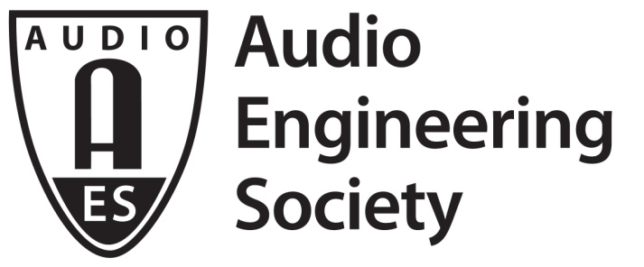

FOR IMMEDIATE RELEASE

AES New York 2018 Convention Set to Take Game Audio to New Worlds

— Audio production for Fortnite, Shadow of the Tomb Raider, Assassin’s Creed Odyssey and Just Cause to be profiled at the 145th International AES Convention Oct 17-20, 2018 —

New York, NY, October 12, 2018 — In reality, the virtual worlds of modern gaming have captured the attention of enormous audiences. The creative minds behind gaming platforms and titles have embraced and driven new technologies as they push the boundaries of imagination. The Audio Engineering Society has been the leading audio production, technology and education organization for the past 70 years, and this year’s AES New York 2018 Convention, taking place October 17 – 20 at the Jacob Javits Center, will again host a exciting program of events outlining the latest in Game Audio and Extended Reality (XR) technologies and practices, along with dedicated presentations covering various aspects of audio production for hit games including Fortnite, Shadow of the Tomb Raider, Assassin’s Creed Odyssey and Just Cause 4. The 145th International Audio Engineering Society Convention is set to present these and other topics head-on over four days of events bringing together industry leaders and game designers for the ultimate behind-the-scenes look at audio production for today’s leading titles.

With registration open to all audio professionals, enthusiasts, students and those interested in related gaming industries, the AES invites you to come Listen, Learn and Connect with some of the most exciting personalities and technologies in the game audio industry today. The Game Audio and XR Track is exclusively available with AES New York 2018 All Access registration. Potential attendees should visit aesshow.com for a complete guide to this year’s events, as well as Advance Registration pricing on All Access badges. If it’s Audio, it’s at AES!

Game Audio engineers and developers are set to present in-depth sessions outlining audio production and considerations for some of today’s most popular games. Looking into the development of the popular Unreal Engine, in “Writing a New Audio Engine for UE4: Innovation Under Pressure” Aaron McLeran of Epic Games will take a look at both previous and next-gen versions of the engine and discuss the launch of the new audio engine on Fortnite’s six platforms without slowing down audio content production or interrupting an ambitious two-week release cadence.

Further Game Audio and XR events highlight other leading games and technologies in the field. In “Just Cause 4: Guns and Music and Mix... oh my!” Avalanche Studios’ Dominic Vega, Jason Kanter and Ronny Mraz will provide insight into the music, weapon sound effects and mix of Just Cause 4, including the approach taken for design and implementation of these systems throughout the game’s massive free-roaming environments. Further, an overview of immersive Dolby Atmos integration in game audio production will be presented by Eidos Montreal’s Rob Bridgett in “Shadow of the Tomb Raider: A Dolby Atmos Video Game Mix Case Study.”

The complexities of open-world interactive dialog will be a topic of discussion in the presentation “A systemic approach to interactive dialogues on Assassin’s Creed Odyssey – from Speech to SFX to Music” by Lydia Andrew and Greig Newby of Ubisoft, while other important aspects of game audio – working with voice-over talent and preparing for a successful recording session – are covered by Blizzard Entertainment’s Andrea Toyias in “Anatomy of Great Voice Over: A Casting & Recording Primer.”

For further information on these and other AES New York Convention Game Audio and XR events, as well as the complete Technical Program of over 300 presentations and experiences covering all things audio and available only with AES New York All Access registration, visit aesshow.com.

About the 2018 AES New York Convention
All Access registration to AES New York 2018 provides four full days of Technical Program sessions, including the Game Audio and XR Track events, papers and posters, workshops and tutorials (October 17-20), while Exhibits-Plus passes give attendees three days of Exhibition Floor showcases and demos (October 17-19). If it’s about audio, it’s at AES – the ultimate opportunity for audio professionals of all specialties and future audio pros to listen, learn and connect!

Register online at aesshow.com for the best possible pricing and options. All Access registration is the ticket to everything the Convention has to offer. AES Members, including student members, enjoy substantial discounts on All Access registration. Registration at any level for AES New York 2018 includes access to the NAB Show New York exhibition. AES New York 2018 Exhibits-Plus registration is complimentary for AES Members and those using the VIP code “AES18NOW” at checkout.

...ends 709 words

Photo File: Fortnite.JPG
Photo Caption: Part of the AES New York 2018 All Access Technical Program’s Game and XR Audio Track, the session “Writing a New Audio Engine for UE4: Innovation Under Pressure” with Aaron McLeran of Epic Games will look into the development of the popular Unreal Engine, both previous and next-gen versions of the engine, and discuss the launch of the new audio engine on Fortnite’s six platforms without slowing down audio content production or interrupting an ambitious two-week release cadence.

About the Audio Engineering Society
The Audio Engineering Society, celebrating its 70th anniversary in 2018, now counts over 12,000 members throughout the U.S., Latin America, Europe, Japan and the Far East. The organization serves as the pivotal force in the exchange and dissemination of technical information for the industry. Currently, its members are affiliated with 90 AES professional sections and more than 120 AES student sections around the world. Section activities include guest speakers, technical tours, demonstrations and social functions. Through local AES section events, members experience valuable opportunities for professional networking and personal growth. For additional information visit aes.org.

Join the conversation and keep up with the latest AES News and Events:
Twitter: #AESorg (AES Official)
Facebook: facebook.com/AES.org

AES Marketing Communications:
Email: robert.clyne@aes.org
Tel: 615-662-1616, Fax: 615-662-1636,
Clyne Media, Inc.,
169-B Belle Forest Circle, Nashville, TN 37221;
Web: http://www.clynemedia.com

