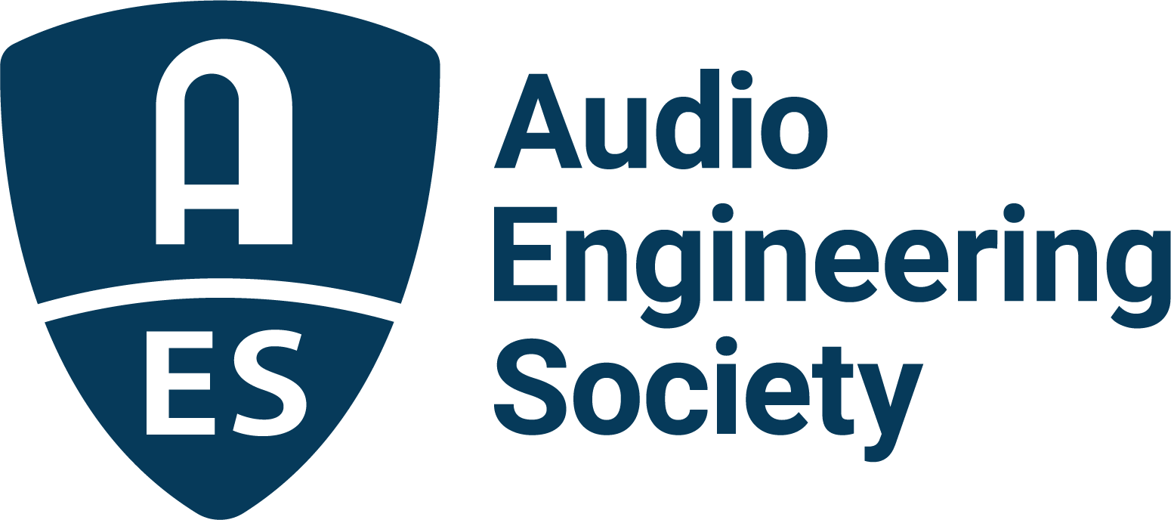

FOR IMMEDIATE RELEASE

AES Announces Equity Learning Series Event: “Immersive and Inclusive – A Discussion of Representation in Immersive Audio”

— AES joins with The Recording Academy’s D.C. Chapter to examine diversity in immersive and spatial audio production —

New York, NY, April 24, 2023 — The Audio Engineering Society continues its AES Equity Learning Series program with the upcoming, “Immersive and Inclusive – A Discussion of Representation in Immersive Audio,” taking place online on Saturday, April 29 from 2:00pm – 3:30pm EDT (USA). Part of the AES’s Diversity, Equity & Inclusion initiative, this educational series helps to promote and educate the audio engineering community on the benefits and challenges of creating a more inclusive environment for all professionals.

This online panel discussion and Q&A will be co-hosted by the AES and the Washington D.C. chapter of The Recording Academy, with funding by a grant from the UK’s University of Surrey. Moderator and AES President-Elect Leslie Gaston-Bird will be joined by an international group of panelists: Erin Barra (Arizona State University / Beats By Girlz), Will Kennedy (Studio Delux at Sound City), Emily Lazar (The Lodge), Carolyn Malachi (Howard University), Marcela Rada (University of Lethbridge) and Mika Sellens (Studio 5B). The event is free (registration required) and open to the entire audio engineering community.

The panel will focus on a series of important topics outlining challenges in the industry related to diversity, equity and inclusion, with some of the most prevalent issues to be discussed being access to immersive content creation tools and other barriers such as industry gatekeeping. Panelists will offer insights on appropriate recruitment practices and what gatekeepers can do to help strengthen the overall audio community.

Additionally, the role of mentorship and providing diverse and varied mentorship opportunities will be highlighted, along with ways industry leaders and organizations can help to create a more inclusive and welcoming industry. Panelists will also reveal challenges and successes with industry initiatives such as the #WomenInTheMix campaign, artist pledges, and research into qualitative data that sheds light on a clearer path to possible improvements in the community. A live Q&A session will conclude the event.

Panelists bios, topics and registration available here.

…ends 313 words

Link:
Equity Learning Series Event: Immersive and Inclusive – A Discussion of Representation in Immersive Audio

Photo File 1: Immersive_Inclusive_panel.jpg
Photo Caption 1: The AES will hold its next Equity Learning Series event, “Immersive and Inclusive – A Discussion of Representation in Immersive Audio,” on Saturday, April 29 with panelists Erin Barra, Will Kennedy, Emily Lazar, Carolyn Malachi, Marcela Rada and Mika Sellens. The online event is free (registration required) and open to the entire audio engineering community.

Photo File 2: LeslieGaston-Bird.jpg

Photo Caption 2: President-Elect Leslie Gaston-Bird will moderate the AES Equity Learning Series online event, “Immersive and Inclusive – A Discussion of Representation in Immersive Audio.”

About the Audio Engineering Society
The Audio Engineering Society celebrates 75 years of audio excellence in 2023. Serving as the pivotal force in fostering the development and dissemination of technical information for the audio community, its members are affiliated with 90 AES professional sections and more than 120 AES student sections around the world where activities include guest speakers, technical tours, demonstrations, online events and social functions. Through Conventions, Conferences, Training and Development, Member Events and peer-reviewed Publications, as well as the Society’s vast online technical document, Standards and video resources, members experience valuable opportunities for professional networking and personal growth. For additional information, visit AES.org.

Join the conversation and keep up with the latest AES News and Events:
Twitter: #AESorg (AES Official)
Facebook: facebook.com/AES.org
LinkedIn: https://www.linkedin.com/company/audio-engineering-society
Instagram: https://www.instagram.com/aes_org/

AES Marketing Communications:
Email: robert.clyne@aes.org
Tel: 615-662-1616
Clyne Media, Inc.,
169-B Belle Forest Circle, Nashville, TN 37221;
Web: http://www.clynemedia.com

