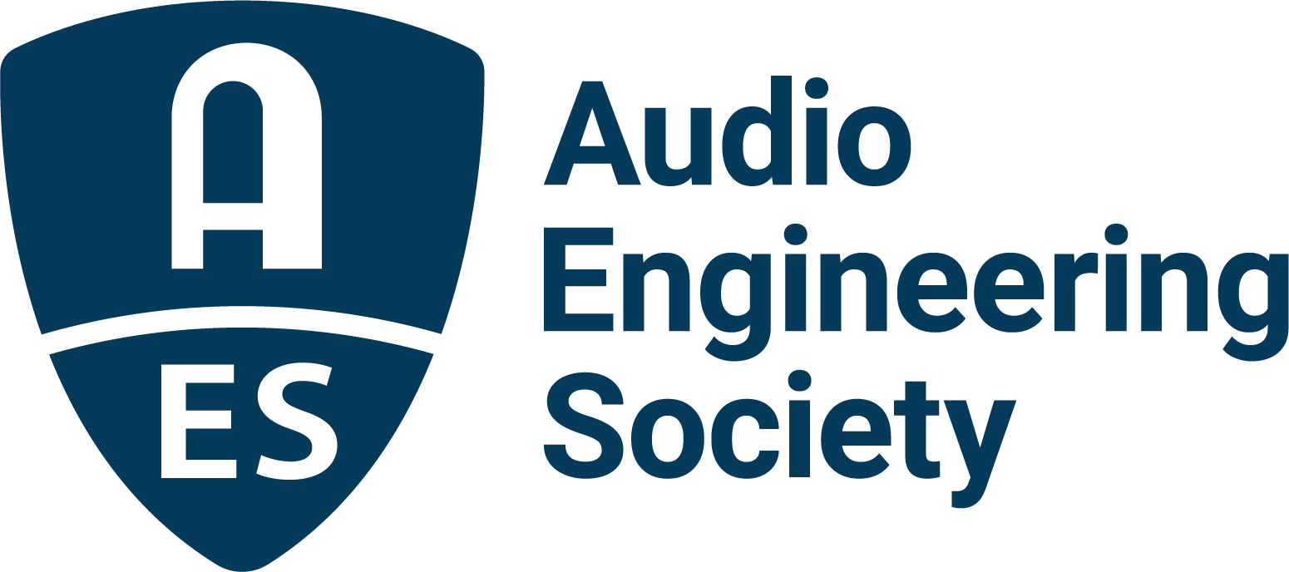

FOR IMMEDIATE RELEASE

The AES Celebrates 75 Years of Audio Innovation in 2023

— The Society’s vast contributions to the art and science of audio engineering are being recognized as the Audio Engineering Society begins its 75th Anniversary year —

New York, NY, January 12, 2023 — In March of 1948, a group of notable engineers committed to improving audio quality held the first meeting of the Audio Engineering Society in New York City. Now, in its 75th Anniversary year, the AES has grown from a charter membership of 37 to a global community of more than 10,000 members affiliated with hundreds of local sections worldwide. The goal of those pioneering members, to share knowledge and advance the science of audio and its application, has been realized in a thriving organization that facilitates communication and collaboration, and unites audio engineers, researchers, content creators and students.

The AES’s 75th Anniversary year begins with the landmark announcement that the Society is being honored by the Recording Academy with a 2023 Technical GRAMMY® Award acknowledging its “contributions of outstanding technical significance to the recording field.”

“The Audio Engineering Society is the only professional society devoted exclusively to advancing audio science, technology and its application,” states AES President Bruce Olson. “The AES has created an amazing community of like-minded, industry-leading professionals along with partner firms and organizations who share their knowledge and experience to improve audio quality. That community has come together and grown across 153 International Conventions since the first took place in 1949, alongside an impressive slate of single-topic-focused International Conferences and application-oriented Academies, as well as the events held by our local sections. Our community has an ongoing and incalculably positive impact on not only professional audio production but wherever audio is created and heard.”

Wherever milestones in audio technology have been laid, the AES has been intimately involved as a perennial driving force by providing the forum for new ideas to be shared and refined as the foundation for next generation products. From the introduction of the large-hole 45 rpm 7-inch record at its first Convention through the debut of surround sound (in 1953!), “Sel-Sync” overdubbing, tape-based noise reduction, the MIDI standard, and the CD and MP3, to evolving digital interconnectivity protocols such as AES10 (MADI), audio distribution by broadcast and physical media and file based distribution, and then digital streaming, the AES is where professionals join together to push boundaries ever further. That drastically compressed list highlights just a few of the milestones being constantly augmented by the AES as technology progresses. The latest areas of advancement include immersive audio technologies, audio for virtual and augmented reality, and the audio applications of artificial intelligence.

The AES provides continuity and drives innovation through local section and regional events, international conferences and conventions, and its online and searchable technical archives – the world’s most comprehensive collection of audio knowledge which includes an ever-growing E-Library housing more than 20,000 technical documents and peer-reviewed papers, the archived Journal of the Audio Engineering Society, AES Standards and Technical Documents, and hundreds of educational and inspirational videos.

The AES sets Standards and defines best practices that create a foundation for new audio technologies to take root and flourish, ensure the interoperability of equipment, improve performance and productivity for audio professionals and enhance the end-user experience. The Society’s heavy emphasis on student education promotes its mission, nurturing successive generations of audio professionals.

“The AES is most noticeably a member-led organization,” says Olson. “Our Society relies on the motivation of shared interest and the benefits of group effort to draw together top audio researchers and engineers, academics, system designers, students and manufacturers. I never cease to be amazed at the fruits of our membership’s labors. Our members generously sharing their time, knowledge and experience is what’s made the AES the world’s preeminent audio organization.”

In 2023 the Audio Engineering Society will continue its mission with events planned around the world throughout the year, culminating in the 155th AES International Convention in New York in October. More on the many resources available to AES members, how to join the Society and upcoming AES events is available at AES.org.

AES 75th Anniversary Year Events:

AES Europe 2023 Convention, being held at Aalto University, Espoo, near Helsinki, Finland, May 13 – 15.

AES Conference on Audio Archiving, Preservation and Restoration at the U.S. Library of Congress National Audiovisual Center in Culpeper, Virginia, U.S.A, June 1 – 3.

AES International Conference on Spatial and Immersive Audio at the University of Huddersfield, United Kingdom, August 23 – 25.

AES International Conference on Audio Education taking place at PXL-Music in Hasselt, Belgium, September 6 – 8.

AES New York 2023 Convention at the Javits Center in New York City, New York, October 25 – 27.

…ends 739 words

Photo File 1: AES_75th_Anniversary_logo.PNG
Photo Caption 1: The Audio Engineering Society celebrates 75 years of audio innovation in 2023

Photo File 2: JAES.JPG
Photo Caption 2: An early edition of the Journal of the Audio Engineering Society invites the audio community to be a part of the first AES Convention which took place at the New Yorker hotel in October of 1949.

Photo File 3: AES_Banquet.JPG
Photo Caption 3: Attendees gather for a banquet during the 5th annual AES Convention banquet in New York, October, 1953.

Photo File 4: Antonoff_Keynote.JPG
Photo Caption 4: Jack Antonoff, winner of the 2022 GRAMMY® Award for Producer of the Year. Non-Classical, addresses the audience at his Keynote during the AES New York 2022 Convention

Photo File 5: Case_Keynote.JPG
Photo Caption 5: Alex Case, then AES President-Elect, presents the keynote address during the opening ceremonies of AES Europe Convention in Paris, France in 2016.

Photo File 6: AES_Exhibits.JPG
Photo Caption 6: Attendees pack the bustling AES New York 2018 Convention exhibition floor, which featured over 300 brands of the latest gear and services showing their new and most popular offerings.

About the Audio Engineering Society
The Audio Engineering Society celebrates 75 years of audio excellence in 2023. Serving as the pivotal force in fostering the development and dissemination of technical information for the audio community, its members are affiliated with 90 AES professional sections and more than 120 AES student sections around the world where activities include guest speakers, technical tours, demonstrations, online events and social functions. Through Conventions, Conferences, Training and Development, Member Events and peer-reviewed Publications, as well as the Society’s vast online technical document, Standards and video resources, members experience valuable opportunities for professional networking and personal growth. For additional information, visit AES.org.

Join the conversation and keep up with the latest AES News and Events:
Twitter: #AESorg (AES Official)
Facebook: facebook.com/AES.org
LinkedIn: https://www.linkedin.com/company/audio-engineering-society
Instagram: https://www.instagram.com/aes_org/

AES Marketing Communications:
Email: robert.clyne@aes.org
Tel: 615-662-1616
Clyne Media, Inc.,
169-B Belle Forest Circle, Nashville, TN 37221;
Web: http://www.clynemedia.com

