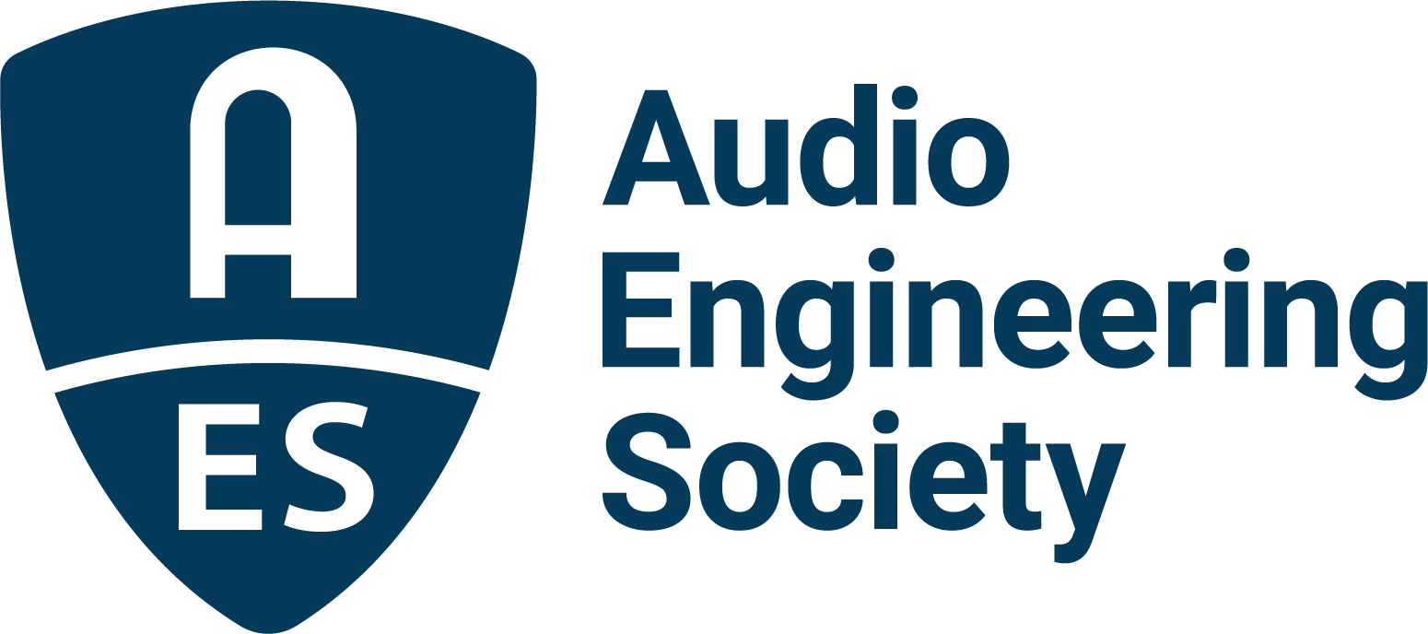

FOR IMMEDIATE RELEASE

AES Delivers in New York and Announces 2023 Anniversary Year Events

— The Audio Engineering Society’s recent 153rd International Convention generates industry enthusiasm as the Society heads into its 75th Anniversary year —

New York, NY, November 28, 2022 — Welcoming a stellar audience of attendees ready to return to international-scale events, the recent AES New York 2022 Convention – the Society’s first in-person U.S. convention in three years – drew unilateral acclaim as an industry homecoming.

With registration for the co-located 2022 NAB Show New York drawing a combined audience of 16,500+ content creation professionals, AES New York 2022 offered an array of audio engineering events and learning opportunities highlighting the past, present and future of audio. Alongside the AES New York Convention’s wealth of cutting-edge presentations and workshops, attendees were able to catch up with the latest tech gear and services from over 100 brands on the show floor.

Several prominent audio manufacturers took their AES New York presence to the next level, hosting a variety of exhibition floor events and opportunities that exemplified the industry’s support and encouragement for the current and up-and-coming audio professionals, students and enthusiasts who packed the aisles. Two such attractions were the Avid Partner Pavilion, which showcased the latest workflow and capability-extending technologies from Avid partners, and the Media Over IP Pavilion, which hosted demonstrations and solutions hosted by the Alliance for Media Solutions (AIMS). Emphasizing their commitments to the next generation of audio professionals, JBL generously provided an extensive monitoring system for the Student Recording Competition and additional sessions requiring high-performance playback, while Genelec sponsored the Convention’s Education Center area.

Additional exhibitor and sponsor contributions to Convention learning opportunities were exemplified by Allen & Heath’s hosting of onsite console training, while Neumann showcased a Dolby Atmos™ demonstration room where numerous immersive audio experience sessions took place. Mix with the Masters also brought their popular series of engineer- and producer-led presentations to a standing-room only crowd. Additionally, a variety of educational and inspirational sessions took place throughout the show on the AES Academy Stage, which featured additional support from show partners Dell, Iron Mountain Entertainment Services (IMES), the Recording Academy Producers & Engineers Wing, and Qualcomm.

“Our enthusiastic and ever-supportive industry partners and sponsors have truly, once again, made the AES Convention an unparalleled experience,” enthused AES New York 2022 Convention chair Jonathan Wyner. “From inspiring and motivating our AES Student Members to audio demonstrations that explore the cutting edge of today’s technology and offer glimpses into audio’s future, the AES is proud to be a converging point for technology, creatives and audio engineers of every facet. A huge shout-out to JBL and Neumann for creating phenomenal listening spaces in the challenging environment of a convention center. We are truly thankful for the crucial support of all of our partners and can’t wait to build an even bigger AES New York 2023 on this year’s success!”

2023 will mark 75 years since the Audio Engineering Society was founded, and it heads into its 75th anniversary year with an impressive event schedule that builds on the New York Convention’s momentum with three hot-topic-focused international conferences and two international conventions, including a return to Manhattan in October 2023:

AES Europe 2023 Convention, being held at Aalto University, Espoo, near Helsinki, Finland, May 13 – 15.

AES Conference on Audio Archiving, Preservation and Restoration at the U.S. Library of Congress National Audiovisual Center in Culpeper, Virginia, U.S.A, June 1 – 3.

AES International Conference on Spatial and Immersive Audio at the University of Huddersfield, United Kingdom, August 23 – 25.

AES International Conference on Audio Education taking place at PXL-Music in Hasselt, Belgium, September 6 – 8.

AES New York 2023 Convention at the Javits Center in New York City, New York, October 25 – 27.

For the latest AES news, events and membership opportunities, visit AES.org.

…ends 595 words

Photo File 1: AESNY_Show_Floor.JPG
Photo Caption 1: Attendees interact with exhibitors on the bustling show floor during the AES New York 2022 Convention in-person events held at the Javits Center.

Photo File 2: AESNY_Academy_Stage.JPG
Photo Caption 2: A variety of educational and inspirational sessions took place throughout the show on the AES New York 2022 Convention Academy Stage, made possible by support from show partners Dell, Iron Mountain Entertainment Services (IMES), the Recording Academy Producers & Engineers Wing, and Qualcomm.

Photo File 3: AESNY_JBL_Room.JPG
Photo Caption 3: AES New York 2022 Convention partner JBL generously provided an extensive monitoring system for the Student Recording Competition and additional sessions requiring high-performance playback.

About the Audio Engineering Society
The Audio Engineering Society, which will next year celebrate 75 years of audio excellence, serves as the pivotal force in fostering the development and dissemination of technical information for the audio community. Currently, its members are affiliated with 90 AES professional sections and more than 120 AES student sections around the world. Section activities include guest speakers, technical tours, demonstrations, online events and social functions. Through Conventions, Conferences, Training and Development, Member Events and peer-reviewed Publications, as well as the Society’s vast online resources, members experience valuable opportunities for professional networking and personal growth. For additional information, visit AES.org.

Join the conversation and keep up with the latest AES News and Events:
Twitter: #AESorg (AES Official)
Facebook: facebook.com/AES.org
LinkedIn: https://www.linkedin.com/company/audio-engineering-society
Instagram: https://www.instagram.com/aes_org/

AES Marketing Communications:
Email: robert.clyne@aes.org
Tel: 615-662-1616
Clyne Media, Inc.,
169-B Belle Forest Circle, Nashville, TN 37221;
Web: http://www.clynemedia.com

