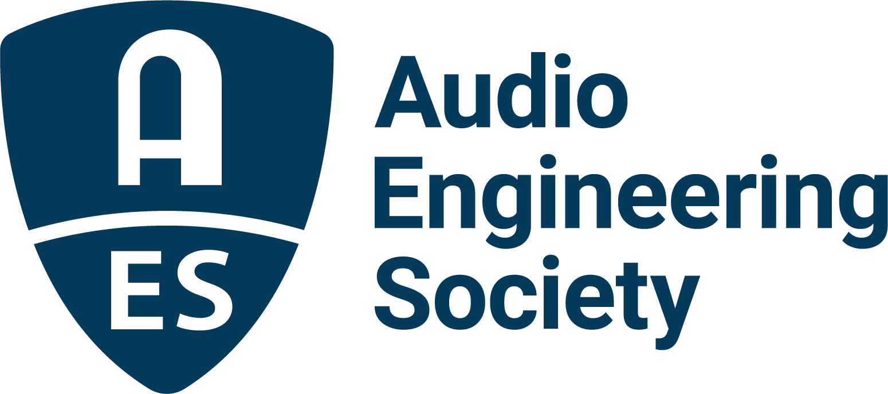

FOR IMMEDIATE RELEASE

AES Offers Membership the Mike Dias-led Human Connection Class “Nobody Likes Networking”

— The three-session, member-exclusive, limited-attendance online course “Nobody Likes Networking: A Practical Human Connection Class for Audio Professionals” begins January 27 —

New York, NY, January 7, 2022 — The Audio Engineering Society invites its membership to join Mike Dias, marketing and sales professional for the international pro audio and consumer electronics communities, as he manifests his passion for teaching people and teams how to effectively build human networks in “Nobody Likes Networking: A Practical Human Connection Class for Audio Professionals.” The member-exclusive, hands-on, three-part online course will break down expanding a network of connections effectively and authentically into simple steps. The course, which begins on Thursday, January 27, 2022, and continues with additional content for two consecutive Thursdays, will provide attendees the tools and confidence needed to turn contacts into relationships and to help attendees advance in their careers and personal lives through helping others succeed.

“Networking isn’t just one potential route to finding a new job — it’s actually the most effective path,” Career Horizons president Matt Youngquist shared in a recent NPR interview. “At least 70 percent, if not 80 percent, of jobs are not published.” That statistic is validated by the U.S. Bureau of Labor Statistics stating in a recent report that “70% of all jobs are found through networking.”

“We get it. You don’t like networking,” states Dias. “Just the mere thought of having to do it makes you feel uncomfortable and uneasy. But you also intuitively know and understand that your career depends on it and that your best jobs and opportunities often come from people you know.”

Dias’ networking philosophy comes from decades of research combined with his experience successfully navigating the music industry and in the effective application of tools like CRM systems to making effective connections. He is a frequent speaker, the author of the “Networking From 6 Feet” column in Pro Sound News and the executive director for the In-Ear Monitor International Trade Organization and vice president of sales for Earthworks Audio.

“Our members rely on the AES to aid in the advancement of their technological knowledge and skills,” says AES Executive Director Colleen Harper. “They have further requested non-technical resources to help them learn and prosper personally and in their careers. Our colleague and AES Member, Mike Dias, has a well-earned reputation for guiding such growth. The Society is simply delighted to offer this enriching series of presentations.”

The course is geared toward audio professionals and taught by audio professionals. It will be practical, applicable and easily approachable, offering concepts that can be put into practice immediately by seasoned veterans, by those just starting their careers and even by those still in school. Registration is now open for the course, consisting of 30-minute classes at 3 PM ET on January 27, February 3 and February 10. Registration is strictly capped at 50 participants, and open only to AES members (Associate and Student Members included). Registration is $50; however, registrants who attend all sessions will have their full registration returned as a credit to their AES account for application to future membership dues or event registrations.

“No one is a natural-born networker,” says Dias. “But skilled networking is a practice that anyone can learn and follow. There is no better time to start investing in yourself and your future than right now – life truly is about who you know!”

Further information is available on the AES.org website event page, including a link to registration. Attendance is strictly limited to the first 50 registrants and, with participation in all sessions, net free with the registration rebate.

…ends 565 words

Photo File 1: Mike–Dias.jpg
Photo Caption 1: Mike Dias, marketing and sales professional for the international pro audio and consumer electronics communities, will lead the three-session, member-exclusive, limited-attendance AES online course “Nobody Likes Networking: A Practical Human Connection Class for Audio Professionals,” beginning January 27

About the Audio Engineering Society
The Audio Engineering Society, celebrating over 70 years of audio excellence, now counts over 12,000 members worldwide. The organization serves as the pivotal force in the exchange and dissemination of technical information for the professional audio community. Currently, its members are affiliated with 90 AES professional sections and more than 120 AES student sections around the world. Section activities include guest speakers, technical tours, demonstrations, online events and social functions. Through Conventions, Conferences, Training and Development, and Member Events, as well as the Society’s vast online resources, members experience valuable opportunities for professional networking and personal growth. For additional information, visit aes.org.

Join the conversation and keep up with the latest AES News and Events:
Twitter: #AESorg (AES Official)
Facebook: facebook.com/AES.org

AES Marketing Communications:
Email: robert.clyne@aes.org
Tel: 615-662-1616
Clyne Media, Inc.,
169-B Belle Forest Circle, Nashville, TN 37221;
Web: http://www.clynemedia.com

