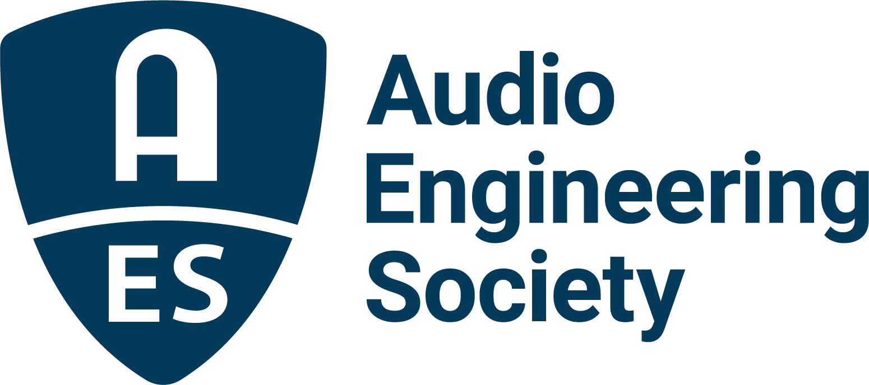

FOR IMMEDIATE RELEASE

Program Details and Keynotes Announced for AES Mastering Academy 2

— The art and science of mastering take focus in follow-up event to last year’s inaugural AES Mastering Academy —

New York, NY, March 15, 2022 — The AES has announced the program of events and presenters for the upcoming AES Mastering Academy 2, taking place online, March 21. This second-in-series AES Training and Development event dives deeper into the art of mastering with presentations from a wide-range of industry professionals who will provide experience, knowledge, advice and guidance to attendees.

The AES Mastering Academy 2 will begin with a masterclass hosted by Bob Katz titled “When to Reach for Analog,” followed by an Immersive Mastering masterclass with Justin Gray, Darcy Proper and Michael Romanowski. The afternoon concludes with the session “Masters Deconstructed,” in which presenters Michelle Mancini (Demifugue Mastering at Larrabee Studios, artist roster includes Jon Batiste, Oliver Tree, Demi Lovato, Álvaro Soler, Royal & the Serpent) and Luca Pretolesi (Studio DMI, artist roster includes Steve Aoki, Diplo, David Guetta, J Balvin, Snoop Lion) walk attendees through a mastering project, from assessment through delivery. The Academy concludes with an attendee networking session utilizing the Gather platform for real-time interaction via text and audio.

Registration for the AES Mastering Academy 2 is open, starting at just $49 for AES Members ($25 for AES Student Members), which includes access to presentation playback through May 21. Learn more and register at aes2.org/events-calendar/16305/.

…ends 203 words

Photo File 1: AES_Mastering_Academy_2.JPG
Photo Caption 1: The AES Mastering Academy 2 will delve into the art and science of audio mastering on March 21, 2022.

About the Audio Engineering Society
The Audio Engineering Society, celebrating over 70 years of audio excellence, serves as the pivotal force in fostering the development and dissemination of technical information for the audio community. Currently, its members are affiliated with 90 AES professional sections and more than 120 AES student sections around the world. Section activities include guest speakers, technical tours, demonstrations, online events and social functions. Through Conventions, Conferences, Training and Development, Member Events and peer-reviewed Publications, as well as the Society’s vast online resources, members experience valuable opportunities for professional networking and personal growth. For additional information, visit AES.org.

Join the conversation and keep up with the latest AES News and Events:
Twitter: #AESorg (AES Official)
Facebook: facebook.com/AES.org
LinkedIn: https://www.linkedin.com/company/audio-engineering-society
Instagram: https://www.instagram.com/aes_org/

AES Marketing Communications:
Email: robert.clyne@aes.org
Tel: 615-662-1616
Clyne Media, Inc.,
169-B Belle Forest Circle, Nashville, TN 37221;
Web: http://www.clynemedia.com

