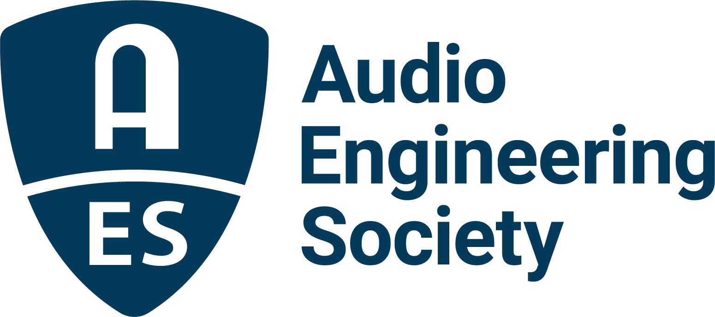

FOR IMMEDIATE RELEASE

Registration Opens for AES Europe Spring 2022 In-Person and Online Convention Events

— Audio Engineering Society set to return to in-person exhibits and presentations at 152nd International Convention, with a full slate of online content to follow —

New York, NY, February 10, 2022 — Registration is now open for the AES Europe Spring 2022 Convention, taking place in-person May 7 – 8 at the Royal Conservatoire, The Hague, Netherlands, and online, May 16 – 19. Featuring the latest in audio engineering technology and innovations, the AES Europe Convention will offer a host of ways to “Listen, Learn, and Connect” with audio peers and pros first in-person, then with additional online programming offering unparalleled access for attendees worldwide. For attendees wanting to have their work featured during the Convention the call for submissions remains open through February 15.

This 152nd International Audio Engineering Society Convention marks the Society’s return to in-person events, offering a variety of presentation formats, from Papers and E-Briefs, to Workshops, Tutorials, Keynotes, Poster sessions and more, being organized by in-person Convention chair Bert Kraaijpoel. Additionally, the in-person experience will include a product showcase featuring gear and software from AES Europe partners, as well as networking opportunities, recording critiques and student and education-focused events. During the online portion of the Convention, being organized by online Convention chair Rafael Kassier, an expansive slate of additional technical program presentations will be streamed to a global audience with opportunities for interactive discussion, Q&A and other ways to connect. The growing list of sponsors for AES Europe Spring 2022 includes Eventide, Genelec, Harman, NAT and Sonoris.

Visit AESEurope.com to register now to attend in-person, online or both, available at a discounted rate.

…ends 234 words

Photo File 1: AES_Europe_Spring_2022_Convention.JPG
Photo Caption 1: The AES Europe Spring 2022 Convention will take place in-person May 7 – 8 at the Royal Conservatoire, The Hague, Netherlands, and online, May 16 – 19. Registration is now open at AESEurope.com.

Photo File 2: Rafael_Kassier.JPG
Photo Caption 2: AES Europe Spring 2022 Convention co-chair Rafael Kassier

Photo File 3: Bert_Kraaijpoel.JPG
Photo Caption 3: AES Europe Spring 2022 Convention co-chair Bert Kraaijpoel

About the Audio Engineering Society
The Audio Engineering Society, celebrating over 70 years of audio excellence, serves as the pivotal force in fostering the development and dissemination of technical information for the audio community. Currently, its members are affiliated with 90 AES professional sections and more than 120 AES student sections around the world. Section activities include guest speakers, technical tours, demonstrations, online events and social functions. Through Conventions, Conferences, Training and Development, Member Events and peer-reviewed Publications, as well as the Society’s vast online resources, members experience valuable opportunities for professional networking and personal growth. For additional information, visit aes.org.
Join the conversation and keep up with the latest AES News and Events:
Twitter: #AESorg (AES Official)
Facebook: facebook.com/AES.org

AES Marketing Communications:
Email: robert.clyne@aes.org
Tel: 615-662-1616
Clyne Media, Inc.,
169-B Belle Forest Circle, Nashville, TN 37221;
Web: http://www.clynemedia.com

