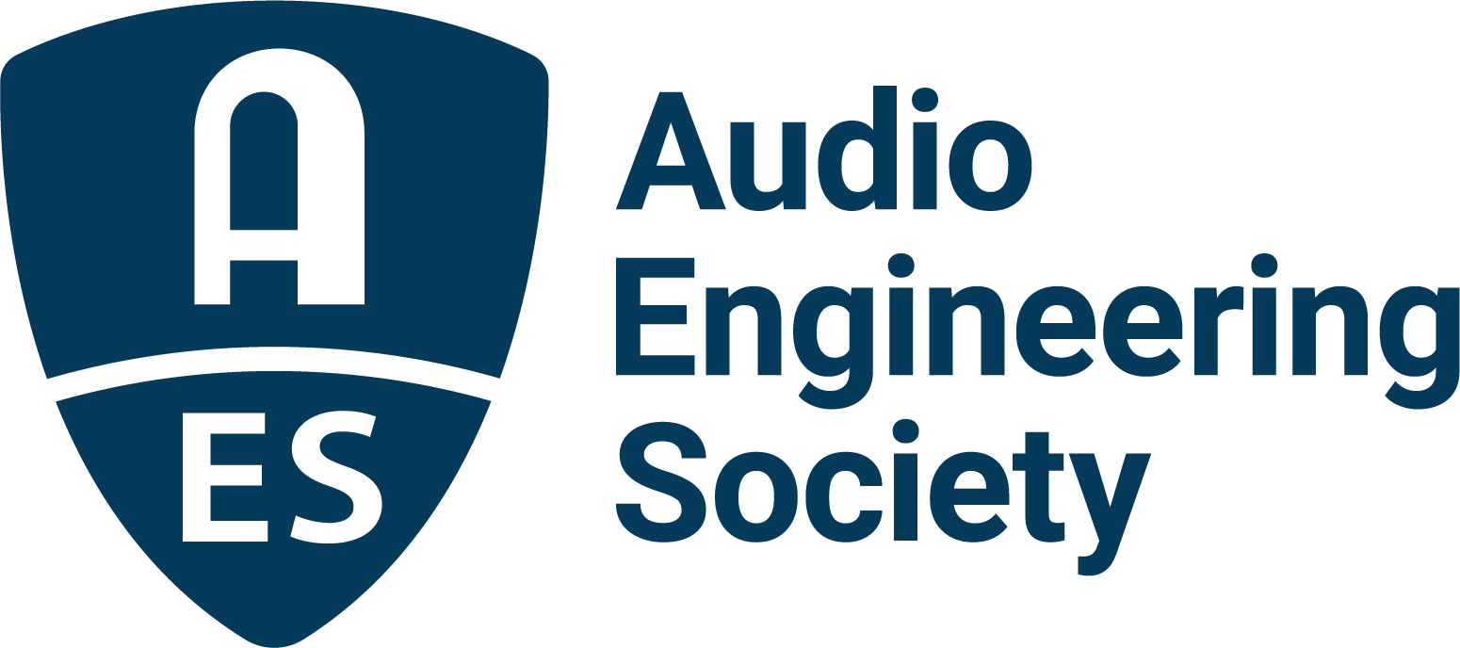

FOR IMMEDIATE RELEASE

AES Europe Spring 2022 Convention Preliminary Program Details and Extended Early Bird Registration Announced

— The AES marks its return to in-person events this May in The Hague, with exclusive content to follow in interactive online event —

New York, NY, April 5, 2022 — The Audio Engineering Society has announced Technical Program details for the upcoming AES Europe Spring 2022 Convention, taking place in-person, May 7 – 8 at the Amare, Royal Conservatoire, The Hague, Netherlands, and online, May 16 – 19. Immersive Audio, Signal Processing, Acoustics and Listening Environments, Electronic Music Performance, Microphone Techniques, Archiving and Restoration and Audio Measurement are among the topics covered in over 100 workshops and presentations featured across the in-person and online components of the 152nd International AES Convention, with both components featuring distinct content and experiences. Best registration pricing for in-person, online and bundled experiences is available through April 11, with additional discounts for AES Members and AES Student Members, at AESEurope.com.

The AES community is eager for the return of the familiar and invaluable aspects of an in-person event. As attendees from across the globe gather in The Hague, this first in-person AES Convention event in two years promises to deliver face-to-face interaction with both peers and the leading minds in the industry, including such noted presenters as Tom Ammerman, Paul Geluso, Brad McCoy, Claire Lim, Thomas Lund, Agnieszka Roginska and Nadja Wallaszkovits. Workshops, Tutorial presentations, panel discussions and select Papers and Engineering Briefs Poster Sessions pack the two-day schedule. Highlights include the Convention’s keynote address on Saturday to be given by Kees Tazelaar – who created a pioneering immersive audio experience for the 1958 Brussels World’s Fair – and Saturday’s live Heyser Lecture “Wave Field Synthesis – Just a Wave … or a Durable Synthesizer in the Audio Field?” which will be presented by Diemer de Vries (a reprise of the Heyser Lecture is scheduled during the Convention’s online portion).

The schedule at The Hague has been designed to maximize networking opportunities. Early arrivals can register for a Friday late-afternoon behind-the-scenes tour of the host venue, which serves as the home to the Royal Conservatoire, Residentie Orkest and the Nederlands Dans Theater, while events tailored for AES Student Members include special Master Class sessions, Mix Critiques, dedicated social time and more.

May 16 – 19, the AES Europe Spring 2022 Convention Online will offer additional exclusive Technical Program offerings, Papers and Engineering Briefs presentations, Partner Presentations and online networking opportunities. Streamed presentations will remain available for on-demand replay for a limited time after the Convention.

The AES Europe Spring 2022 Convention Committee includes Bert Kraaijpoel, Ben Kok and Ulrike Schwarz (The Hague), Nils Peters and Jamie Angus-Whiteoak (The Hague and Online) and Rafael Kassier and Katharina Pollack (Online).

Technical Program details and registration are available now at AESEurope.com.

AES Europe Convention partners include Eventide, Genelec, Harman, New Audio Technology, Prism Sound, Sonoris, and Steinberg.

…ends 433 words

Photo File 1: AES_Europe_2022.JPG
Photo Caption 1: The AES Europe Spring 2022 Convention will take place in-person, May 7 – 8 at the Amare, Royal Conservatoire, The Hague, Netherlands, and online, May 16 – 19. Registration is now open at AESEurope.com.

The AES Welcomes You to The Hague
The Audio Engineering Society has chosen The Hague for its 152nd International Convention as a central hub of commerce, arts and travel, located conveniently near to Amsterdam’s popular Schiphol Airport, among other easy transportation options. Whether attending your first AES Convention, coming again as a dedicated attendee or presenting your own work to the enthusiastic gathering of attendees from around the world, this year’s return to in-person AES events in The Hague presents a prime opportunity to “Listen, Learn and Connect” with peers and pros in an easily accessible and culturally rich environment. The AES invites you to enjoy our spectacular venue and surrounding area, dotted with gardens and canals, world-class museums and art, restaurants, shops and more. Join us as we celebrate the best in audio art, science and education at the AES Europe Spring 2022 Convention.

About the Audio Engineering Society
The Audio Engineering Society, celebrating over 70 years of audio excellence, serves as the pivotal force in fostering the development and dissemination of technical information for the audio community. Currently, its members are affiliated with 90 AES professional sections and more than 120 AES student sections around the world. Section activities include guest speakers, technical tours, demonstrations, online events and social functions. Through Conventions, Conferences, Training and Development, Member Events and peer-reviewed Publications, as well as the Society’s vast online resources, members experience valuable opportunities for professional networking and personal growth. For additional information, visit AES.org.

Join the conversation and keep up with the latest AES News and Events:
Twitter: #AESorg (AES Official)
Facebook: facebook.com/AES.org
LinkedIn: https://www.linkedin.com/company/audio-engineering-society
Instagram: https://www.instagram.com/aes_org/

AES Marketing Communications:
Email: robert.clyne@aes.org
Tel: 615-662-1616
Clyne Media, Inc.,
169-B Belle Forest Circle, Nashville, TN 37221;
Web: http://www.clynemedia.com

