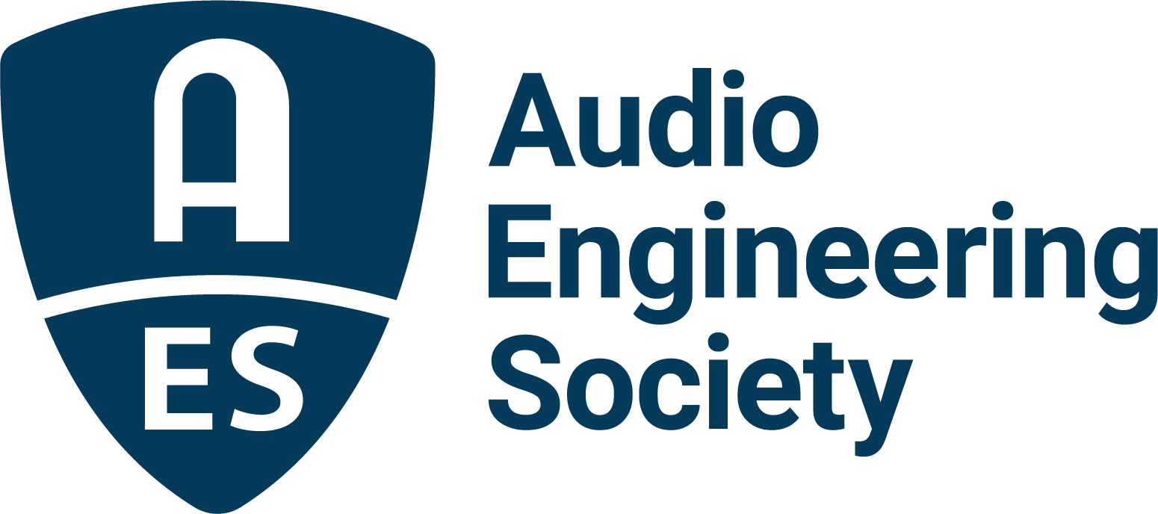

FOR IMMEDIATE RELEASE

AES Europe Spring 2022 In-Person Convention Set to Inform, Educate and Inspire in The Hague, May 7 - 8

— Attendees are set to take in a world of all-things-audio at the 152nd International AES Convention —

New York, NY, May 5, 2022 — The AES Europe Spring 2022 Convention begins this week with the Audio Engineering Society’s return to in-person events, May 7 – 8 in The Hague, Netherlands. “The AES Europe 152nd Convention venue is the brand-new Amare building and The Royal Conservatory will be our host as it opens its studios and halls for us, including technical tours and demos,” states AES Europe Spring 2022 Convention in-person event chair Bert Kraaijpoel. “The convention program is interesting for both students and professionals, with workshops, paper presentations in poster sessions, tutorials, master classes and social events. To mention but a few: Diemer de Vries will deliver the Heyser Lecture on Wave Field Synthesis and its current applications; Kees Tazelaar will present the historical Keynote “le poème électronique; and Ian Corbett has put together a fantastic team for the Student Mix Critiques (don’t forget to bring a memory stick carrying your mix!). We are looking forward to seeing you all ‘in person’ again!”

Audio engineers, musicians, producers, manufacturers, students and industry pros will once again connect face-to-face to build core knowledge, learn advanced techniques, gain insights into future tech, and network for skill and career advancement. The exclusive onsite content will not be live streamed or available on demand after the show; in-person attendance is the only way to join delegates and presenters from companies including Eventide, Genelec and JBL/Harman for two days of intensive education and networking.

AES Europe Workshops co-chair, Ben Kok, states: “Like many others, I am looking forward to meeting many of our professional friends again. Due to the pandemic, it will be the first in-person meeting in a long time. In recognition of this aspect, one of our goals was to offer maximum personal interaction between attendees, so we decided on poster presentations for the papers and we worked to synchronize the breaks between the multitude of workshops and tutorials. We also kept the breaks a bit longer than usual to allow for more time for informal meetings in between.”

Ulrike Schwarz, AES Europe Workshops co-chair, shares: “What a joy to hold this AES Convention in-person again. We are very happy to welcome everybody at the Royal Conservatory in The Hague to experience workshops from past presidents and trail blazers Agnieszka Roginska on immersive audio objects and Nadja Wallaszkovits on audio preservation, learn immersive mixing with Tom Ammerman, hear complementary lectures about listening environments from Jamie Angus-Whiteoak and Ben Kok, join get togethers for the young and young at heart, and much more. It’s going to be great to be back!”

Further featured sessions include:
- Exclusive venue tours of The Amare and demonstrations of their cutting-edge production facilities
- AES Student sessions, recording critiques and a social gathering
- Technology showcase presentations from AES Europe Event Partners Eventide, Genelec, Harman, IMES (Iron Mountain Entertainment Services), Prism Sound, Sonoris, Steinberg and New Audio Technology
- Over 145 featured presenters in over 100 sessions, comprising almost 60 hours of content for one low price

The complete Technical Program schedule and presenter bios are available at AESEurope.com, the destination to explore the interactive program of events and begin to plan an optimal AES Europe Spring 2022 Convention experience. Advance Registration discounts are available through May 5 – with options to attend in-person, online or both, and bonus discounted rates for AES Members and AES Student Members.

…ends 559 words

Photo File 1: AES_Europe_2022.JPG
Photo Caption 1: The AES Europe Spring 2022 Convention is set to inform, educate and inspire attendees in The Hague, Netherlands, May 7 – 8, at the Amare, Royal Conservatoire. The Convention program will continue online, May 16 – 19. Registration is now open at AESEurope.com.

The AES Welcomes You to The Hague
The Audio Engineering Society has chosen The Hague for its 152nd International Convention as a central hub of commerce, arts and travel, located conveniently near to Amsterdam’s popular Schiphol Airport, among other easy transportation options. Whether attending your first AES Convention, coming again as a dedicated attendee or presenting your own work to the enthusiastic gathering of attendees from around the world, this year’s return to in-person AES events in The Hague presents a prime opportunity to “Listen, Learn and Connect” with peers and pros in an easily accessible and culturally rich environment. The AES invites you to enjoy our spectacular venue and surrounding area, dotted with gardens and canals, world-class museums and art, restaurants, shops and more. Join us as we celebrate the best in audio art, science and education at the AES Europe Spring 2022 Convention.

About the Audio Engineering Society
The Audio Engineering Society, celebrating over 70 years of audio excellence, serves as the pivotal force in fostering the development and dissemination of technical information for the audio community. Currently, its members are affiliated with 90 AES professional sections and more than 120 AES student sections around the world. Section activities include guest speakers, technical tours, demonstrations, online events and social functions. Through Conventions, Conferences, Training and Development, Member Events and peer-reviewed Publications, as well as the Society’s vast online resources, members experience valuable opportunities for professional networking and personal growth. For additional information, visit AES.org.

Join the conversation and keep up with the latest AES News and Events:
Twitter: #AESorg (AES Official)
Facebook: facebook.com/AES.org
LinkedIn: https://www.linkedin.com/company/audio-engineering-society
Instagram: https://www.instagram.com/aes_org/

AES Marketing Communications:
Email: robert.clyne@aes.org
Tel: 615-662-1616
Clyne Media, Inc.,
169-B Belle Forest Circle, Nashville, TN 37221;
Web: http://www.clynemedia.com

