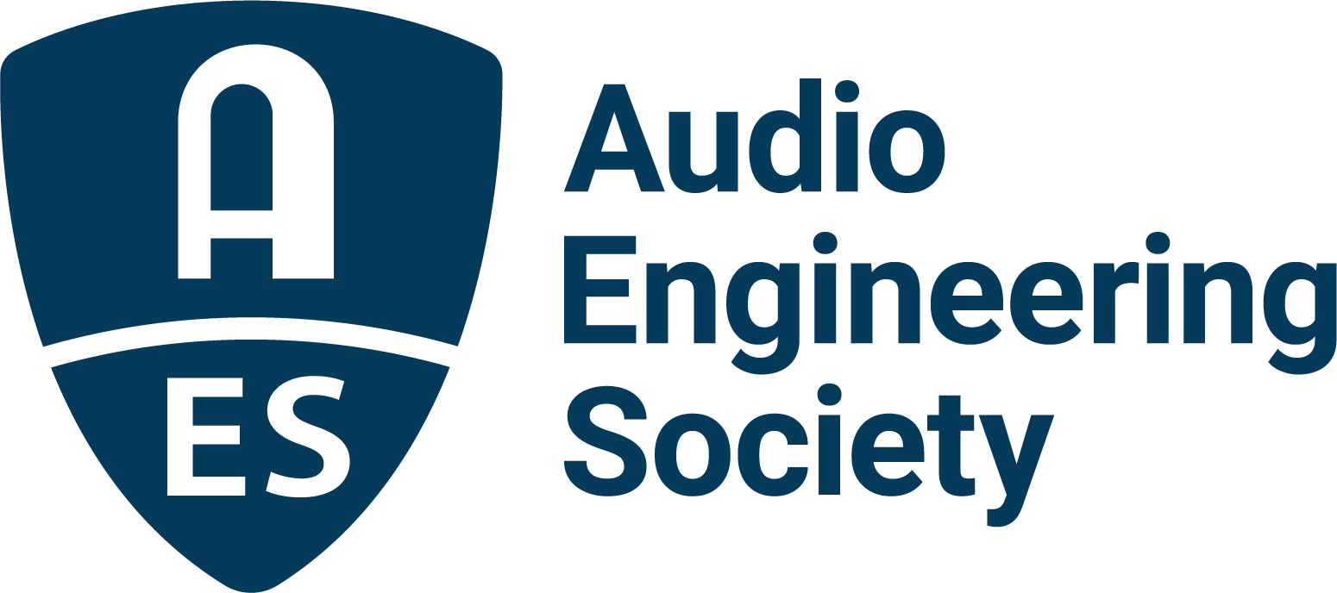

FOR IMMEDIATE RELEASE

Recording and Studio Technology Sessions Hold the Line at AES Europe Spring 2022 Convention

— Chart-topping engineers offer insights on cutting-edge techniques and the latest gear for music production —

New York, NY, April 26, 2022 — Whether at the top of their game, or just beginning their journey as an audio engineer, AES Europe Spring 2022 Convention attendees can hone their skills in a host of sessions led by chart-topping recording pros both in-person (May 7 – 8) at the Amare, Royal Conservatoire in The Hague, Netherlands, and online (May 16 – 19).

Several featured sessions at this year’s in-person event will take attendees through both traditional and experimental aspects of recording. A practical guide to recording tools will be examined in the panel discussion “What Gear Do You REALLY Need?” with Dr. Ian Corbett (Educator, Kansas City Kansas Community College), Wes Maebe (engineer-producer, RAK, Galaxy Studios, Wheelhouse Productions, Sonic Cuisine), Paul Thompson (Reader, Popular Music, Leeds Beckett University) and Doris Veldman (music producer, recording engineer and mixing engineer). For the curious wondering why loudspeakers-turned-microphones are deployed by engineers for kick drum or other instruments, the session “On Loudspeakers as Recording Devices” will highlight manipulation of the linear actuator technology used in loudspeakers for creative miking applications with panelists Tobias Roest (Delft University of Technology), Jorge Martinez (Delft University of Technology), Han Oosterom (Bosch Security Systems B.V.) and Richard Hendriks (Delft University of Technology). In “Materialization of Fixed Media Music” Siamak Anvari (Royal Conservatoire, The Hague) will explore fixed media from production through playback for concert venues, while the session “Storytelling Principles in Recording and Mixing” will explore more intimate aspects of supporting a story though sound with presenter Wessel Oltheten (Utrecht University of the Arts / HKU).

Recording and Studio Technologies will be explored further during AES Europe’s online sessions, offering insights and listening experiences to worldwide attendees. Highlighted sessions on microphone techniques include: “Professional Miking Workshop” with engineers Brandon Bell, J.J. Blair, Darrell Thorp, Joey Waronker and Joe Zook; “Comparison of Stereo Microphone Configuration and Playback Modes of Optimal Source Distribution Technique” featuring Tsuguto Hoshino (Kajima Technical Research Institute), Toru Kamekawa (Tokyo University of the Arts), Atsushi Marui (Tokyo University of the Arts) and Motoki Yairi (Kajima Technical Research Institute); while “Microphones Techniques for Natural Music Recording” presented by Kimio Hamasaki (ARTSRIDGE LLC) delves into the challenges of native immersive sound capture.

Further sessions will include the topics of “Perceptual Optimization of Hybrid Stereo Width Control Method Compared with Loudspeakers Reproduction” with Toshiharu Horiuchi (KDDI Research, Inc.), Mitsunori Mizumachi (Kyushu Institute of Technology) and Yui Ueno (Kyushu Institute of Technology), along with introspective issues such as “Why Does Anyone Still Invest in Analog Equipment?” to be presented by Daniel Dettwiler (Idee und Klang Studio). The capabilities offered by networked audio recording workflows are explored in “Recording arts and studio engineering for high-fidelity multitrack network music production” with Scott Miller (Developer of Netty-McNetface, St. Cloud State University) and Jiayue Cecilia Wu (University of Colorado Denver).

Additional sessions will be presented across the full span of the Convention by AES Europe Event Partners Eventide, Genelec, Harman, IMES (Iron Mountain Entertainment Services), Prism Sound, Sonoris, Steinberg and New Audio Technology.

Complete Tech Program schedule and presenter bios are available at AESEurope.com, the destination to explore the interactive program of events and begin to plan an optimal AES Europe Spring 2022 Convention experience. Advance Registration discounts are available through May 5 – with options to attend in-person, online or both, and bonus discounted rates for AES Members and AES Student Members.

…ends 550 words

Photo File 1: AES_Europe_2022.JPG
Photo Caption 1: Recording and Studio Technologies take center stage at the AES Europe Spring 2022 Convention, taking place in-person, May 7 – 8, at the Amare, Royal Conservatoire in The Hague, Netherlands, and online, May 16 – 19. Registration is now open at AESEurope.com.

The AES Welcomes You to The Hague
The Audio Engineering Society has chosen The Hague for its 152nd International Convention as a central hub of commerce, arts and travel, located conveniently near to Amsterdam’s popular Schiphol Airport, among other easy transportation options. Whether attending your first AES Convention, coming again as a dedicated attendee or presenting your own work to the enthusiastic gathering of attendees from around the world, this year’s return to in-person AES events in The Hague presents a prime opportunity to “Listen, Learn and Connect” with peers and pros in an easily accessible and culturally rich environment. The AES invites you to enjoy our spectacular venue and surrounding area, dotted with gardens and canals, world-class museums and art, restaurants, shops and more. Join us as we celebrate the best in audio art, science and education at the AES Europe Spring 2022 Convention.

About the Audio Engineering Society
The Audio Engineering Society, celebrating over 70 years of audio excellence, serves as the pivotal force in fostering the development and dissemination of technical information for the audio community. Currently, its members are affiliated with 90 AES professional sections and more than 120 AES student sections around the world. Section activities include guest speakers, technical tours, demonstrations, online events and social functions. Through Conventions, Conferences, Training and Development, Member Events and peer-reviewed Publications, as well as the Society’s vast online resources, members experience valuable opportunities for professional networking and personal growth. For additional information, visit AES.org.

Join the conversation and keep up with the latest AES News and Events:
Twitter: #AESorg (AES Official)
Facebook: facebook.com/AES.org
LinkedIn: https://www.linkedin.com/company/audio-engineering-society
Instagram: https://www.instagram.com/aes_org/

AES Marketing Communications:
Email: robert.clyne@aes.org
Tel: 615-662-1616
Clyne Media, Inc.,
169-B Belle Forest Circle, Nashville, TN 37221;
Web: http://www.clynemedia.com

