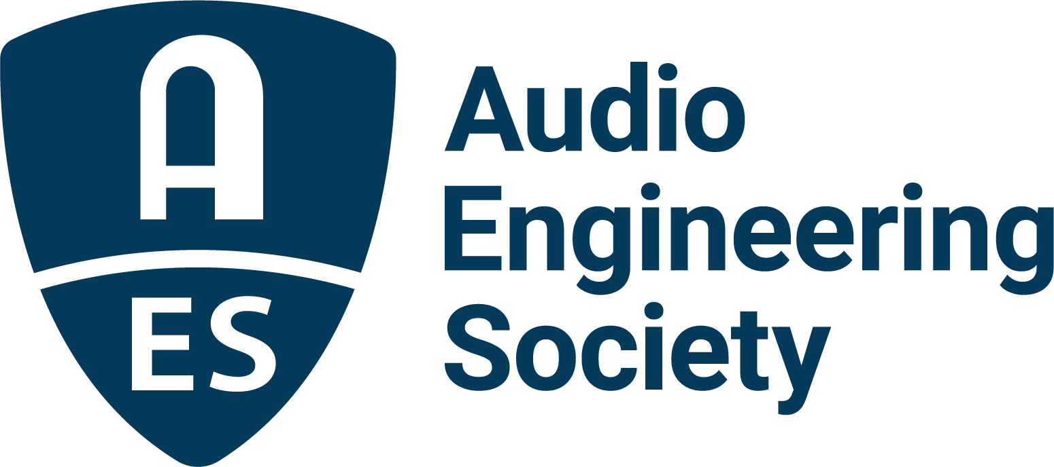

FOR IMMEDIATE RELEASE

Immersive Audio, Synthesis and Effects in Focus at AES Europe Spring 2022 Convention in May

— Top researchers and cutting-edge practitioners will share insights on new and groundbreaking audio technologies though workshops, panel discussions and demonstrations throughout the Convention —

New York, NY, April 22, 2022 — Submersion in immersion is in store for AES Europe Spring 2022 Convention attendees through innovative experiences, demonstrations and presentations, with cutting-edge researchers and practitioners offering a deep dive into Immersive, 3D and Spatial Audio, Audio Synthesis and Effects. This year’s combination of exclusive in-person sessions taking place May 7 – 8 at the Amare, Royal Conservatoire in The Hague, Netherlands (not available on-demand after the event), along with the online event May 16 – 19 with independent and unique content, offers a range of experiences including both face-to-face interaction and in-depth listening sessions.

Immersive Audio content production is fast becoming ubiquitous. Understanding both content creation and the end-user experience is now a must for all audio professionals. Convention sessions will cover foundational topics including the creation of a predictable listener experience in scenarios ranging from typical to advanced; the necessary transducer and acoustic properties for transmission of immersive sound and integration with Virtual and Augmented Reality; multi-channel sound design philosophy; and peeks into what’s-next in this evolving field. Additionally, a host of sessions on Binaural Audio will be featured during the Convention’s online experience.

Immersive Audio sessions at AES Europe illustrating the quality of presenters and depth of content will include, “The Inception Dilemma Revisited” with presenters Thomas Lund (Genelec OY), Hyunkook Lee (University of Huddersfield) and Kimio Hamasaki (ARTSRIDGE); “Directions of Sounds in 3D Audio Productions” with Lasse Nipkow (Silent Work GmbH); “Immersive Audio Tools for Beginners” led by Marcela Rada (University of Lethbridge); “Considerations to building multi-dimensional objects for immersive experiences” with Agnieszka Roginska (New York University) and Paul Geluso (New York University); and the panel discussion “What’s the Next Step Towards Advanced 3D Audio Recording?” featuring Kimio Hamasaki (ARTSRIDGE), Misaki Hasuo (WOWOW Inc.), Toru Kamekawa (Tokyo University of the Arts), Hideo Irimajiri (WOWOW Inc.) and Kazuya Nagae (Nagoya University of the Arts).

AESEurope.com is the destination to explore the interactive program of events and plan an amazing AES Europe Spring 2022 Convention experience. Advance Registration discounts are available through May 5 – with options to attend in-person, online or both, and bonus discounted rates for AES Members and AES Student Members.

Additional sessions will be presented across the full span of the Convention by AES Europe Event Partners Eventide, Genelec, Harman, IMES (Iron Mountain Entertainment Services), Prism Sound, Sonoris, Steinberg and New Audio Technology.

…ends 384 words

Photo File 1: AES_Europe_2022.JPG
Photo Caption 1: The AES Europe Spring 2022 Convention will take place in-person, May 7 – 8, at the Amare, Royal Conservatoire in The Hague, Netherlands, and online, May 16 – 19. Registration is now open at AESEurope.com.

The AES Welcomes You to The Hague
The Audio Engineering Society has chosen The Hague for its 152nd International Convention as a central hub of commerce, arts and travel, located conveniently near to Amsterdam’s popular Schiphol Airport, among other easy transportation options. Whether attending your first AES Convention, coming again as a dedicated attendee or presenting your own work to the enthusiastic gathering of attendees from around the world, this year’s return to in-person AES events in The Hague presents a prime opportunity to “Listen, Learn and Connect” with peers and pros in an easily accessible and culturally rich environment. The AES invites you to enjoy our spectacular venue and surrounding area, dotted with gardens and canals, world-class museums and art, restaurants, shops and more. Join us as we celebrate the best in audio art, science and education at the AES Europe Spring 2022 Convention.

About the Audio Engineering Society
The Audio Engineering Society, celebrating over 70 years of audio excellence, serves as the pivotal force in fostering the development and dissemination of technical information for the audio community. Currently, its members are affiliated with 90 AES professional sections and more than 120 AES student sections around the world. Section activities include guest speakers, technical tours, demonstrations, online events and social functions. Through Conventions, Conferences, Training and Development, Member Events and peer-reviewed Publications, as well as the Society’s vast online resources, members experience valuable opportunities for professional networking and personal growth. For additional information, visit AES.org.

Join the conversation and keep up with the latest AES News and Events:
Twitter: #AESorg (AES Official)
Facebook: facebook.com/AES.org
LinkedIn: https://www.linkedin.com/company/audio-engineering-society
Instagram: https://www.instagram.com/aes_org/

AES Marketing Communications:
Email: robert.clyne@aes.org
Tel: 615-662-1616
Clyne Media, Inc.,
169-B Belle Forest Circle, Nashville, TN 37221;
Web: http://www.clynemedia.com

