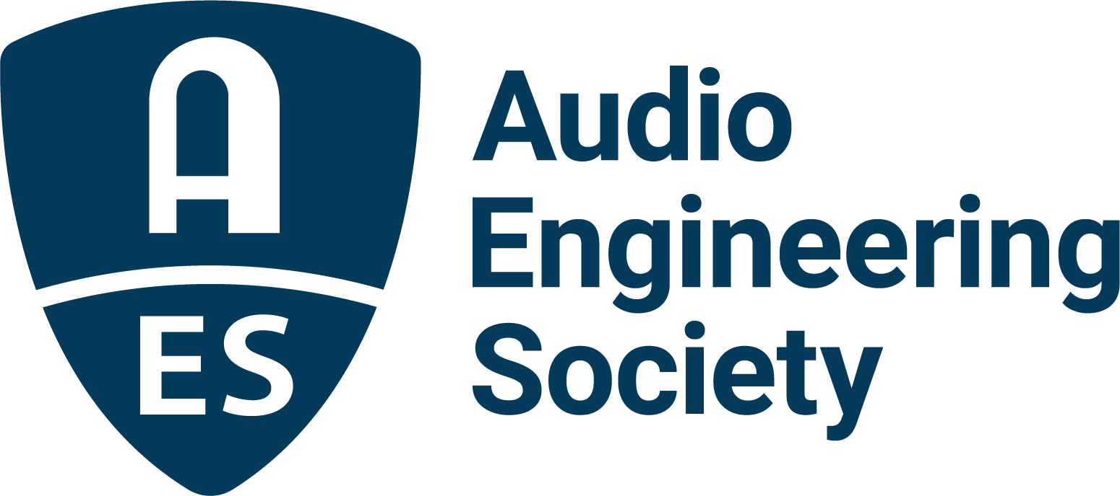

FOR IMMEDIATE RELEASE

AES Announces Results of 2022 Elections

— Leslie Gaston-Bird will join the Board of Directors as President-Elect —

New York, NY, August 1, 2022 — The Audio Engineering Society has announced the incoming Officers and Governors following the 2022 Board of Directors and Board of Governors elections. The Society’s membership has elected Leslie Gaston-Bird, as President-Elect. Also on the Board of Directors, Valerie Tyler has been reelected as Secretary and Marina Bosi reelected as Treasurer. In the AES Elections for the Board of Governors (BoG), Angela Piva has been elected Vice President Eastern Region, USA/Canada, David v.R. Bowles has been elected Vice President Western Region, USA/Canada and Jamie Angus-Whiteoak has been elected as Vice President Northern Europe Region. Additionally, newly elected Governors-at-large are Lesley Fogle, Toru Kamekawa and Marcela Zorro. Save for the President-Elect, each newly-elected individual will serve a two-year term and Bosi and Tyler with have their current terms extended by two years. Gaston-Bird will serve a year on the AES Board of Directors as President-Elect, in 2024 as President, in 2025 as Past-President, followed by two years as a Governor. All those newly elected will begin their terms on January 1, 2023.

Also on January 1, 2023, current Past-President Jonathan Wyner will transition to Governor for the first year of a two-year term. Beginning one-year terms will be President Josh Reiss, who will transition to Past-President, and President-Elect Bruce Olson, who will become President.

Outgoing from the Board of Governors in 2023 as regional Vice Presidents are Gabriel Herman (Eastern Region, USA/Canada), Alex Kosiorek (Western Region, USA/Canada) and Elena Prokofieva (Northern Region, Europe). Governors with terms ending this year are Brad McCoy, Paul Womack, Jun Yamazaki and Governor and Past-President (twice removed) Nadja Wallaszkovits who completes her five-year commitment to the BoG. Board of Governors-elected Director Brecht De Man’s two-year term will also end; his replacement on the Board will be named by the Board of Governors in 2022 Q4.

“On behalf of the entire Society,” says AES President Josh Reiss, “I offer a hearty congratulations to all the newly elected Governors and officers – we look forward to your contributions to AES governance. We also offer a heart-felt ‘Thank you’ to all who showed their willingness to serve by accepting a nomination. And those who are leaving the Boards at the end of the year go with our deep gratitude for their service and commitment to the Society.”

The election was monitored, and the results presented, by Gary Louie, Chair of the AES’s Tellers Committee.

The 2023 Audio Engineering Society Board of Directors will be:
Bruce Olson: President
Joshua Reiss: Past-President
Leslie Gaston-Bird: President-Elect
Valerie Tyler: Secretary
Marina Bosi: Treasurer
Cesar Lamschtein: Director
One additional Director will be named by the Board of Governors per the AES Bylaws in 2022 Q4.

In addition to the Directors listed above, the 2023 Board of Governors will be:
Bill Schulenburg: Vice President, Central Region, USA/Canada
Ewa Lukasik: Vice President, Central Region, Europe
Angela Piva: Vice President, Eastern Region, USA/Canada
David v.R. Bowles: Vice President, Western Region, USA/Canada
Jorge M. Azama: Vice President, Latin American Region
Jamie Angus-Whiteoak: Vice President, Northern Region, Europe
Alberto Pinto: Vice President, Southern Europe/Middle East/Africa Region
Kazuhiko Kawahara: Vice President, Asia-Pacific Region
Prince Charles Alexander: Governor
Areti Andreopoulou: Governor
Toru Kamekawa: Governor
Hyunkook Lee: Governor
Lesley Fogle: Governor
Agnieszka Roginska: Governor
Jonathan Wyner: Governor
Marcela Zorro: Governor

...ends 536 words

For more information on the Audio Engineering Society, please visit www.aes.org.

Photo File: LeslieGaston-Bird.jpg
Photo Caption: Leslie Gaston-Bird, AES President-Elect 2023

About the Audio Engineering Society
The Audio Engineering Society, celebrating over 70 years of audio excellence, serves as the pivotal force in fostering the development and dissemination of technical information for the audio community. Currently, its members are affiliated with 90 AES professional sections and more than 120 AES student sections around the world. Section activities include guest speakers, technical tours, demonstrations, online events and social functions. Through Conventions, Conferences, Training and Development, Member Events and peer-reviewed Publications, as well as the Society’s vast online resources, members experience valuable opportunities for professional networking and personal growth. For additional information, visit AES.org.

Join the conversation and keep up with the latest AES News and Events:
Twitter: #AESorg (AES Official)
Facebook: facebook.com/AES.org
LinkedIn: https://www.linkedin.com/company/audio-engineering-society
Instagram: https://www.instagram.com/aes_org/

AES Marketing Communications:
Email: robert.clyne@aes.org
Tel: 615-662-1616
Clyne Media, Inc.,
169-B Belle Forest Circle, Nashville, TN 37221;
Web: http://www.clynemedia.com

