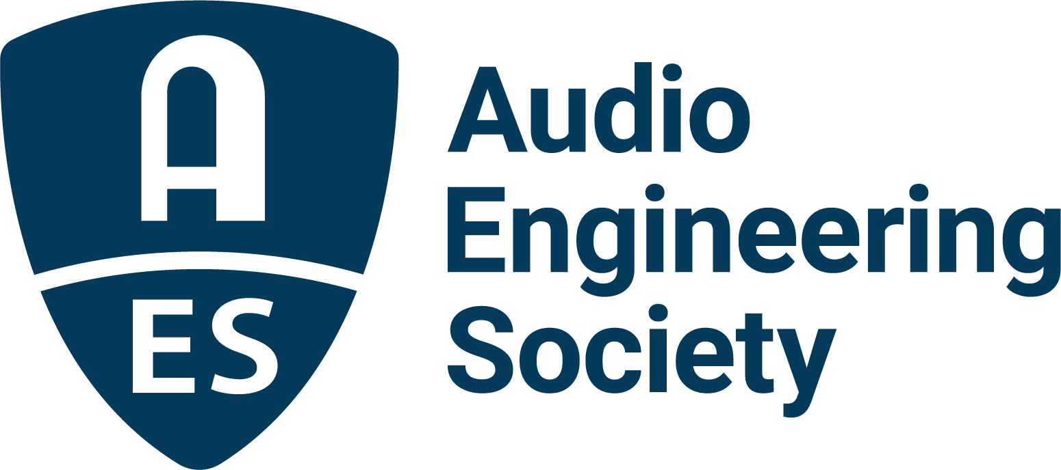

FOR IMMEDIATE RELEASE

AES to Immerse Attendees in Audio for Virtual and Augmented Realities in Redmond, WA, August 15 – 17

— AES AVAR 2022 Conference unites an elite international roster of presenters and attendees —

New York, NY, August 10, 2022 – The AES welcomes top Virtual and Augmented Reality industry talent to DigiPen Institute in Redmond, WA, August 15 – 17, for the latest installment of the premiere gathering of researchers, product developers and content creators in the Mixed Reality space.

This fourth AES International Conference on Audio for Virtual and Augmented Reality (AVAR), held in partnership with pioneering brands including Meta’s Reality Labs Research, Brandenburg Labs, HEAD acoustics, Audioscenic and Microsoft, will educate attendees on the latest in industry-warping technologies and techniques addressing hot topics such as Head Related Transfer Function (HRTF) protocols, AR/VR/XR production workflows, and the latest implementations of immersive content for both utilitarian and entertainment purposes. Complete program and registration information is available online, including deep discounts for AES Members and AES Student Members.

One of the more complex facets of Virtual and Augmented Reality being examined at the AVAR Conference is the inclusion of the listener as part of the audio soundscape, often achieved by means of HRTF measurement and implementation. A closer look and listen at creating an even more impactful experience will be offered through sessions on HRTF personalization based on ear morphology, XR-based HRTF Measurements, and a Research Paper presentation by Nikhil Javeri of Embody on Machine Learning-based prediction of Personalized Head Related Transfer Functions based on video capture.

Bringing these new and enhanced realities into the tangible world in both practical and entertaining ways is also a popular topic at this year’s AVAR Conference. Examples include a Workshop on producing audio for Virtual Concerts and the Metaverse, research presentations on sound design for Augmented Reality and Virtual Reality in learning environments, and the Workshop “Using 3D Audio to Augment the Museum Experience,” led by Kyla McMullen, Chenshen Lu and Armisha Roberts from the University of Florida, which will delve into some of the interactive and educational aspects of immersive audio experiences.

Another attendee-favorite component of AES events are the technology showcases and demonstrations from leading brands and innovators in the audio industry, offering insights and hands-on opportunities to check out the latest hardware and software offerings. The 2022 AVAR Conference will host demo rooms from sponsors Audioscenic, Brandenburg Labs, HEAD acoustics and Meta’s Reality Lab Research.

Details on registration, housing and venue information are available at the AES International Conference on Audio for Virtual and Augmented Reality event page.

…ends 386 words

Photo File 1: AES_AVAR_2022.JPG
Photo Caption 1: The 2022 AES International Conference on Audio for Virtual and Augmented Reality will take place August 15 – 17 at the DigiPen Institute of Technology in Redmond, WA

Links:
AES International Conference on Audio for Virtual and Augmented Reality

About the Audio Engineering Society
The Audio Engineering Society, celebrating over 70 years of audio excellence, serves as the pivotal force in fostering the development and dissemination of technical information for the audio community. Currently, its members are affiliated with 90 AES professional sections and more than 120 AES student sections around the world. Section activities include guest speakers, technical tours, demonstrations, online events and social functions. Through Conventions, Conferences, Training and Development, Member Events and peer-reviewed Publications, as well as the Society’s vast online resources, members experience valuable opportunities for professional networking and personal growth. For additional information, visit AES.org.

Join the conversation and keep up with the latest AES News and Events:
Twitter: #AESorg (AES Official)
Facebook: facebook.com/AES.org
LinkedIn: https://www.linkedin.com/company/audio-engineering-society
Instagram: https://www.instagram.com/aes_org/

AES Marketing Communications:
Email: robert.clyne@aes.org
Tel: 615-662-1616
Clyne Media, Inc.,
169-B Belle Forest Circle, Nashville, TN 37221;
Web: http://www.clynemedia.com

