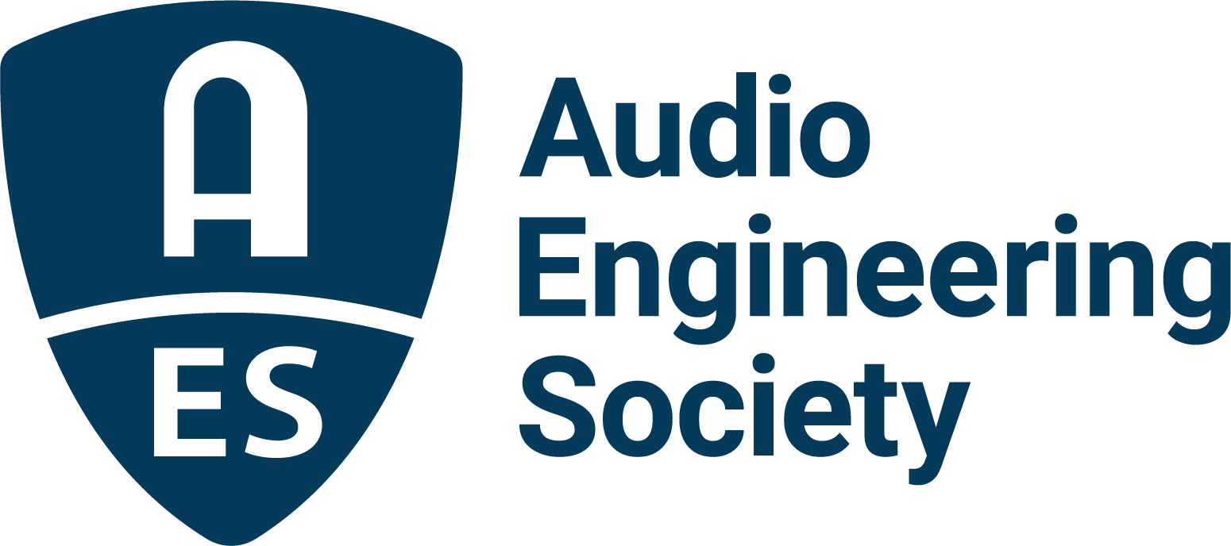

FOR IMMEDIATE RELEASE

AES Audio Product Education Institute Event to Explore Next Level of Transducer Development Using the Latest Electroacoustic Simulation Tools

— The AES Audio Product Education Institute (APEI) promotes a new Modeling and Measurement webinar exploring the latest updates to the Acoustics Module in COMSOL Multiphysics 6.0 and its possibilities for loudspeaker development —

New York, NY, February 25, 2022 — The AES Audio Product Education Institute (APEI) is promoting a new Modeling and Measurement webinar focused on the latest advancements in loudspeaker design. The session, presented by Mads Herring Jensen, Technology Manager, Acoustics, at COMSOL, will explore the latest updates in COMSOL Multiphysics 6.0 software, and specifically the significant improvements to transducer development introduced to its Acoustics Module.

Launched December 15, 2021, COMSOL 6.0 introduced a simplified workflow for setting up hybrid lumped-FEM models of loudspeakers, a user interface for the simulation of magneto-mechanical forces in transducers, and much more. Focusing on electroacoustic transducer applications, this webinar will be a unique opportunity for an audio-centric audience to learn about the new features, several of which are the direct result of feedback collected from users within the audio industry.

With the audio industry increasingly initiating new product development efforts with simulation-driven designs, and progressing gradually to Digital Twins, it becomes important to understand all the vast possibilities these tools can offer. Using modeling and simulation systematically through the design and optimization stages of an acoustic device is proving to enable significant performance breakthroughs – not only by removing variables, but by identifying key undesired properties and effects, while enabling practical solutions that can be prototyped, verified and implemented.

The Acoustics Module in COMSOL Multiphysics 6 introduces many highly requested features that reflect the software’s increasing use in the audio industry. The session will provide an overview of those important areas of improvement, such as the possibility to model piezoelectric phenomena in the time domain for wave propagation using a time-explicit formulation, physics-controlled mesh for pressure acoustics problems, or new high-frequency wave methods. Speaker designers in particular can benefit from a new Lumped Loudspeaker boundary condition and sector symmetry options in the exterior field.

This event will benefit from the participation of Roger Shively (JJR Acoustics, LLC), highly experienced in the areas of transducers, automotive audio, psychoacoustics, and computer modeling, and Tim Whitwell (Tectonic Audio Labs), who currently leads cutting-edge efforts in transducer development using COMSOL. Roger will share his experience and ask questions, while Tim will discuss his work with the new software, as well as his familiarity modeling external pressure fields using the new cyclic symmetry feature. The session will be open for questions following presentations.

The Audio Product Education Institute’s Modeling and Measurement education pillar is sponsored by COMSOL and underscores the AES’s commitment to providing its membership and the industry at large with information on real-world solutions for audio product development.

Webinar registration: https://audioproducteducationinstitute.org/electroacoustic-simulation-in-comsol-multiphysics-6/

…ends 415 words

Photo File 1: APEI2022-ModelingMeasurement-COMSOL6-March2-12x9-Names.jpg
Photo Caption 1: The AES Audio Product Education Institute (APEI) will present the webinar Electroacoustic Simulation in COMSOL Multiphysics 6.0 – Getting to The Next Level in Transducer Development, on Wednesday, March 2, at 12:00pm EDT.

Photo File 2: APEI2022-AESSTPromo-ModelingMeasurement-COMSOL6-March2.jpg
Photo Caption 2: The AES Audio Product Education Institute (APEI) presents a must-attend online session for audio developers and specifically loudspeaker designers, exploring the major updates to the COMSOL 6 Acoustics Module and the simulation of electroacoustic transducers.

About the Audio Engineering Society
The Audio Engineering Society, celebrating over 70 years of audio excellence, serves as the pivotal force in fostering the development and dissemination of technical information for the audio community. Currently, its members are affiliated with 90 AES professional sections and more than 120 AES student sections around the world. Section activities include guest speakers, technical tours, demonstrations, online events and social functions. Through Conventions, Conferences, Training and Development, Member Events and peer-reviewed Publications, as well as the Society’s vast online resources, members experience valuable opportunities for professional networking and personal growth. For additional information, visit aes.org.

About the Audio Product Education Institute (APEI)
The Audio Product Education Institute (APEI) was launched in January 2020, as an initiative of the Audio Engineering Society (AES), to focus on promoting methodologies, practices and technologies involved in developing and bringing audio products to market. The Institute roadmap intends to focus on seven educational pillars: Voice and DSP; Supply Chain and Sourcing; Modeling and Measurement; Product Management; Automotive Audio; Artificial Intelligence and Machine Learning; and Business Management. For more information, visit https://audioproducteducationinstitute.org.

Join the conversation and keep up with the latest AES News and Events:
Twitter: #AESorg (AES Official)
Facebook: facebook.com/AES.org

AES Marketing Communications:
Email: robert.clyne@aes.org
Tel: 615-662-1616
Clyne Media, Inc.,
169-B Belle Forest Circle, Nashville, TN 37221;
Web: http://www.clynemedia.com

