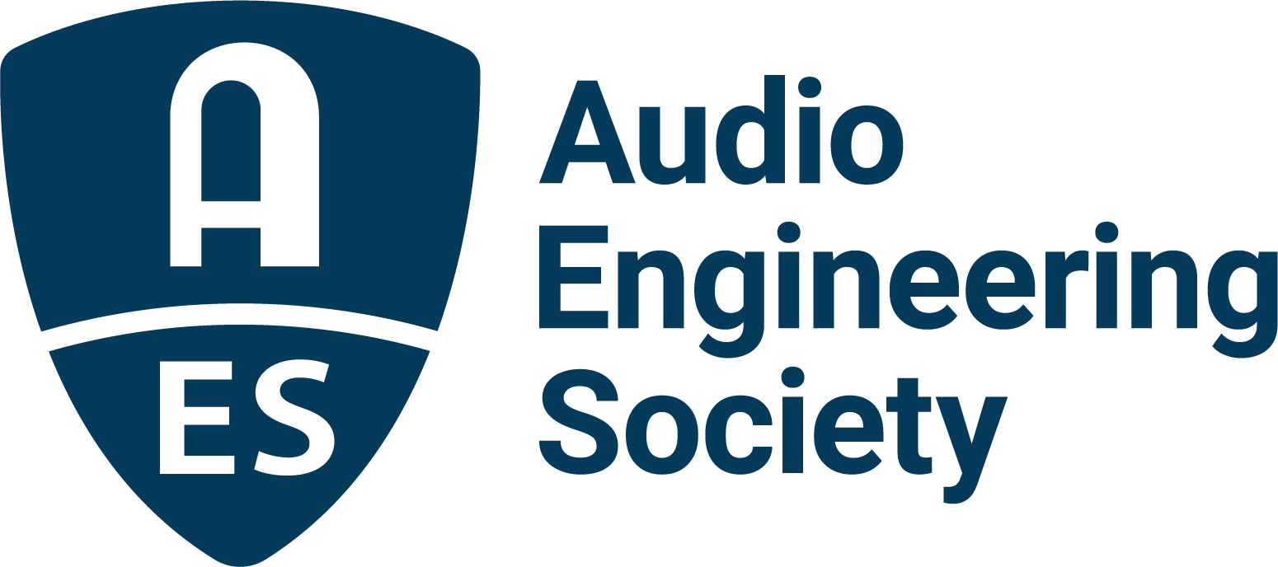

FOR IMMEDIATE RELEASE

AES Audio Product Education Institute Webinar to Demystify Microphone Beamforming for Voice Interface Applications

— The AES Audio Product Education Institute (APEI) to present a new Voice and DSP webinar exploring the application and optimization of microphone beamforming techniques —

New York, NY, July 8, 2022 — The Audio Product Education Institute (APEI), an initiative of the Audio Engineering Society (AES), presents a new webinar in its Voice and DSP education pillar, “Demystifying Beamformers,” addressing microphone beamforming in theory and practice and the latest optimizations for voice recognition platforms. The unique knowledge-sharing online session, featuring three top industry experts with vast experience in the development of the latest cutting-edge voice-based products, will be held Wednesday, July 13, at 12:00pm EDT.

Beamforming is a signal processing technique extensively explored in radio frequency and acoustics applications. Thanks to advancements in DSP, beamforming is now widely implemented in loudspeaker directivity control and for the processing of signals from multiple omnidirectional microphones to optimize the performance of speakerphones and voice recognition systems. By giving a voice recognition AI system the cleanest possible voice signal to work with, engineers can assure the most accurate voice recognition and the greatest reliability for voice interface applications.

The performance of a beamformer in voice capture depends on how well the beam pattern of the microphone array can be optimized, and the signal-to-noise ratio (SNR) of the array. In this webinar, attendees will learn about beamformer functionality, including how the number of microphones and geometry impacts performance, the importance of microphone matching and SNR, and how to create steerable arrays. The presentation will also address the technical challenges with beamforming and how new MEMs microphones can help give consistent directionality across the audible range and good SNR.

Following an introduction on beamformers by Paul Beckmann (the co-founder and CTO of DSP Concepts), Sahil Gupta (co-founder and Product Lead at Soundskrit) will discuss the frequency dependency of broadside beamformers and the SNR challenge with differential endfire beamformers when trying to create dipoles. In the third presentation, Arash Radmoghadam (Director of Engineering and Applied Machine Learning at Fluent.ai) will discuss improving voice activation and recognition with beamforming.

The webinar will be hosted by Dave Lindberg (DB Enterprises, Hong Kong), APEIs Supply Chain and Sourcing pillar co-chair. Attendees will be able to submit questions to the presenters, which will be addressed in the last 30 minutes of this session.

The Audio Product Education Institute’s Voice and DSP education pillar is sponsored by DSP Concepts and underscores the AES’s commitment to providing its membership and the industry at large with information on real-world solutions for audio product development.

Webinar registration: https://audioproducteducationinstitute.org/demystifying-beamformers/

…ends 391 words

Photo File 1: APEI-VoiceDSP-July13-cleanT.jpg
Photo Caption 1: The AES Audio Product Education Institute (APEI) will present the webinar Demystifying Beamformers, on Wednesday, July 13, at 12:00pm EDT.

Photo File 2: APEI-VoiceDSP-July13-12x9.jpg
Photo Caption 2: The AES Audio Product Education Institute (APEI) will present a webinar exploring application and optimization of microphone beamforming techniques, with presentations from Paul Beckmann (the co-founder and CTO of DSP Concepts), Sahil Gupta (co-founder and Product Lead at Soundskrit) and Arash Radmoghadam (Director of Engineering and Applied Machine Learning at Fluent.ai).

About the Audio Engineering Society
The Audio Engineering Society, celebrating over 70 years of audio excellence, serves as the pivotal force in fostering the development and dissemination of technical information for the audio community. Currently, its members are affiliated with 90 AES professional sections and more than 120 AES student sections around the world. Section activities include guest speakers, technical tours, demonstrations, online events and social functions. Through Conventions, Conferences, Training and Development, Member Events and peer-reviewed Publications, as well as the Society’s vast online resources, members experience valuable opportunities for professional networking and personal growth. For additional information, visit aes.org.

About the Audio Product Education Institute (APEI)
The Audio Product Education Institute (APEI) was launched in January 2020, as an initiative of the Audio Engineering Society (AES), to focus on promoting methodologies, practices and technologies involved in developing and bringing audio products to market. The Institute roadmap intends to focus on seven educational pillars: Voice and DSP; Supply Chain and Sourcing; Modeling and Measurement; Product Management; Automotive Audio; Artificial Intelligence and Machine Learning; and Business Management. For more information, visit https://audioproducteducationinstitute.org.

Join the conversation and keep up with the latest AES News and Events:
Twitter: #AESorg (AES Official)
Facebook: facebook.com/AES.org

AES Marketing Communications:
Email: robert.clyne@aes.org
Tel: 615-662-1616
Clyne Media, Inc.,
169-B Belle Forest Circle, Nashville, TN 37221;
Web: http://www.clynemedia.com

