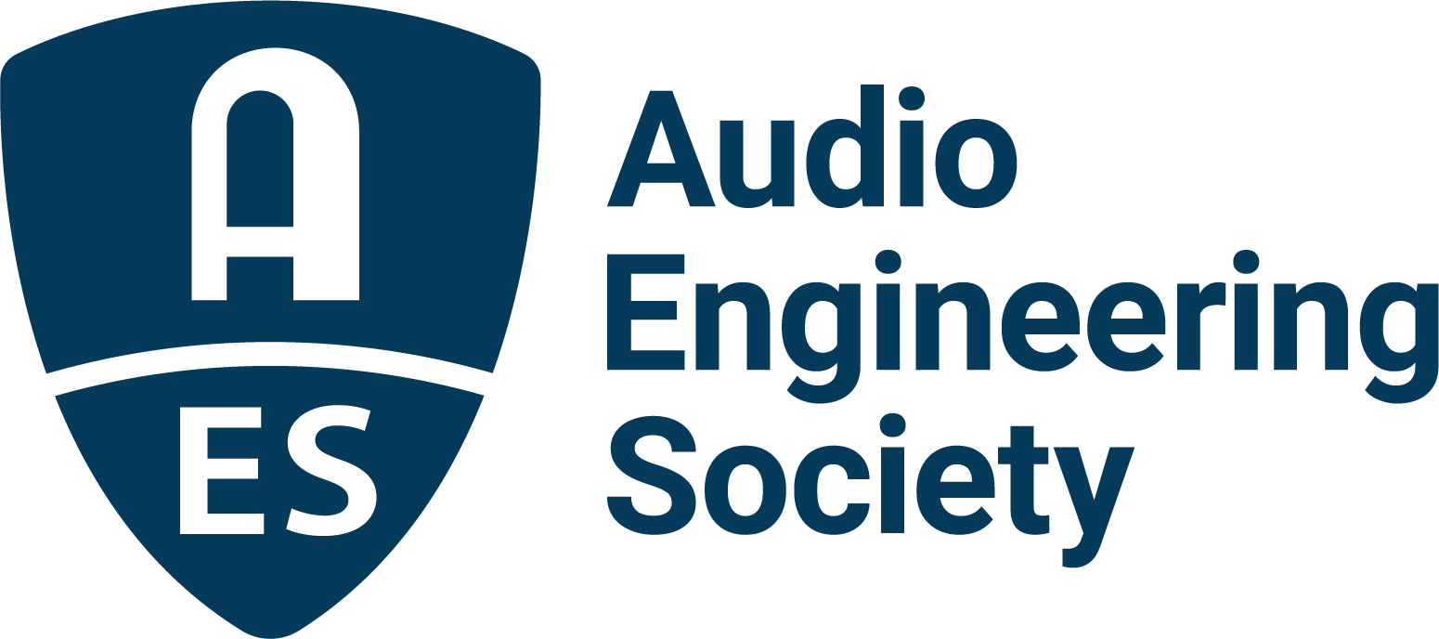

FOR IMMEDIATE RELEASE

Get Your Free Pass to the AES New York 2022 Convention Experience with Exhibits+ Registration

— Complimentary registration offers two full days of exhibition floor access, Audio Experience Stages, Special Events, Keynotes and much more —

New York, NY, September 8, 2022 – The Audio Engineering Society hosts the worldwide audio engineering community as they gather for the AES New York 2022 Convention, October 19 – 20, at the Jacob Javits Center in New York City. AES members enjoy the benefit of complimentary Exhibits+ registration to the Convention, while non-members keen to learn about the latest trends in audio technology can also claim a free Exhibits+ registration, but only during the Early Bird Registration period ending next Monday, September 12.

Exhibits+ registration includes two full days of access to top professional audio brands displaying the latest in audio gear and services, a host of Exhibition Floor sessions with elite audio engineers and experts, and the chance to reconnect with peers and pros who share a passion for the art and science of audio. Registrants can also upgrade to All Access registration at any time for the complete Convention experience that provides expanded offerings, offsite events, additional programming and training from October 18-21. The best-rates for All Access registration at AESShow.com, including deep discounts for AES members, also ends September 12.

An ever-popular component of AES Conventions is the Exhibition Floor, hosting a hands-on showcase with product experts and special guests showing off the latest audio products and solutions, and the opportunity to gain valuable face time with end users from all aspects of the industry. This year’s co-location and shared Exhibition Floor access with the NAB New York Show combine to offer a one-stop-shop for checking out the hottest gear for content creators, producers, engineers and students looking to stay on the cutting edge of A/V technology.

Exhibits+ registration also gives access to the Software@AES Pavilion, an AES partnership with the International Music Software Trade Association (IMSTA) showcasing the leading audio software manufacturers demonstrating their latest products; the AVID Software Pavilion, with AVID and partners demonstrating the latest in Pro Tools and third-party production plug-ins; the Academy Stage, with special guest panels and Q&A’s; Mix with the Masters, where elite producers and engineers discuss and demonstrate their skills and techniques; the Media over IP Pavilion for the latest in networked audio; the AES Student & Education “Future of the Industry” Pavilion with presentation theater, networking and a Career Fair; and much, much more.
All Access registration presents an additional multitude of exclusive opportunities to hear from some of the top producers, engineers, artists, researchers and product designers who shape our industry today. From the Keynote and Special Events series sessions, to one-on-one encounters and insights on the Convention floor, AES New York 2022 promises to deliver interactive elements that bring professional audio to life and foster lifelong industry relationships.

AESShow.com is the destination for program, lodging and registration information for the year’s premier professional audio experience, the AES New York 2022 Convention, with September 12 being the last chance for Early Bird free non-member Exhibits+ registration and the best rates on All Access upgrades.

About the AES New York 2022 Convention
The ultimate audio experience begins in New York City with the return of the AES in-person Convention on October 19–20 (with additional training opportunities on October 18 and Tech Tours and Networking events on October 21). Then, on October 26–27, the online event will bring its own separately curated program of workshops and papers to a world-wide audience.

AES New York 2022 event partners include Dell, IMES (Iron Mountain Entertainment Services) and Qualcomm. The Convention will once again be collocated with NAB Show New York with a shared exhibits space. Exhibits+ registration, giving access to the in-person exhibition floor and related sessions, is free for all during the Early Bird period, while full technical program registration for the in-person or online components and All Access bundles are available at Early Bird pricing through September 12 at AESShow.com. AES members benefit from preferential pricing and complimentary Exhibits+ registration.

…ends 636 words

Links
AES New York 2022 Convention

Photo File 1: AESNY_2022_Registration.JPG
Photo Caption 1: Get your free pass to the AES New York 2022 Convention experience with Exhibits+ registration at AESShow.com.

About the Audio Engineering Society
The Audio Engineering Society, celebrating over 70 years of audio excellence, serves as the pivotal force in fostering the development and dissemination of technical information for the audio community. Currently, its members are affiliated with 90 AES professional sections and more than 120 AES student sections around the world. Section activities include guest speakers, technical tours, demonstrations, online events and social functions. Through Conventions, Conferences, Training and Development, Member Events and peer-reviewed Publications, as well as the Society’s vast online resources, members experience valuable opportunities for professional networking and personal growth. For additional information, visit AES.org.

Join the conversation and keep up with the latest AES News and Events:
Twitter: #AESorg (AES Official)
Facebook: facebook.com/AES.org
LinkedIn: https://www.linkedin.com/company/audio-engineering-society
Instagram: https://www.instagram.com/aes_org/

AES Marketing Communications:
Email: robert.clyne@aes.org
Tel: 615-662-1616
Clyne Media, Inc.,
169-B Belle Forest Circle, Nashville, TN 37221;
Web: http://www.clynemedia.com

