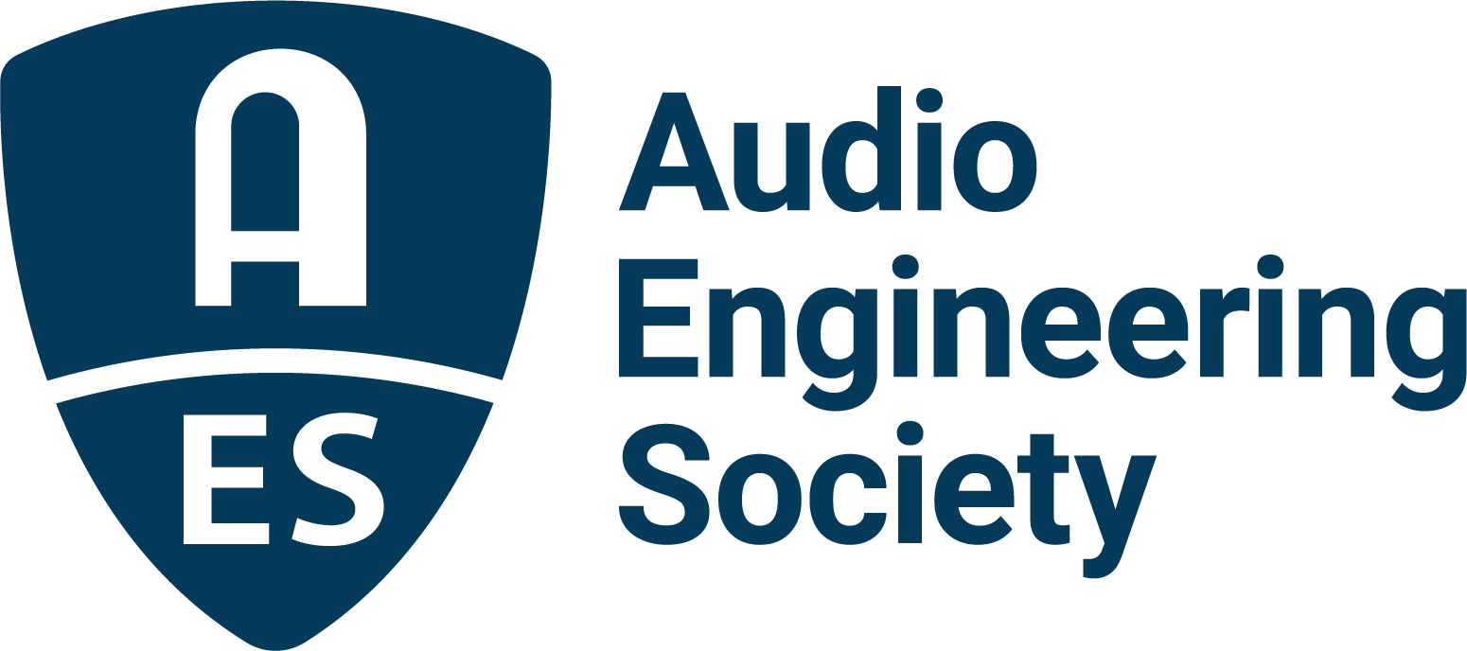

FOR IMMEDIATE RELEASE

Multi-Award-Winning Producer/Songwriter/Instrumentalist/Singer Jack Antonoff to Give Opening Day Keynote at AES New York 2022 Convention

New York, NY, October 13, 2022 – Next Wednesday, October 19, Jack Antonoff will offer insights into his GRAMMY®-winning career from both sides of the glass and his workflow on projects with some of today’s top artists. As a songwriter and producer, Antonoff, who in 2021 was credited by the BBC for having “redefined pop music,” has collaborated with the likes of Diana Ross, Taylor Swift, Lorde, St. Vincent, Florence + The Machine, Lana Del Rey and Kevin Abstract, in addition to his celebrated work with his current band, Bleachers. He curated and produced the 2022 Minions: The Rise of Gru soundtrack, featuring the single “Turn Up the Sunshine” by Diana Ross and Tame Impala. Over the years Antonoff has collected numerous accolades, including six GRAMMY Awards®, most recently winning the 2022 GRAMMY® Award for Producer of the Year.

“The Audio Engineering Society is beyond excited to have Jack Antonoff give our opening keynote at the AES New York Convention,” stated Jonathan Wyner, AES New York 2022 Convention Chair. “Jack is a driving force in an exciting time in the world of music production as one of the most sought-after producers by chart-topping artists. He is in full command of his technology and tools as he innovates to help projects ‘find their voice’. The diversity of projects he works on is a testament to his remarkable versatility. We look forward to gaining insights about his work and his personal connection to the technology and art of music production.”

The Keynote will take place at 12:15 pm on Wednesday, October 19, as part of the Convention’s Opening Ceremony. Information about free Exhibits+ or upgraded All Access registration, along with details on hundreds more events and opportunities happening during the Convention, can be found at AESShow.com.

About the AES New York 2022 Convention
The ultimate audio experience begins in New York City with the return of the AES in-person Convention on October 19–20, with additional training opportunities on October 18 and Tech Tours and Networking events on October 21. Then, on October 26–27, our online event will bring its own separately curated program of workshops and papers to a world-wide audience.

AES New York 2022 event partners include Avid, Dell, IMES (Iron Mountain Entertainment Services), The Recording Academy Producers & Engineers Wing and Qualcomm. The Convention will once again be collocated with NAB Show New York with a shared exhibits space. Exhibits+ registration, giving access to the in-person exhibition floor and related sessions, is free for AES Members and with available VIP codes, while full technical program registration for the in-person or online components and All Access bundles are also available for the full convention experience. AES members benefit from preferential pricing and complimentary Exhibits+ registration. Find out more and register now at AESShow.com.

…ends 457 words

Links
AES New York Convention – Jack Antonoff Keynote
AES New York 2022 Convention

Photo File 1: Jack_Anotonoff_1.JPG
Photo Caption 1: Multi-Award-Winning Producer/Songwriter/Instrumentalist/Singer Jack Antonoff to Give Opening Day Keynote at AES New York 2022 Convention on Wednesday, October 19, at 12:15 pm.

Photo File 2: Jack_Anotonof_2.JPG
Photo Caption 2: Multi-Award-Winning Producer/Songwriter/Instrumentalist/Singer Jack Antonoff to Give Opening Day Keynote at AES New York 2022 Convention on Wednesday, October 19, at 12:15 pm.

About the Audio Engineering Society
The Audio Engineering Society, celebrating over 70 years of audio excellence, serves as the pivotal force in fostering the development and dissemination of technical information for the audio community. Currently, its members are affiliated with 90 AES professional sections and more than 120 AES student sections around the world. Section activities include guest speakers, technical tours, demonstrations, online events and social functions. Through Conventions, Conferences, Training and Development, Member Events and peer-reviewed Publications, as well as the Society’s vast online resources, members experience valuable opportunities for professional networking and personal growth. For additional information, visit AES.org.

Join the conversation and keep up with the latest AES News and Events:
Twitter: #AESorg (AES Official)
Facebook: facebook.com/AES.org
LinkedIn: https://www.linkedin.com/company/audio-engineering-society
Instagram: https://www.instagram.com/aes_org/

AES Marketing Communications:
Email: robert.clyne@aes.org
Tel: 615-662-1616
Clyne Media, Inc.,
169-B Belle Forest Circle, Nashville, TN 37221;
Web: http://www.clynemedia.com

