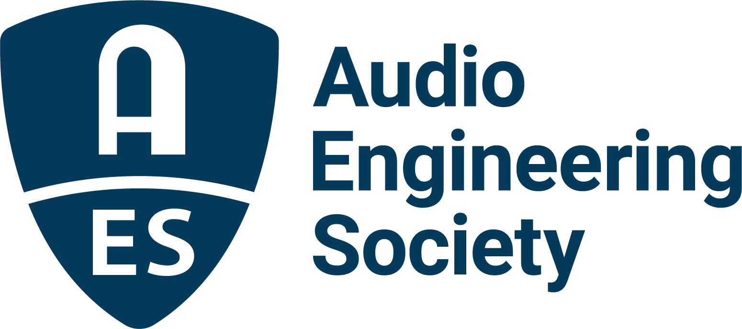

FOR IMMEDIATE RELEASE

Tomorrow’s Tech Revealed at AES New York 2022

— The Audio Engineering Society returns to New York for an unequaled in-person Audio Engineering Convention experience —

New York, NY, August 9, 2022 – AES Conventions are technology incubators. For more than seven decades, these events have been where new ideas are introduced, where experts discuss, debate and refine concepts, and where revealed science meets innovative application. It is when elite researchers, product developers and content creators gather to collaborate. Early peeks at the in-person AES New York 2022 Audio Engineering Convention’s technical program reveal that these disruptive traditions will be upheld during two full days of comprehensive sessions on October 19-20 (with targeted sessions on the 18th and related events on the 21st).

A case in point: DSP software engineers have longed to unleash GPU (Graphics Processor Unit) computing power for audio applications, though the difficulties in doing so seemed unsurmountable. In the session “Real-Time Parallel DSP Processing on GPUs,” GPU Audio co-founders Jonathan Rowden and Alexander “Sasha” Talashov will share how a new approach enables extremely low-latency GPU audio processing for uses such as multi-channel processing, cloud-based DSP, networked collaboration and the use of AI. Audio DSP developer Alexander Prokopchuk will give a practical demonstration using the FIR Convolver Reverb plug-in.

Speaking of alternative processing paradigms, in the workshop “Mixing Spatial Audio in the Game Engine,” Mirek Stiles, the head of Audio Products at Abbey Road, will walk through the recording, DAW mixing and final Unity game engine mixing process for creating a “gamified” 6 Degrees of Freedom Virtual Reality music experience. A stem mix of an “in the round” string quartet recording of a piece by film and game composer Stephen Barton will provide a proof of concept.

Can machines enhance creativity? In the session “Human Machine Creativity,” Nadine Raihani – head of UX and market research | design at Native Instruments and a producer/engineer – will be joined by iZotope associate director of engineering Caroline Lacoste for an exploration of how new and innovative assistive technology tools can unleash creativity and make music creation more accessible to everyone.

Audio application of Artificial Intelligence is a hot new field with demonstrable early results. Three PhDs combine as an amazing brain trust for the session “Moving Picture, Audio, and Data Coding by Artificial Intelligence (MPAI) – New Audio Standards Exploiting Artificial Intelligence.” Leonardo Chiariglione, the creator of the Moving Picture Experts Group (MPEG) standards development organization has founded MPAI to extend coding technologies far beyond the long-in-tooth MPEG algorithms. Chiariglione will be joined by Marina Bosi, who brings decades of coding and content management development expertise, and Mark Seligman, chief linguist at Speech Morphing, a natural language speech synthesis company working to improve human machine communication, for an exploration of the role AI plays in the standards defining what you’ll be hearing in the future.

“Discover More” at the 153rd International Audio Engineering Convention – AES New York 2022. The ultimate experience begins in NYC with the return of the unparalleled interaction of an in-person Convention. Then, on October 26-27, the online Convention event will bring its own separately curated program of workshops and papers to a world-wide audience. AES New York 2022 event partners include Dell, IMES (Iron Mountain Entertainment Services) and Qualcomm. The Convention will once again be collocated with NAB Show New York with a shared exhibits space. Exhibits+ registration, giving access to the in-person exhibition floor and related sessions, is free during the early bird period, while full technical program registration for the in-person or online components and All Access bundles are available at early bird pricing through August 31 at AESShow.com.

…ends 570 words

Links
AES New York 2022 Convention

Photo File 1: AESNY_2022.JPG
Photo Caption 1: Tomorrow’s technology will be revealed at the AES New York 2022 Audio Engineering Convention taking place at the Jacob Javits Center, October 19 – 20, with pre-and post-show activities on the 18th and 21st, followed by an online component, October 26 – 27. Register now at AESShow.com.

About the Audio Engineering Society
The Audio Engineering Society, celebrating over 70 years of audio excellence, serves as the pivotal force in fostering the development and dissemination of technical information for the audio community. Currently, its members are affiliated with 90 AES professional sections and more than 120 AES student sections around the world. Section activities include guest speakers, technical tours, demonstrations, online events and social functions. Through Conventions, Conferences, Training and Development, Member Events and peer-reviewed Publications, as well as the Society’s vast online resources, members experience valuable opportunities for professional networking and personal growth. For additional information, visit AES.org.

Join the conversation and keep up with the latest AES News and Events:
Twitter: #AESorg (AES Official)
Facebook: facebook.com/AES.org
LinkedIn: https://www.linkedin.com/company/audio-engineering-society
Instagram: https://www.instagram.com/aes_org/

AES Marketing Communications:
Email: robert.clyne@aes.org
Tel: 615-662-1616
Clyne Media, Inc.,
169-B Belle Forest Circle, Nashville, TN 37221;
Web: http://www.clynemedia.com

